Analysis

Project Definition

In 1991 The 16-Bit classic SEGA game Sonic The Hedgehog created by SEGA was released, and had the focus of being able to move at incredible speeds due to the superior processing speed of the SEGA genesis in comparison to Nintendo’s SNES console. The game was massively successful selling 24 million copies worldwide and proved itself as a staple of the gaming era.

With Sonic’s focus being speed and being able to manoeuvre through a level in the fastest time possible it naturally brought about the need to remember and react to the layout of a level, whilst being able to defeat enemies and bypass obstacles in the most efficient manner possible all to get the timer as low as possible. This made the game almost synonymous with speed runs, and increased the longevity of the game with people trying to find new methods to complete the game in shorter and shorter times. Such a mantra is even held and consolidated in the more modern Sonic games today.

For my project, I would like to elicit the same incentive and focus of speed through precise platforming and movement, whilst also being able to add a dynamic attack system to enable for more precise movement, as well as more efficient methods to take out enemies, culminating in a flashy style of gameplay which presents the same satisfaction of mastery as the original Sonic game had.

I will start by analysing the movement of Sonic and more modern momentum-based games, and analyse principles of level design, to make challenging but satisfying tasks for the player to explore and play through.

Stakeholders

For the potential demographic of my game will be teenagers/ young adults as my game will have a focus on skilful and masterful execution of platforming and attacking enemies. I have chosen this demographic as this age range of people are attracted to fast paced- flashy movements which make executing difficult inputs fulfilling. In terms of testing interactions of my project, I will use a range of students from my Sixth Form as a form of black box testing- to see how they experience playing throughout the game externally excluded from prior computer science insight. However, as a form of white box testing, I will use students and teachers from my Computer Science class to test my game from a gameplay, level design, and code efficiency standpoint.

My Stakeholders will test the game from a general player standpoint, and will test the game from a perspective of retention, ease of use and intuitiveness. In addition to this they will also help give me feedback as to what aspect I should improve which would hence mean that the usability of my game will increase. For example, after giving a simple explanation as to what I aim my game to portray my stakeholder has mentioned that for my game to be dynamic and face-paced I should also implement a grappling hook this is because It Is quite common in 2d platform games such as a game called flinthook where this builds the core aspect of the players movement.

For my Computer Science Colleagues, they will test the game from a standpoint of having already inspected the code. This will allow for thorough testing of every aspect of the program as they would have experience in testing more professionally, contrasting to my other stakeholders who would be giving feedback on the usability of the game. Some ways in which they would test my game is by making sure that my collisions are working appropriately. For example, they would jump towards a platform from several different directions as mentioned by a stakeholder, they would also use multiple different movement options in unintended scenarios to see if they produce any erroneous results.

Game Analysation

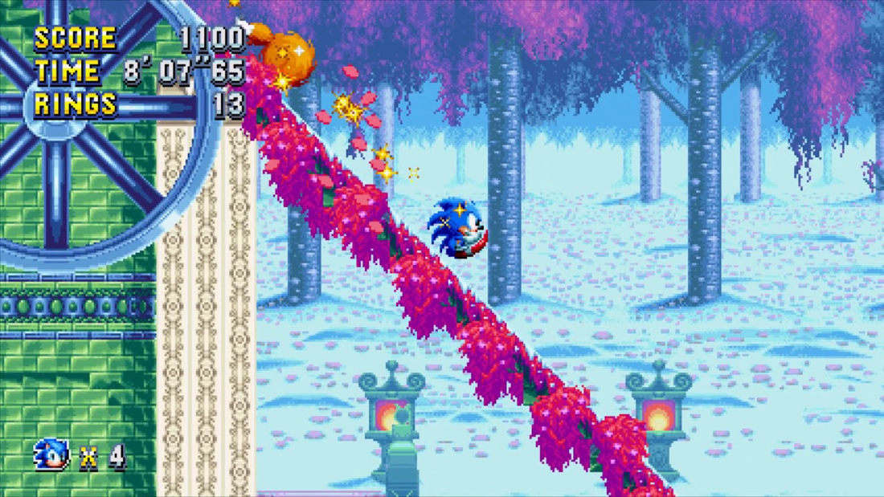

I am using Sonic Mania’s Physics as the main basis for movement of my character. Sonic’s movement is based on momentum, and he builds up speed the faster he runs to a cap, this speed can be affected by the terrain, sloping up and down as well as different platforms to jump from and to. In Sonic’s case his fastest speed is achieved when running downwards on a slope, so it is incentivised to find paths which allow you to run on the most ground whilst being able to avoid the most obstacles. For my game I would take inspiration from my characters speed building up over time and being affected by the inclination of the terrain, however for my character I would incentivise being in the air for maximum speed, whilst keeping ground movement incentivised for retaining and building speed. In this respect I would follow how Sonic will not keep as much momentum in the air as he does on the ground but still only allow for my Characters max speed to be attained while in mid-air. To do this will give my character a higher deceleration value when in mid-air but give them a higher cap on their max speed.

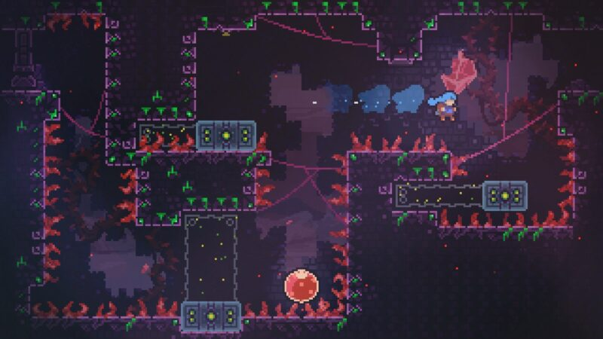

Although I am basing my momentum physics of off that of Sonic Mania, I would like the feel and motion of my character to be of that more akin to Celeste, as Madeline has a weightier feel to her jumps and has a mid-air dash ability. This propulsion of force is like that of my attack system, in that my characters attacks will push the character in such a manner whilst damaging any enemies it passes through. In Celeste, the force of the dash is not kept after the move has finished, and returns her back to her previous speed. In my project I would like to simulate this, where the attack / dash does not provide a continuous boost to the speed of the character, but is only a temporary bi-product of the attack move.

Decomposition And Essential Features

While these games both are 2D Platformers, their movement Decomposition is quite dissimilar in that Sonic focuses on momentum-based movement with simple wall collision and loop collision. Whereas Celeste’s Movement has more precise attributes such as sticking to walls, wall jumping and mid-air dashing. Through these decompositions, I have decided to integrate the momentum-based movement of Sonic whilst taking inspiration from Madeline’s Wall Jump ability and heightened mid-air manoeuvrability skills. Adding on to this I will give the player a health system which will undergo more damage depending on the level of the enemy. For my project since I am aiming to only make one huge level a lives system would be redundant so can be left out for the project. Apart from having various levels of enemies to be obstacles for the character I will also add various environmental obstacles such as flames and blades for the player to dodge. Additionally, I would follow more closely the level design principles of Sonic Mania, being more open air instead of being split into methodical platforming challenges like that of Celeste; this is because I still want my game to have a focus and incentive of speed, and Sonic Mania’s design philosophy indulges heavily in this concept.

Limitations

Non infinite runner games always have the limitation of requiring manually forged levels, and this will be reflected in the fact that my project will only consist of one level, however to circumvent the disadvantages of playtime this causes I will aim to make my level quite large. This will mean I have to hand-make a level which has the potential to be extremely time consuming. In addition to this, my game project will not feature any power-ups to affect the gameplay of the character, as creating such a refined character physics controller will be complex enough, and adding additions to the player control will add unnecessary complexity to the project. An additional limitation may the simulation of a physical Console Controller to interact with the game. Even though I do have access to controllers to test for usage it may prove difficult to get the inputs to have the desired output.

Abstractions

Abstracting the project Idea, the character and enemy health bars can all be displayed as simple solid colour bars, decreasing in length in respect to the remaining health. Enemy Projectiles can be displayed as basic solid colour orbs. The attack range of the player will be displayed as a translucent ring around the character and the indicator will swivel around the ring. The attack range and affect area can be shown as a triangle covering the initial and impact zones of the attack.

Thinking Ahead

Thinking ahead, I will develop my game for controller input, using the joystick as a direct controller for the attack aiming system. This will be most preferable as the joystick has innate 360-degree control and can instantly relate to any direction, rather than using the arrow keys to swivel around as aim.

Thinking Procedurally

Through Procedural methods, the code will have to be split into player physics, enemy interaction, attack system, and visual effects. Separating the code in such a way will make the program more organised and will allow me to debug my code much easier- additionally it will allow me to use code such as my player script in multiple other projects as it is a good basis for movement.

Thinking Concurrently

Multiple processes will have to be processed simultaneously, such as the movement of enemies and the player, as well as projectiles and a game timer. These will also have to run concurrently to a dynamic camera system.

Hardware & Software Requirements

To program my project, I will be using Lua through the Defold Game Engine. Lua is a high-level programming language comparable to python. This comes with the requirement of a minimum 4GB RAM for smaller sized less object intensive projects, however with my game requiring multiple enemies to be loaded and interacted with at once- whilst having individual AI components may require 6GB RAM to process. Deploying the game to a standalone program requires a running capability of 4GB RAM and Windows 7 or higher. As I do not plan to have extensive and expensive graphics in my project the project should not require a dedicated GPU- although it is worth noting that the machine that I am programming my project on does contain a dedicated GPU.

Due to my disposition to Controller Output, my project would be able to be processable by console and desktop machines alike. Mobile devices would pose a technological and software-based barrier.

Success Criteria

|  |  |  |
| --- | --- | --- |
| No | Criteria | Justification |
| 1 | Menu Screen | A simple screen for the player to choose when to start the game. |
| 2 | Health Bar | Showing the player how much health, they have left, so that they do not play too recklessly |
| 3 | Score | A scoring system to provide incentive to play better |
| 4 | Allow the player to move left and right on the ground and in air- build speed, and have a powerful jump. | Movement should be gratifying and fun to use. Making movement dynamic will also increase the number of different ways different obstacles can be tackled. |
| 5 | Dynamic Scoring System | The score for killing enemies will be calculated from the level of enemies killed, the number of enemies killed at once and the amount of hits it took to kill an enemy. Score will also be heavily based on time taken to complete the level, so faster times and speed will be highly valued |
| 6 | Enemies have basic AI systems | Enemies wont simply be size adjusted carbon copies of each other, and instead will allow for more dynamic and reactive gameplay |
| 7 | Attack Range Indicator | The range of the attack needs to be displayed to the player so that they know exactly how far they will go when executing the attack. This is so they do not over/ undershoot their attack and put themselves in precarious positions |
| 8 | Attack Cooldown | This is to stop the player from spamming their attack and taking advantage of it. |
| 9 | Attack Cooldown Reduction: The faster the speed of the character will make the Cooldown replenish faster and the number of enemies killed from the previous attack will reduce the overall time required for the Cooldown to replenish. | This will give the player incentive to go faster and to kill more enemies with their attacks, so that they must wait less time to use their next attack |
| 10 | Screen Effect Overlay | As the player may be focused on the character too much to see their health bar, having a whole screen effect (such as a pulsating red tint) will not only add to the atmosphere of the game but also allow the player to “feel” how much health they have left. It also will be able to heighten the experience of attacks. |
| 11 | Timer / Stopwatch | Requiring the level to be completed in a specific amount of time will add to the sense of speed in the game. Having a stopwatch will make it easy to see how long It took a player to complete the level and can incite competition. |

Design

Structure Chart

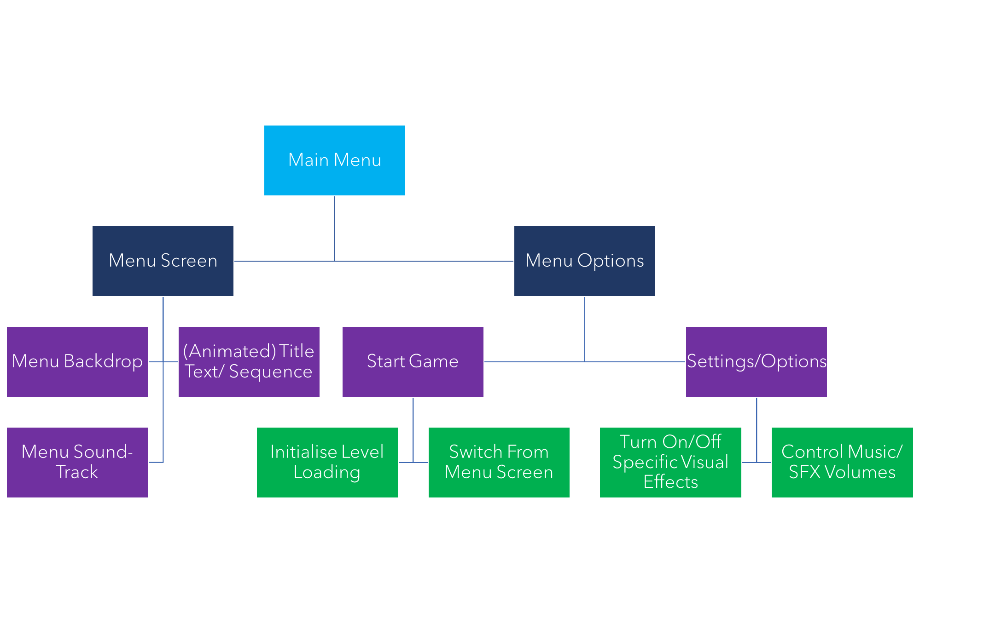

The Main Menu of my game will have two main interactions- this being the Start of the game and access to options for the game. This will serve as a hub for the game to be interacted with outside of gameplay. Being a simple project, the settings will only consist of audio control and potential visual effect toggles- such as the visual overlay or screen shakes/ vibrations. The initialisation of the menu will have an animated title transitioning to the screen. It will also have a slight delay before the menu buttons appear to allow the title sequence to occur. The start button will have the menu complete a smooth transition to the game level.

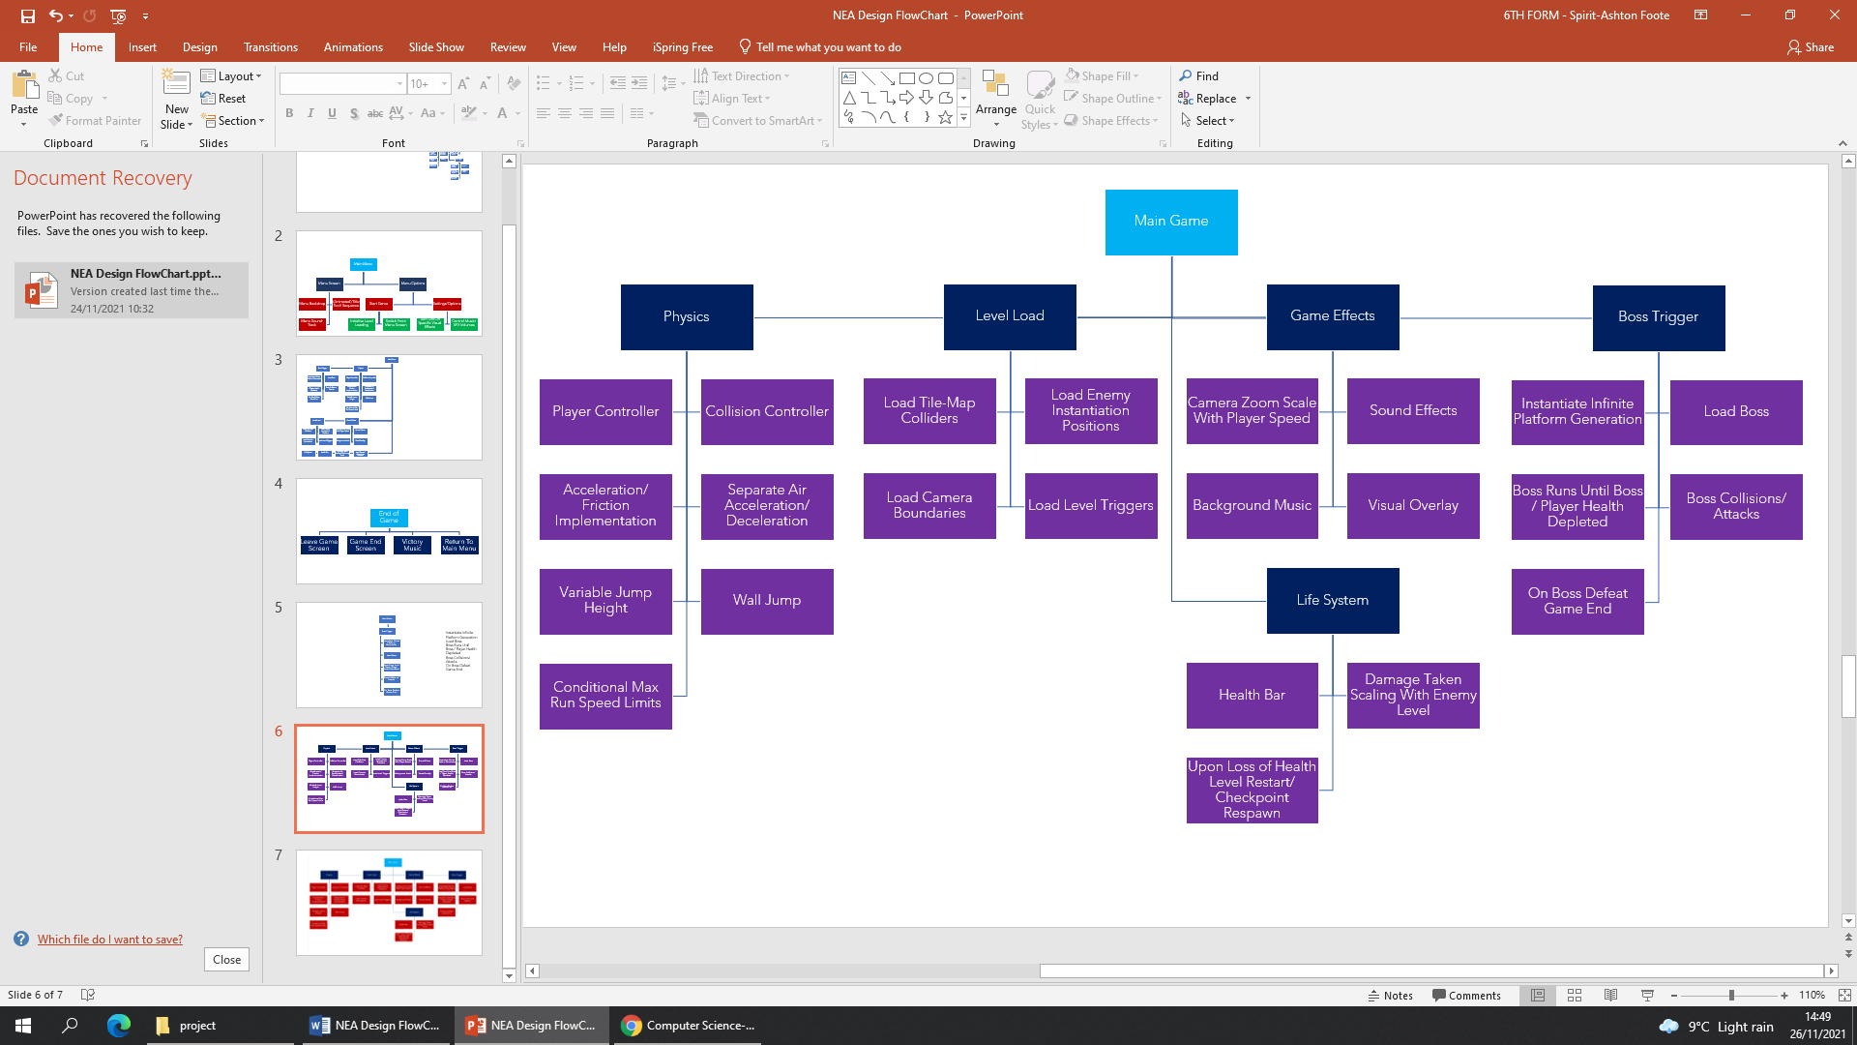

The Main Game Loop has 5 Major factors. Initially the level will have to load- for defold I am using a tile map based- system to create the level, where this does make the creation of the level much more streamline and efficient to develop, defold treats each tile as a separate block collider, this could potentially cause issues with load times as the level increases in size. If the load times become significant then a load screen may be required. Another development of the level initialization will be triggers such as Camera Boundaries, Enemy Spawn-points, and The Boss trigger.

Next The Physics of the game will be immediately active as soon as control of the character is gained. The character physics will have to specifically fine-tuned and detailed for diverse traversal through the landscape; this includes additions such as a variable jump height which varies in length in proportion to the time the jump button is pressed, a wall jump system to allow the player to wall jump within a specific register of time from contacting a wall.

Apart from the extensive list of physics attributes which will have to be added to the physics engine another attribute of the player will be the lives system. This will be a variable health bar which scales damage taken in ordinance to the level of enemy attacked by, this meaning that the player will take more damage from more dangerous enemies and take less damage from less dangerous ones. There will not be a traditional “lives system” such as where you can reach 0 lives as the will only be a single level. The only situation in which a lives system could be implemented is if the level becomes large enough to require checkpoints otherwise death will result in a restart of the level from the beginning.

There will also be a myriad of visual effects throughout the game. This will heighten the experience of playing the game and make skilful executions more flashy, exciting, and satisfying to carry out on the various enemies throughout the game. This will include camera shakes and streaks when attacking an enemy, the camera zooming out as you gain speed and a pulsating red vignette as your health depletes. There will also be a soundtrack playing in the background of the game as you play with sound effects for running and defeating/ attacking the enemies.

When the boss trigger is initiated, the game will initialise an infinite runner track for the player to run across until the boss is defeated. This is required as the player builds attack power and range through gaining speed, therefore an indefinite method to increase speed is crucial. Once the boss is initialised going back to before the boss trigger will be impossible and the rest of the level will not be able to be returned to. This will cause the player to run in the right direction where different platforms will spawn as they are needed. There will be an off camera invisible wall which follows the leftmost side of the screen to stop the player from running off from the camera, which will also be prevented from scrolling back too far. The Boss sequence will require to build up enough speed to attack through the boss without getting damaged themselves, however obstacles the boss will cause will try to prevent the player from building up enough speed. The player will have to manage dodging the boss’s attacks, obstacles, building up speed and attacking the boss before their health depletes.

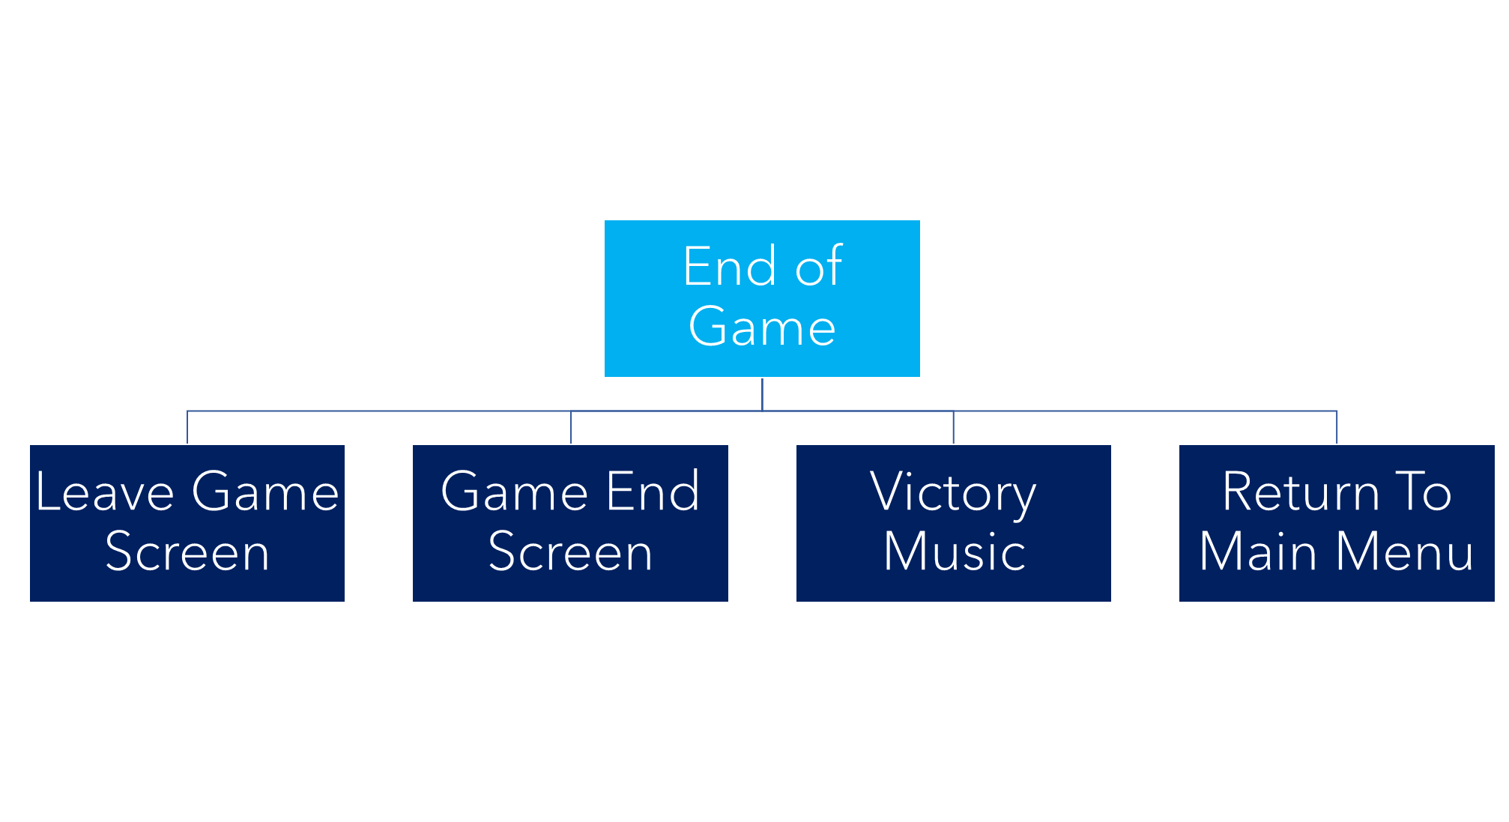

Upon the defeat of the boss the game would have been successfully completed, and a protocol for ending the game will be called. This will cause the game screen to be transitioned to a victory screen with visual effects and victory music. After the victory fanfare has ended the player will be sent back to the menu. As a bonus completion of the game could result in a star graphic being added to the main menu to signify that the player has completed the game.

Player Controller Variables

|  |  |  |
| --- | --- | --- |
| No | Variables | Justification |
| 1 | Acceleration | Will allow the player to slowly build up speed. Makes movement smoother and can add weight to a character for more intuitive motion |
| 2 | Max Speed | Will stop the player from exceeding a certain speed. |
| 3 | Ground Friction | Will slow down the player when not giving horizontal input and on the ground- can also give specific surfaces a slippery feel or can make specific surfaces harder to move on |
| 4 | Jump Force | Will give an upward force to the player to propel them in the Y direction |
| 5 | Jump? | Boolean value to decipher whether the player is currently jumping or not. |
| 6 | Gravity | Will pull the player downwards until they touch the floor. |
| 7 | Alt Gravity | A different gravity value which can be manipulated to allow for a variable jump height in which the length of time the jump button is pressed changes the height the player reaches |
| 8 | Air Friction | Will Slow the player down in mid-air when not giving horizonal motion but at a slower rate than on the ground as there is “no surface friction” |
| 9 | Health | The health of the player, affected by the enemies' level of attacks. Will slowly regenerate over time if damage has not been recently taken. |
| 10 | Attack Range | The range at which the attack will boost the player to. Is varied by the speed at which the player Is moving at. |
| 11 | Boost Force | A double-jump-esque move which allows for refined in air mobility and can be used to reposition after an attack or to platform over areas |
| 12 | Attack Meter | A timer for how long the attack is on cooldown until it can be reused again. The speed of the player will be associated to a tick value which slightly decreases the cooldown meter. The number of enemies killed in the previous attack will result in the initial level of the meter being decreased- Making it less incentivised to use the attack simply for platforming as it leaves you vulnerable. |
| 13 | Attack Strength | The amount of damage the attack does to all enemies it hits- bigger enemies will require faster attacks with higher strength values. |

Player Controller Pseudocode

|  |  |  |
| --- | --- | --- |
| No | Pseudocode | Justification |
| 1 | If user input == “left”:  playerspeed = playerspeed - acceleration  If user input == “right”:  playerspeed = playerspeed + acceleration  If user input == “up”:  playerforcey = jump force | When the player uses left or right inputs the acceleration will add to the magnitude of the current speed in the appropriate direction.  playerspeed and playerforcey are placeholders for however Defold innately controls player movement values. |
| 2 | If user input == “attack”:  tempx = playerx  Damage hitbox = off  Attack hitbox = on  Playerforce = attackrange  If playerx = tempx + attackrange:  Attack hitbox = off | When the user inputs for the attack, the Damage hit box for the player is switched off (the hit box used to determine enemy/ projectile collisions) so the player cannot be damaged. An attack hit box will be turned on to kill all enemies passed through. |
| 3 | If user input == “up” and jump == false:  playerforcey = jump force  jump = true  If user touch? = ground:  jump = false | This detailed look at a jump pseudo code uses a jump variable to determine whether the players currently jumping or not- and restricts them from jumping again until they land back on ground- this will stop infinite flight. |
| 4 | If health >= 0:  player dies  restart level  Set health to 1000 | When the players health is depleted, they will lose control of the player and a death animation will play. Then the level restarts and replenishes the players health. |
| 5 | If health < 1000 and not damaged = true:  Every tick:  Health = health + 0.5 | When the player has not been damaged for a specific amount of time their health will slowly start to regenerate. |
| 6 | If Roll == false:  If user input == “down” and user input == “up”:  playerforcex = 700 * player direction  hitboxy = hitboxy – 400  If Roll == finished:  hitboxy = hitboxy + 400 | This will make the player go into a roll position which will make them move faster along the floor whilst giving them a smaller hitbox. This will let the player dodge attacks and move between small gaps. |
| 7 | If player invincible == true:  repeat 5 times:  Set Player Alpha = 0  Time delay (0.2)  Set Player Alpha = 1  Time delay (0.2) | When the player is invincible, they will blink visible and invisible to show that they cannot take damage for a brief amount of time, this is done in most retro games to portray this effect |
| 8 | If player on wall and user input == “up”:  playerforcey = jump force  jump = true  playerforcex = 400 * -1 * wall direction | This would allow players to wall jump across alternating platforms as long as they are close enough together. This adds to the dynamic of the movement system and allows the player to traverse the world in a more complex way which is directly affected by the layout of the level. |

Graphical Representation

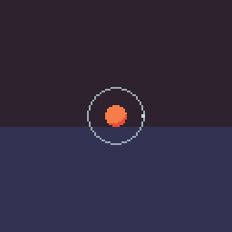Here shows the attack range ring of the character- it will have a small indicator around the edge of the ring and will swivel around the ring in response to user input. Once attacked the attack action will be put on a cooldown until it can be used again.

Here are some examples of movement within the player controller. The player will 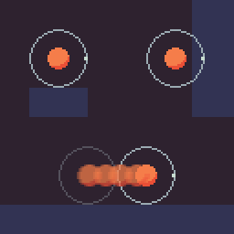be able to have a simple variable jump- which changes in height depending on how long the jump input button is pressed. The player will also be able to wall jump off walls and has access to an” air boost” ability, an ability which acts as an extra control of movement whilst in the air- initiated by re-pressing the jump button. This air boost will follow the current inputted direction- and not the current direction of movement of the character- this makes it extremely useful for changing direction in mid-air and allows for more refined dodging of enemies and their attacks.

This is a simple portrayal of how the player will be able to build up speed through running for longer periods of times and being able to successfully manoeuvre through the stage. As the speed of the player builds up the range of their attack will also scale up- allowing the player to commit to a larger- more damaging attack.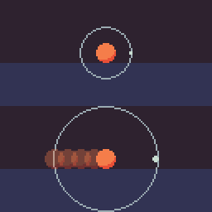

Upon using the attack- the player will enter a state of temporary invincibility- and will not be able to be damaged by oncoming enemies or attacks. The total damaging area will be from the initial position of the player to the end of the indication range of the attack. The displacement caused by the attack will be controlled as a force- but will reduce some of the added force it gives at the end of the attack- as to not dramatically increase the speed of the player without the player earning the achieved speed.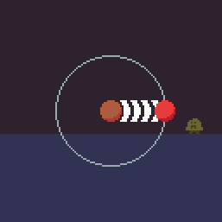

Any enemy that encounters the damaging area will receive damage scaling up with the speed of the player. Bigger enemies will require more damage as they will have higher health values. Larger enemies will also require larger attack ranges so that the player does not damage themselves by colliding with the enemy after their invincibility frames from the attack run out.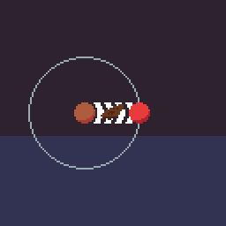

Key Development Milestones

|  |  |  |
| --- | --- | --- |
| No | Milestone | Justification/ Prediction |
| 1 | Basic Player Movement | As an introduction to using and learning how to use Lua and defold. Creating a basic physics engine to allow for simple left and right movement as-well as jumping and simplistic gravity will be able to introduce me to how the engine handles collisions and calculations. |
| 2 | Basic Camera | Before being able to create any test scene or level I would need to have a basic camera that simply follows my player around. |
| 3 | Test Scene/ Level | Next a complicated landscape would have to be made to test more intricacies of player movement and allow for the addition of more complicated forms of world traversal such as wall jumps. A level would either be made through tiles or through manual collision setting |
| 4 | Background | A simple background behind the scene should not be too hard to implement. It would be a start on increasing the visual fidelity of the project |
| 5 | Complicated Player Movement | Now with a larger world to move around in, I would now have the freedom in space to be able to test my boost jump idea. As a separate target (however still part of complicated movement) I could work on creating a wall jump as well to be able to scale walls |
| 6 | Basic Enemy | With the movement of my player having a strong base to work from, having an enemy to interact with the player would allow me to further test for limitations of my player movement and create an enemy that can exploit this so it can pose a proper challenge. |
| 7 | Health / Damage System | For my enemy to pose a threat I would need to implement health and a damage system. This damage system would stun the player briefly when being attacked being both a visual indicator that they have been hit as well as a repercussion for being hit. It would also give the player some lenience with invincibility frames so they cannot be hit multiple times in a row |
| 8 | HealthBar | With my health variables being in use and interacting with the enemy, I would need a visual healthbar to convey this information to the player, so that they know how much health they have left. |
| 9 | Death | A simple protocol for when the player dies. Due to the project only planned to have one level the protocol would only act as a quick restart to the level. However, it could pose a timer handicap or score handicap. |
| 10 | Attack | Implementing my attack seems like it would be difficult but at this stage of the project it would be required to work any further in game fidelity. |
| 11 | Prototype Level | Creating an actual level instead of test space so that the player has a goal to get to. |
| 12 | Boss | Creating a boss with multiple attack phases and a large healthbar for the player to whittle down. |
| 13 | Scoring System | Using statistics such as time taken, times hit, enemies killed etc to calculate a score at the end of the level. Potentially a way of saving these scores to make a high score challenge. |
| 14 | Basic Menu | A simple interface to start the game/ look at different statistics or change controls. |
| 15 | Visual Fidelity | This would be making the game look nicer for more appeal |

Milestone Testing

Player Movement

|  |  |  |
| --- | --- | --- |
| No. | What is being tested | Expected Output |
| 1 | Fast Speed | The player starts slow and slowly builds up speed the longer they run for. |
| 2 | Player moves with Joystick | The player moves left and right in relation to the joystick, but only when it is held far enough in either direction |
| 3 | Player Boosts in direction of Joystick | The player has a boost that works in the direction of the joystick, and upon completion, allows the player to move normally. |
| 4 | Wall Jump | The player will have to jump alternately from wall to wall to be able to scale up higher, otherwise they will slide down a single wall. |
| 5 | Grappling Hook | The player will shoot out a grappling hook and be able to swing from platforms using the force the swing was initially given |

Basic Camera

|  |  |  |
| --- | --- | --- |
| No. | What is being tested | Expected Output |
| 1 | Camera Follow | The Camera follows the player with a slight delay so it is not too rigid. |

Background

|  |  |  |
| --- | --- | --- |
| No. | What is being tested | Expected Output |
| 1 | Parallax Background | A background with parallax effect to create the illusion of depth |

Enemy

|  |  |  |
| --- | --- | --- |
| No. | What is being tested | Expected Output |
| 1 | Enemies that follow the player | Enemies that can track the player and go in the same direction as the player |
| 2 | Attack | Some form of attacks that damages the player and stuns them briefly |
| 3 | Death | Health attached to the enemy that when reaches 0, results in the enemy dying and staying unloaded in the level. |
| 4 | Multiple Enemies | Multiple Enemies which range in size, power, and health. |

Health/ Healthbar

|  |  |  |
| --- | --- | --- |
| No. | What is being tested | Expected Output |
| 1 | Health affected by attack | Health that gets reduced when being attacked by an enemy |
| 2 | Passive Health Regeneration | The health value slowly increasing over a period |
| 3 | Healthbar | A simple healthbar which shows the player how much health they have left |
| 4 | Healthbar Warning | A warning to the player that their health is dangerously low |

Death

|  |  |  |
| --- | --- | --- |
| No. | What is being tested | Expected Output |
| 1 | Death | The user loses player control and the level resets |

Attack

|  |  |  |
| --- | --- | --- |
| No. | What is being tested | Expected Output |
| 1 | Attack Collision | A Collision that varies in size and damage applied to enemies hit |
| 2 | Boost | A Boost that sends the player to the extent of the attack range |

Boss

|  |  |  |
| --- | --- | --- |
| No. | What is being tested | Expected Output |
| 1 | Large Boss | A Boss with a lot of health that the player must slowly defeat |
| 2 | Multiple Attacks | Many Different Attacks the player must fight against and dodge |
| 3 | Attack Phases | Different Phases of collections of attacks that increase in difficulty and damage as the health of the boss decreases. |

Post-Development Testing

|  |  |  |  |
| --- | --- | --- | --- |
| No | Post-Development Test | How its achieved | Justification |
| 1 | Difficulty Increasing as level progresses | Increasing the Health and Damage of the enemies as the level progresses. Whilst also increasing the size of the enemies for fairness | This will create more of a challenge for the player and will give a sense of progression through the world |

Development

Development Key A: Basic Movement

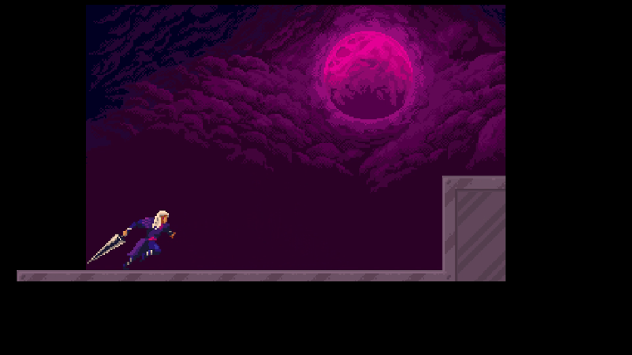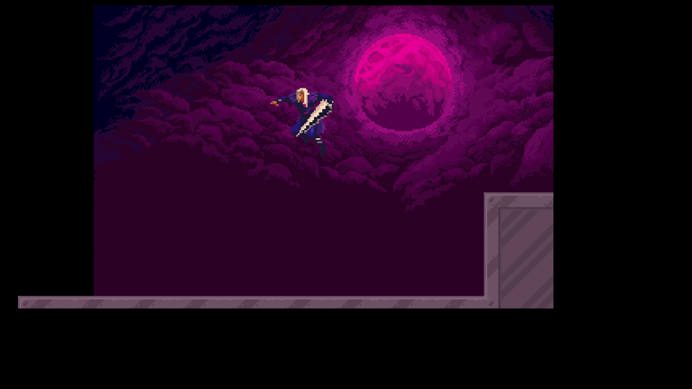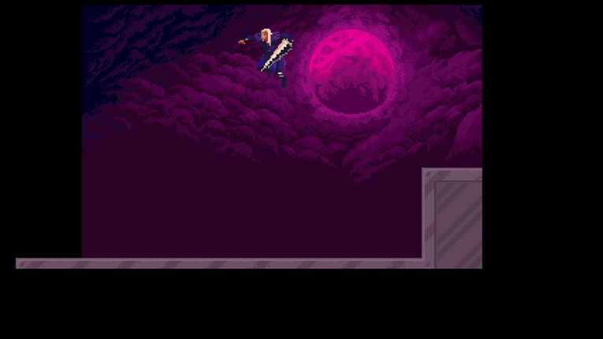https://share.vidyard.com/watch/5iBkgJ88qFZpVTR9rwvpxj?

Here is an example of the first key milestone being achieved. Basic Movement where you can run left and right with a variable jump height. Here however the camera does not follow the players movements and a simple background imported from external sources has been placed in the game scene. However, it is not lined up with the main screen. There were many non- code hurdles that had to be crossed to reach this point. The main non-code problem was getting the resolution size and view area to be standard regardless of the window dimensions. This was important because the resolution of the game is extremely important for a pixel art style- dynamic. I was also easily able to create tiled collisions by using my own tile-set which I had created and imported and using the tile-map function built within defold.

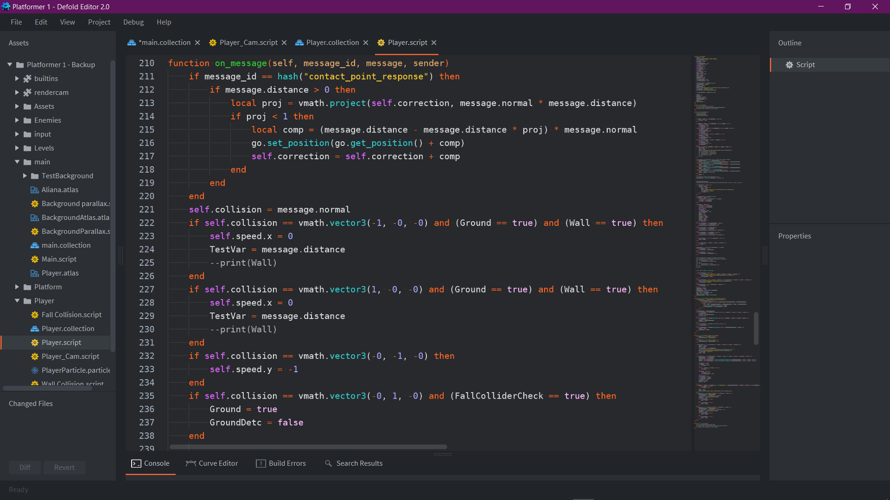

First, since I am creating my own physics engine by using a kinematic collider for my player (A collider that registers the direction and position of collisions but needs to have interactions coded for it). I had to register collisions. Defold works by using messages to communicate between scripts and colliders. Here it uses a vector3 using the x and y values to determine what direction it is colliding with x: 1= right, -1= left and y: 1= floor, -1= ceiling. Using these collisions, I can simply set the vertical speed of the character to 0 or the horizontal speed to –1 for ceiling interaction. For the floor interaction this is held accountable by a separate floor function and sets two variables (Ground, GroundDetc) to their respective values. The collision system in defold however, with tiles possess a large barrier issue to movement. With tilemap management each tile is considered as a separate box of collision. This causes issues when running across the floor due to inconstant or lags in frame rate the collisions can read as running into a wall when you are in-fact supposed to be running on a straight line; this results in the player “tripping” and coming to a complete halt run running on flat ground which obviously is a large hindrance to gameplay and actively goes against my games philosophy of reaching fast speeds. In other game engines such as unity this is solved by using a function (composite collider) which procedurally makes all colling boxes connected to each other into one large shape, eradicating this issue all together. However, defold does not contain this feature and so requires a workaround, this was my intended purpose with the variable Wall however I could not work out a solution to the problem now.

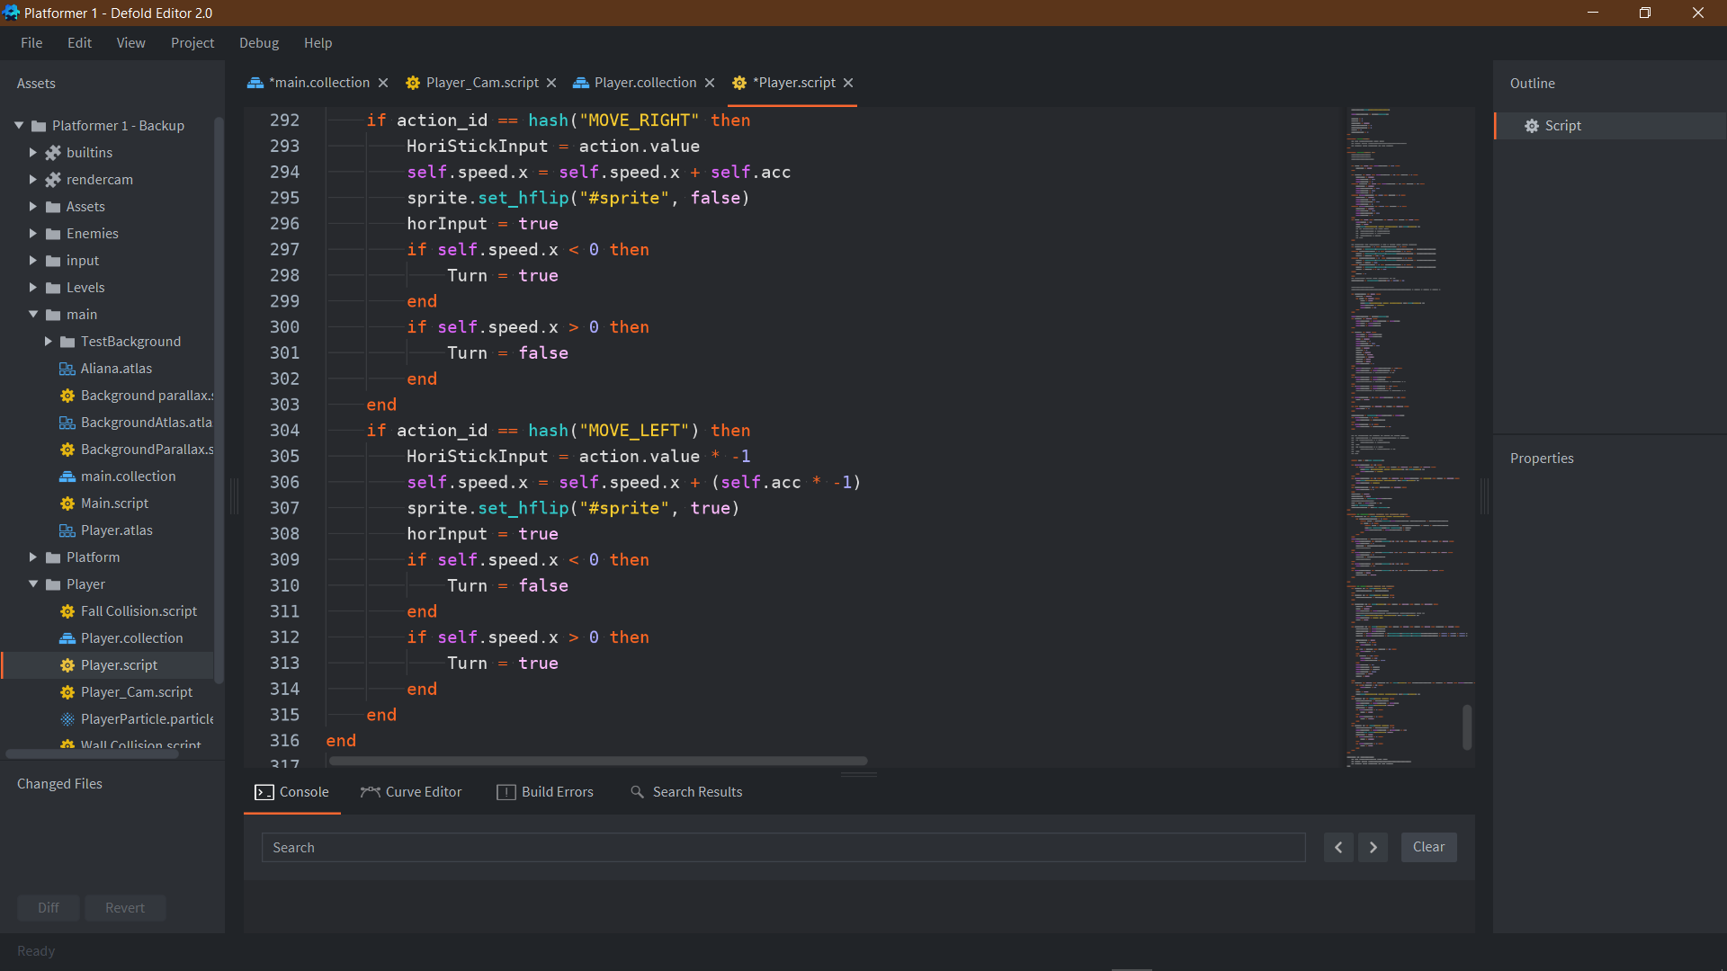

Here shows the left and right movement of the player. It is very simple code that will increase the speed by the current value of acceleration in whatever direction is being held, as well as flipping the sprite to the appropriate direction. It also has a turn function which simply sets a variable true or false depending on if the player is moving in the opposite directions to what they are pressing. This links to a simple code which will turn the friction on so that the player can turn quicker. This simply feels nicer in game to be able to turn quicker- however not completely removing the sense of fighting against your movement completely. Here is where I learnt the simplicity of being able to import joystick input. Defold can register gamepad input innately from its input files. I only had to set it to a hash which my code can then refer to.

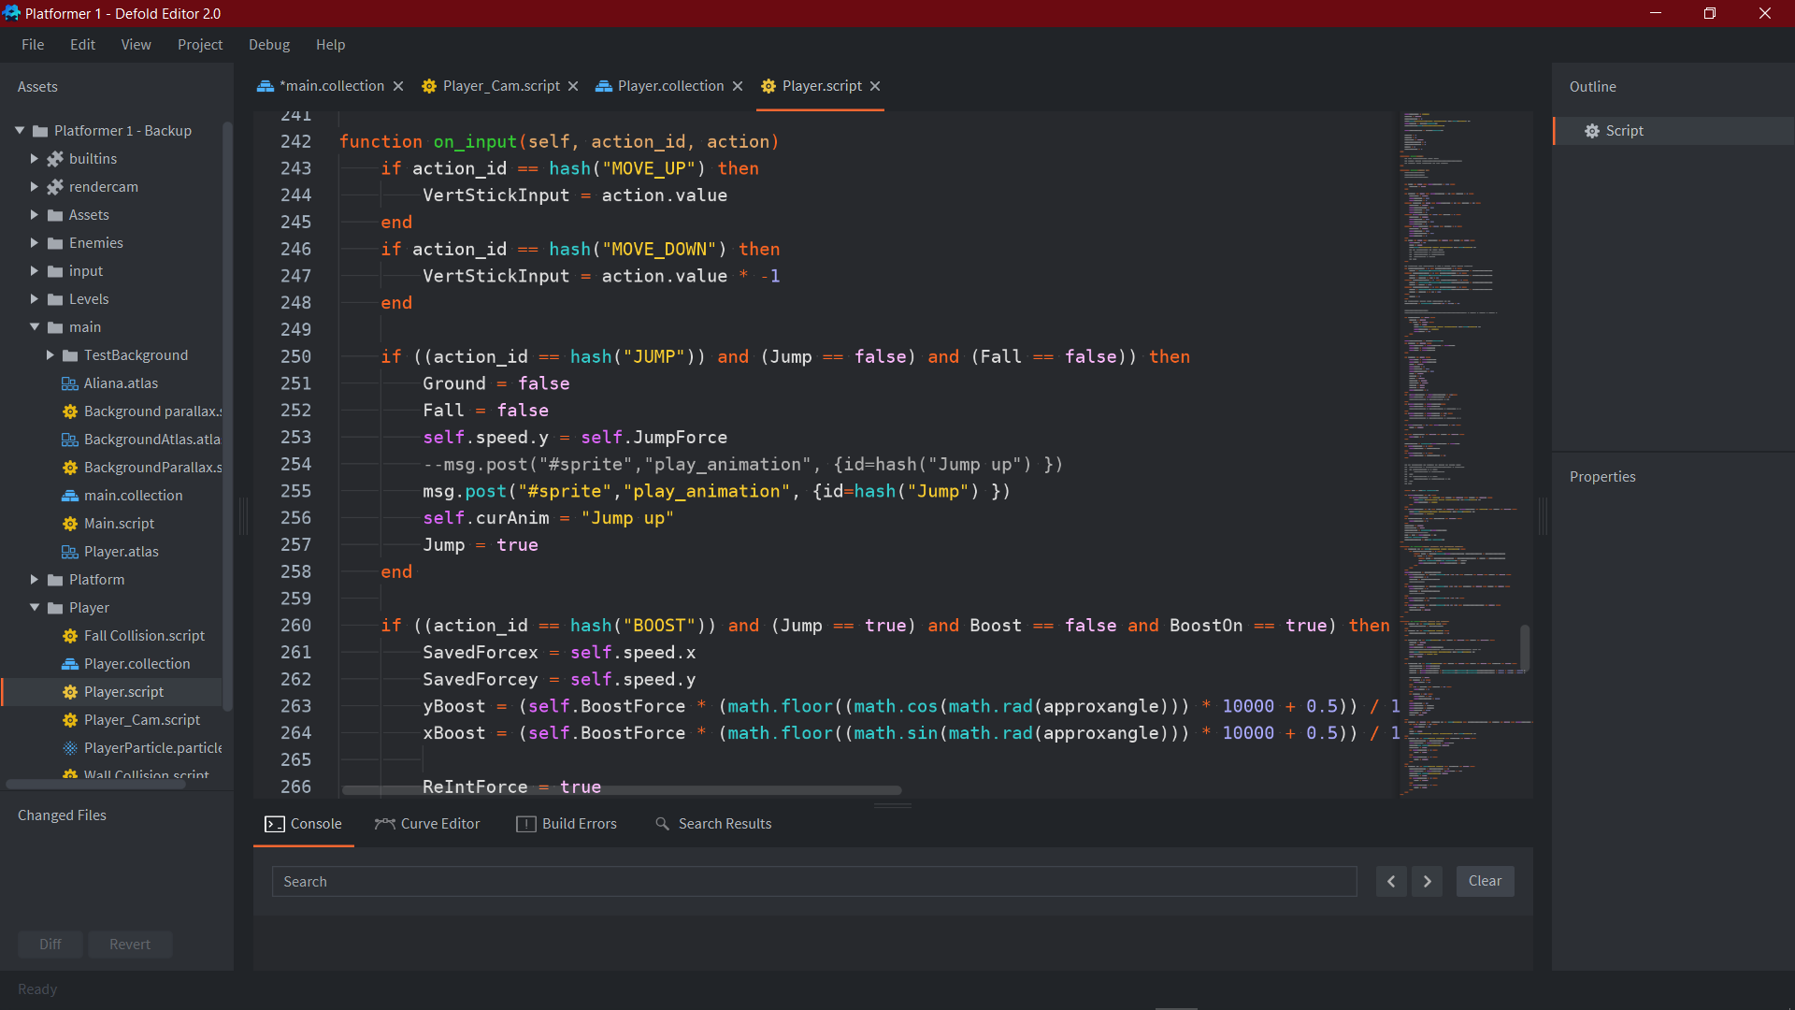

Here is the Jump Control of the player, it simply sets the y value of the player to the set jump force (550) and plays the Jump animation. It also sets the Jump variable to true for other functions in the script as well as setting the ground and fall variables to false as the player would be in neither of those states. The Jump can only be initialised if the player is not already in mid-air after jumping or if they are on ground- registered by the fall variable.

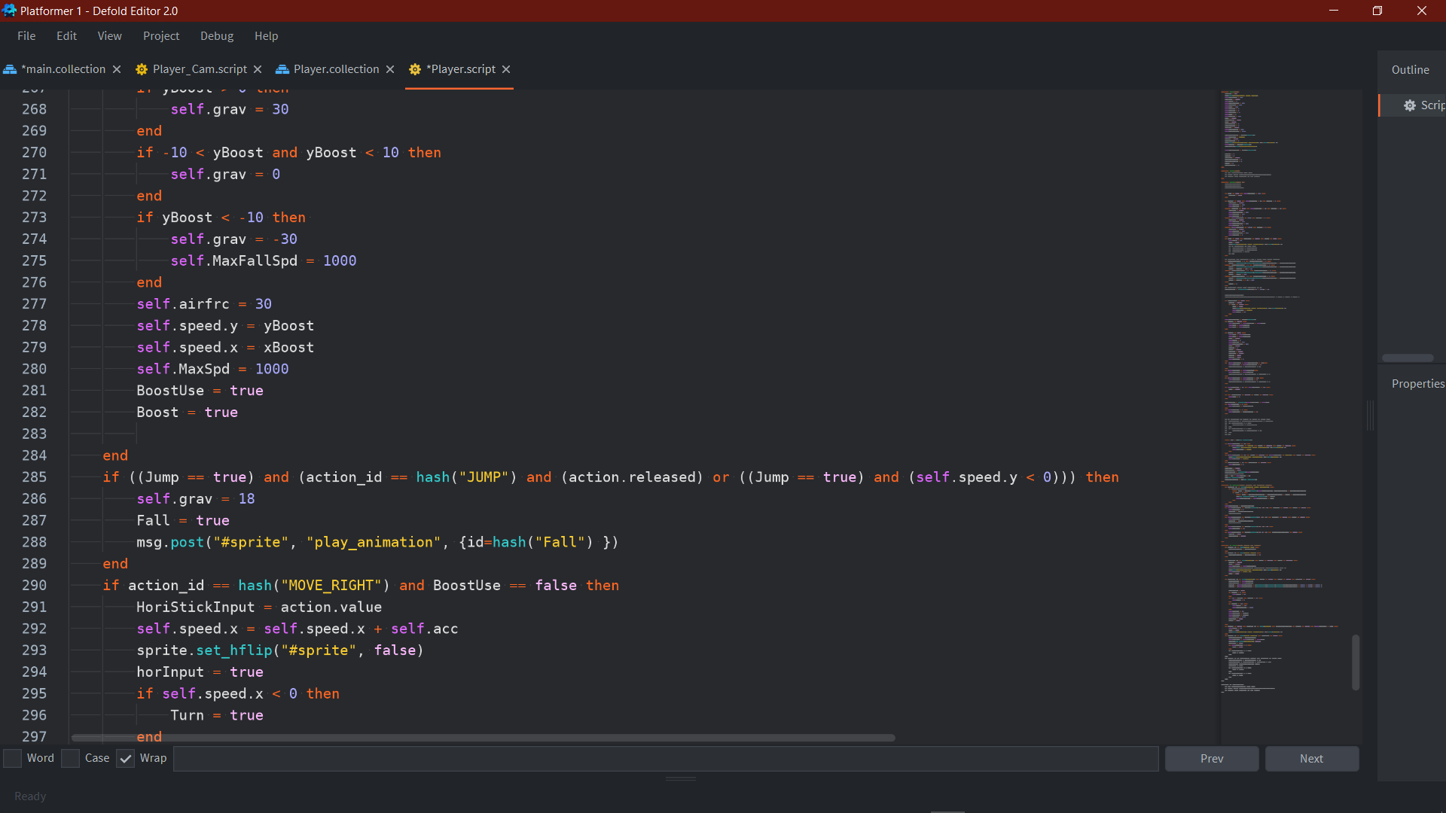

This Code here makes the Jump into a variable jump. When the Jump is initialised, the gravity is originally set to 8, but here the code will set the gravity to 18 if the Jump button is released or when the y velocity reaches 0 from the prior gravity. In this way it achieves two things. It makes the fall of the jump faster than the rise; this is commonly done in game design to make the main character feel weightier and to give a good game feel. It also means that the player will jump higher depending on how long the jump button is held for, as when the jump button is released gravity will turn to 18 earlier than it usually would, meaning that the character reaches a lower peak height.

Development Key B: Parallax Background and Boost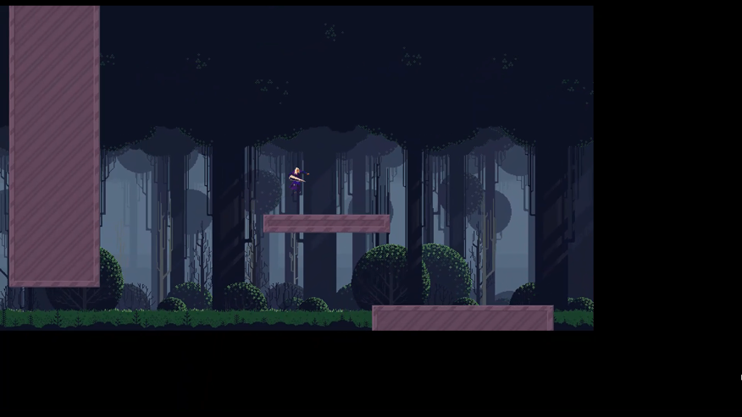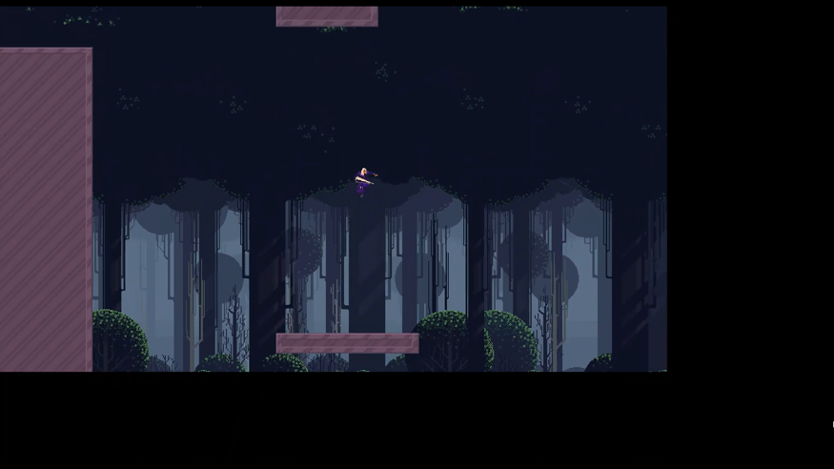

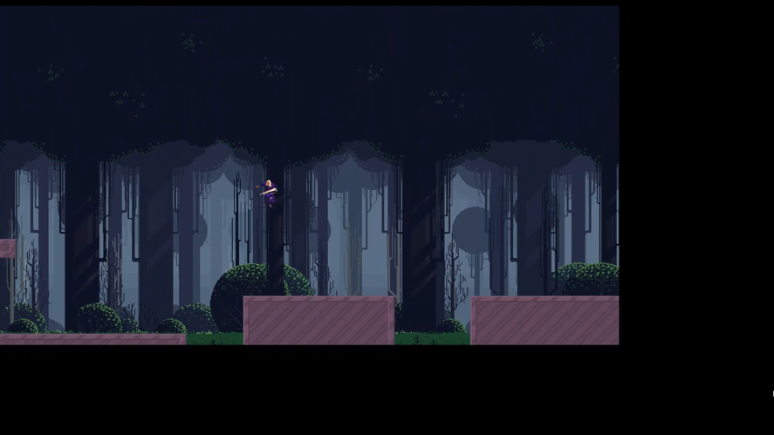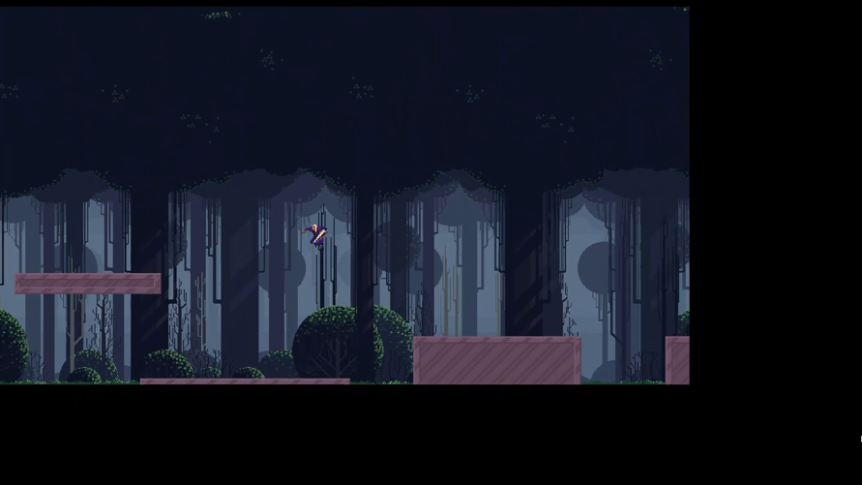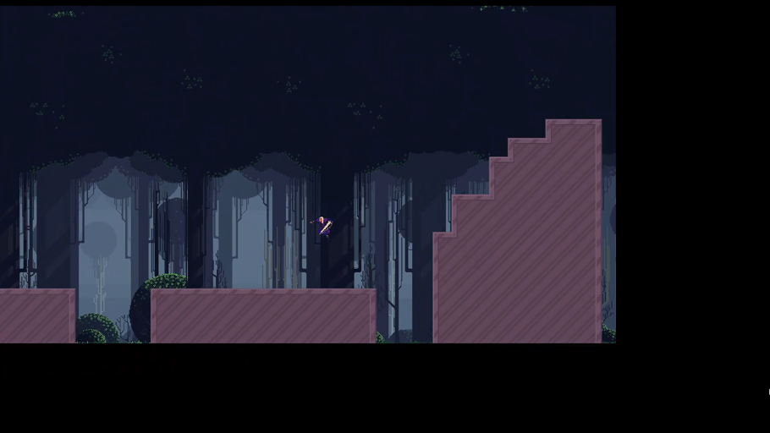<https://share.vidyard.com/watch/LMxu5hs8ntWE2F5EbnDAHN>?

Here a lot more development has been done. First the camera has been developed more to zoom out based on character speed and a parallax background has been added which infinitely scrolls across the screen with the player. To accompany this larger view area a more developed testing scene has been created. This extra space had also allowed me to develop a boost jump which is directional by the joystick position. The main difficulty throughout this stage was being able to get the boost to work appropriately to how id envisioned it. The parallax background did not prove to be much of a challenge- however its main obstacles proved to be the resolution and sprite size of the sprite I decided to use for the background as it made the process just slightly more complicated needing to account for it.

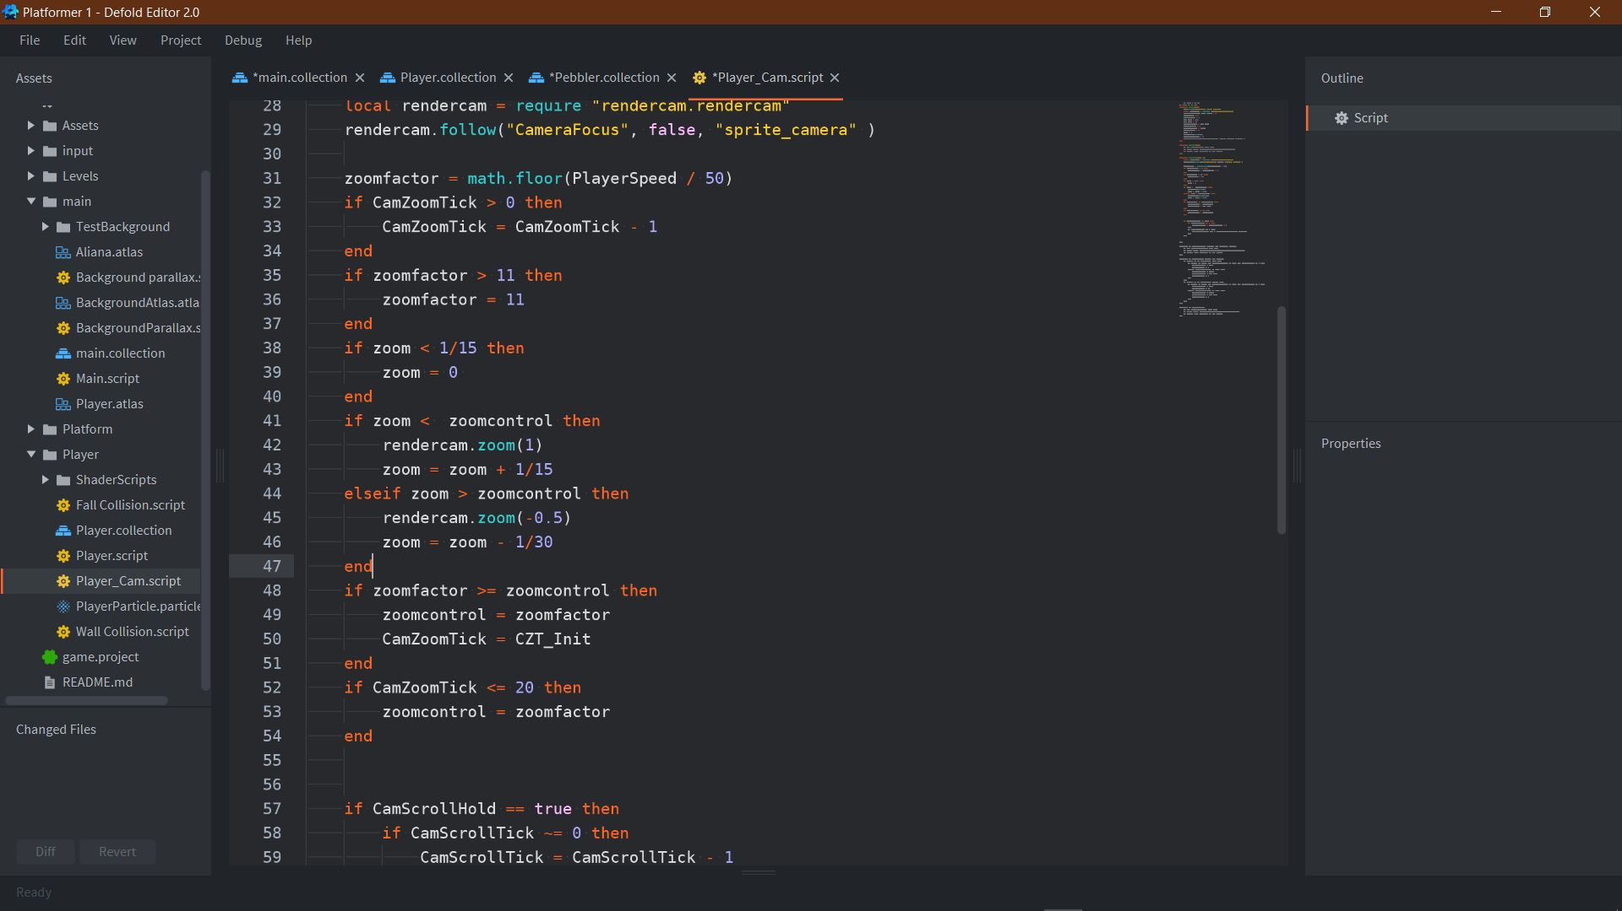

To achieve the screen zooming out in respect to PlayerSpeed I had to find a work around. This is because for the camera I found and installed a library called rendercam as it has functions such as camera zoom readily available. The only problem is the zoom function is treated as an incremental function- not a setting function. The problem with this is that I could not easily set a value inside of the function in respect to my speed as it would just infinitely zoom my screen out just at differing rates. To work around this, I had to link a positive and negative zoom function to the value of the variable zoom, and then only allow these functions to carry out when the value in zoom is smaller than the value zoomcontrol- which is the value controlled by the speed of the player. In this way I achieve having a zoom which is limited / controlled by the speed of my player and is reversed by the slowing down of the player. However, at first testing this effect did prove to be very distracting as the screen would be constantly zooming in and out, this is the purpose of the CamZoomTick statements, these statements only allow the zoomcontrol value to decrease after a specific amount of time has gone, so that even after coming to a standstill the player has some time to breathe and register their surroundings before the screen starts to limit them. It is important to state that this timer resets itself if zoomfactor is larger than or equal to zoomcontrol, so the zoom counter will only come into effect if the player is completely still or has been moving at a lower speed for a quite a considerable amount of time.

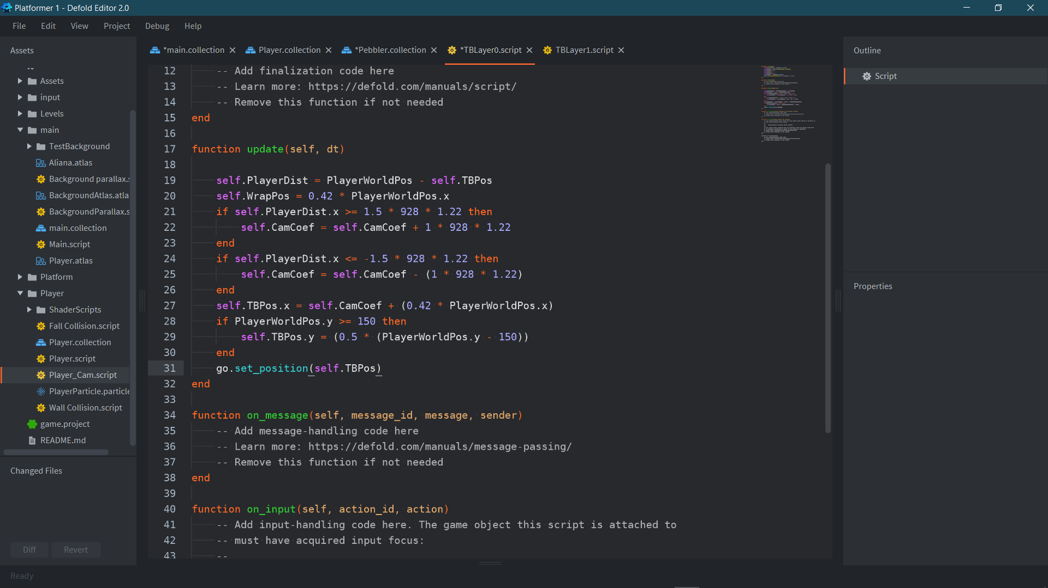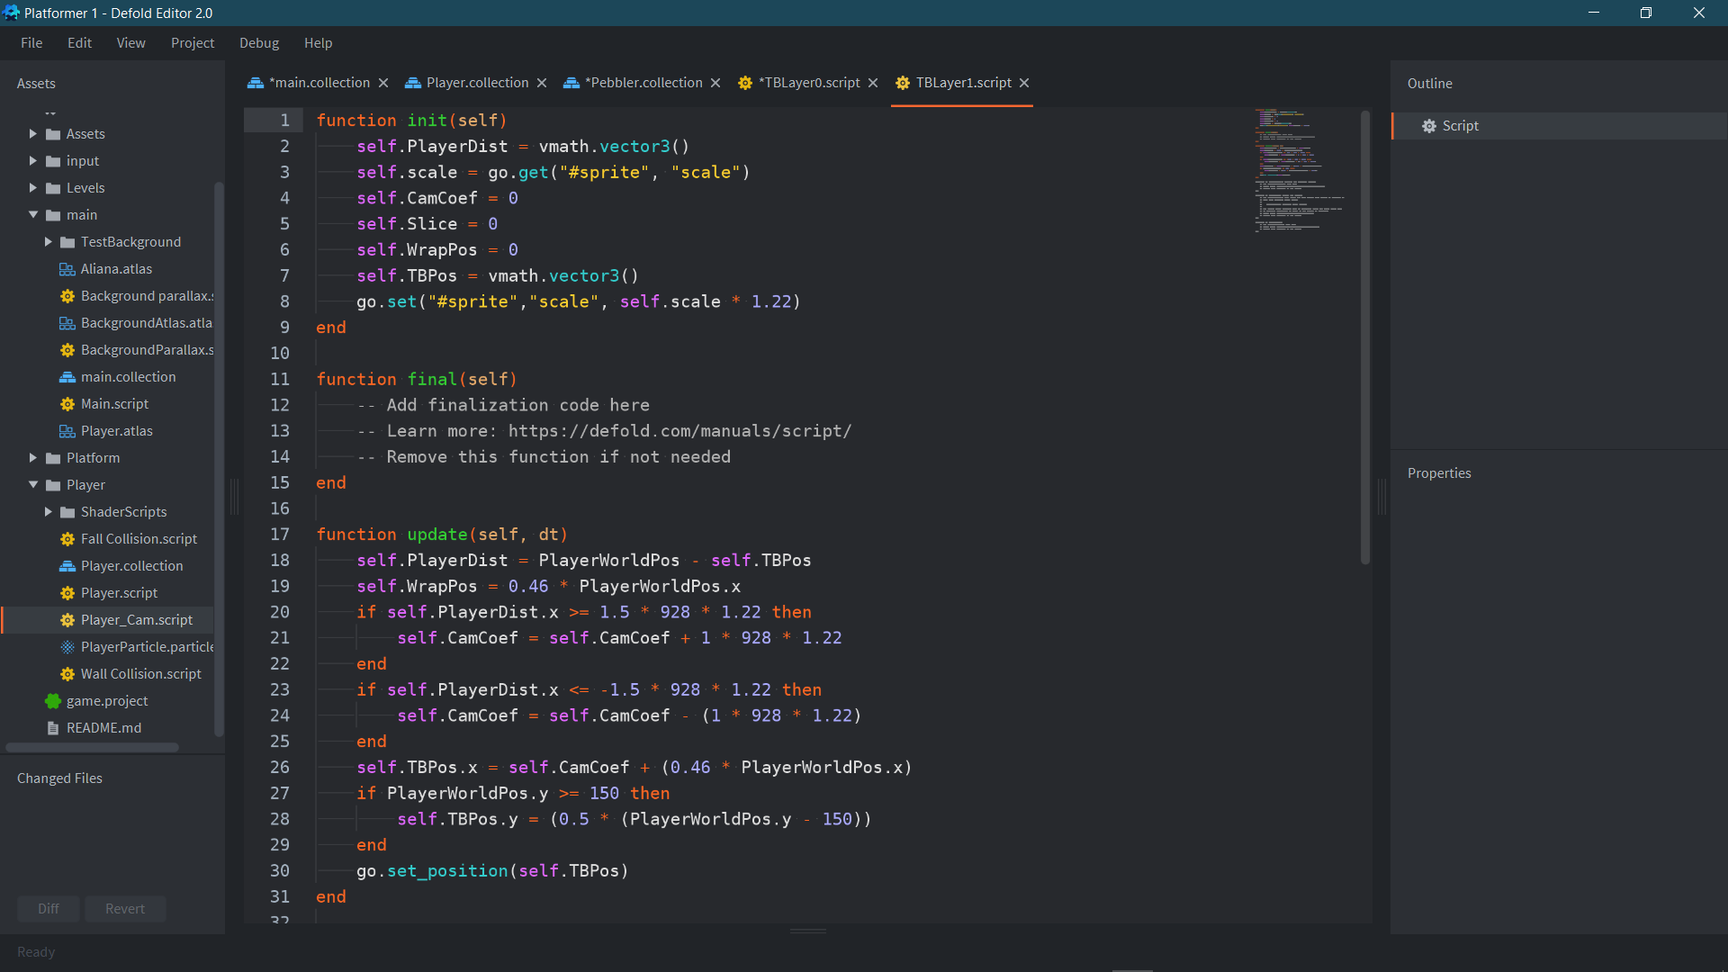

The finalised code for the parallax background ended up being very simple however the difficulty was in the multiple revisions of trying to find different ways to do it. Simply the parallax effect is just making a background into multiple layers and moving each layer at a slightly incremented speed in relation to the player to simulate depth within the environment, the slower the layer moves and extensively the faster the player can move away from a certain point on a layer will create the illusion that the layer is closer to the player than something that moves closer to a 1:1 ratio with a player for example bushes in the background will be moving away much faster than a sunset in the background would, if at all. This is because as the sun is perceived to be so far away and so massive it would just stay with the player as the player can never move far enough to get out of its view.

The difficulty came with managing to get the background to be infinitely scrolling, as it was difficult to position the background image to move the exact amount of screen space at the exact time needed to be without creating any visual tears or screen glitches. At first, I tried to make multiple copies of the background image manually through code and then switch between each of those on specific switch over points however after a lot of messing with instances and collections I realised that this was a very inefficient method of looking at the problem. On further inspection and researched I had learned that the method to achieve infinite scrolling was to curate a background image 5 times longer than the screen, and then shift the image by the exact amount (depending on the length of the original image) when it surpasses a whole wrap (once the entire length of the original image has been passed through). This method is highly effective as it does not risk the player seeing the “end” of the background sprite as the sprite goes on for an entire length more as it covers the switch. Upon learning this I simply remodelled the background sprites in a pixel art editing software to copy them 5 times in a line, and then created the code here which simply moves over the sprite forward or backward (depending what direction you are moving in) the exact amount so that it looks perfectly seamless. The only extra work here was adding a couple extra numbers to account for differences such as a manual increase in sprite size (1.22) and the exact length of the original sprite files (928px). Now with the scrolling complete all was required was to move the layers at different speeds, shown with the WrapPos and TBPos (Test Background) Variable numbers (0.42 and 0.46 respectively).

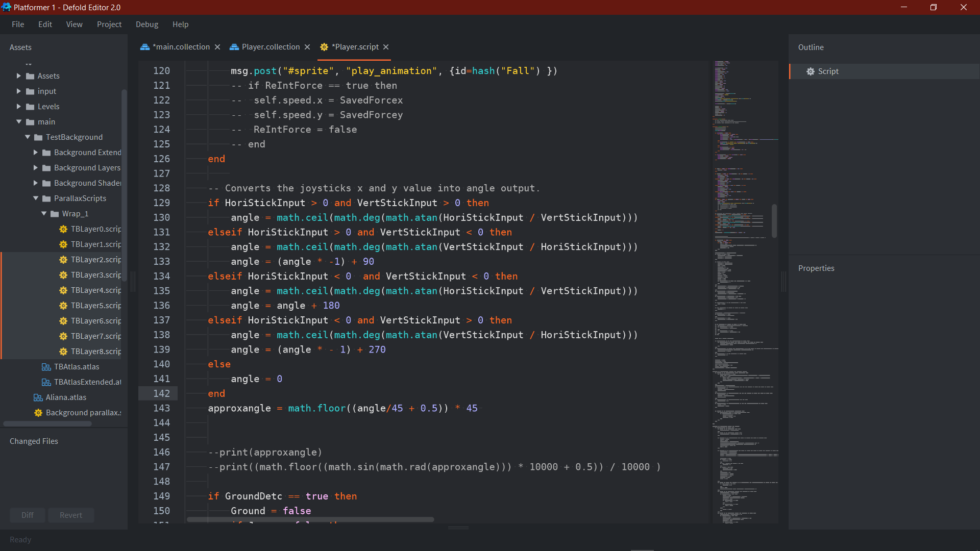

The Boost was a large hurdle to get over in terms of understanding how defold works and specific variable management, however I very clearly had the idea of what I wanted this boost to achieve and start out with getting directional output from my controller, this even, was not a simple task. The way defold registers joystick input is with two values, horizontal force (how far the stick is being pushed in the horizontal) and vertical force. These two forces were set to variables Hori and Vert – Stick Input, however to output an angle from them using math functions, I would only get values between 0 and 180 and with the negative values, the 0 – 180 values are swapped backwards, this resulted in a lot of printing and testing different amendments I should make to achieve the correct value for angle depending on the possible negative value arrangements there were. After working all of this out I set another value to simplify the angle into exact intervals of 45, so I have a 45-degree accuracy or 8 directional controls.

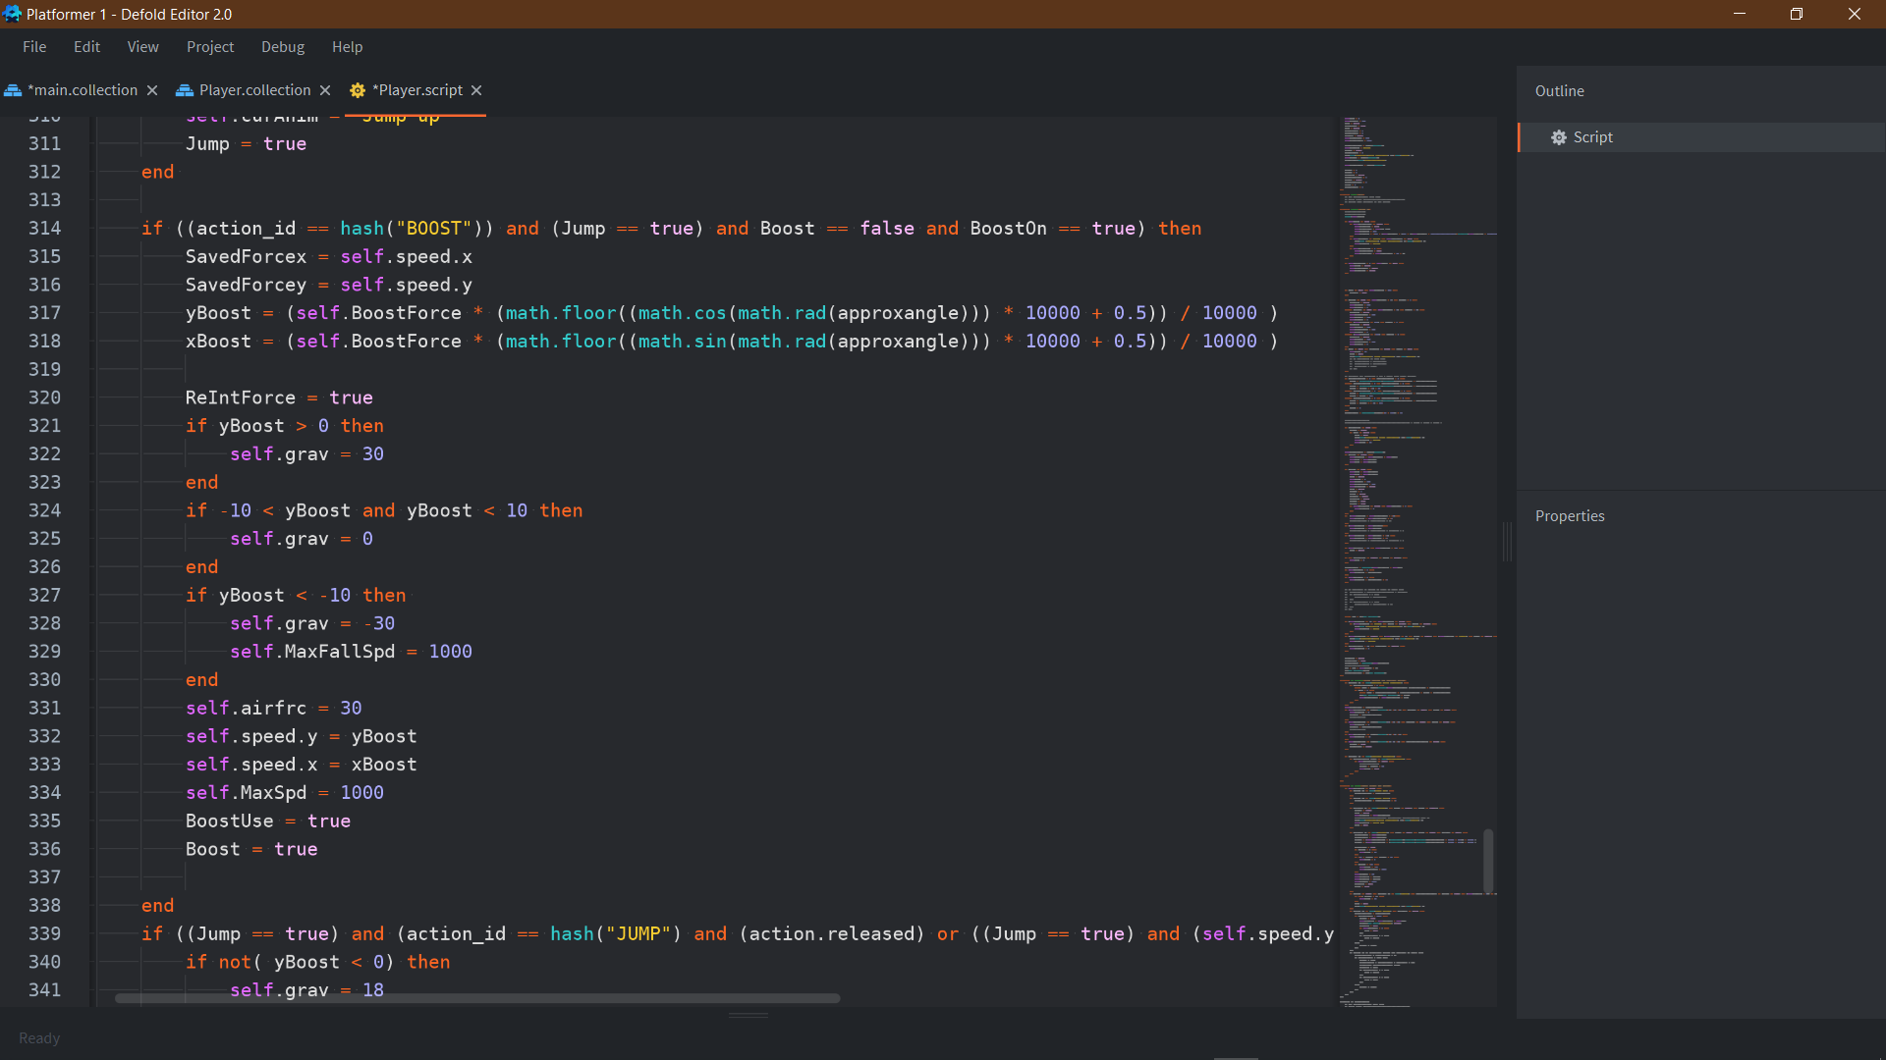

When first testing the Boost although my initial idea was to map it to the JUMP button so it works as sort of a double boost for testing purposes, I had chosen to map it to a separate button. This was a beneficial choice as working on the boost itself posed many challenges and there were multiple bugs for the boost that were cause by either variable management from the jump before the boost or from the boost itself and having two different button commands made finding these errors clear to spot out. When the boost command is pressed it uses the calculated angle from the prior segment to calculate two coefficients for vertical and horizontal force using sin and cos functions, in this way it gives the appropriate force in respect to the targeted direction. It then sets the y and x speeds to these values. However, there are a multitude of different protocols that it goes through depending on the direction the boost is aimed in. If the Boost is aimed upwards since it is given such a high force the function will increase the gravity all the way to 30 so that it slows down a lot quicker. This lets the boost be more of a direction realignment tool less than a large burst of speed as it will slow you down faster. When the yBoost value is not specifically high (so the boost is being aimed in ONLY a horizontal direction) the gravity gets set to 0 so that the player does not fall while using it, this makes it useful in that it can be used to reach platforms the player is just short off from as long as they are above it. When the yBoost value is negative the gravity gets set to –30, this is to cause the same effect as in the positive direction. These protocols work in tandem with Active Boost protocols to switch them off once the movement of the Boost has finished.

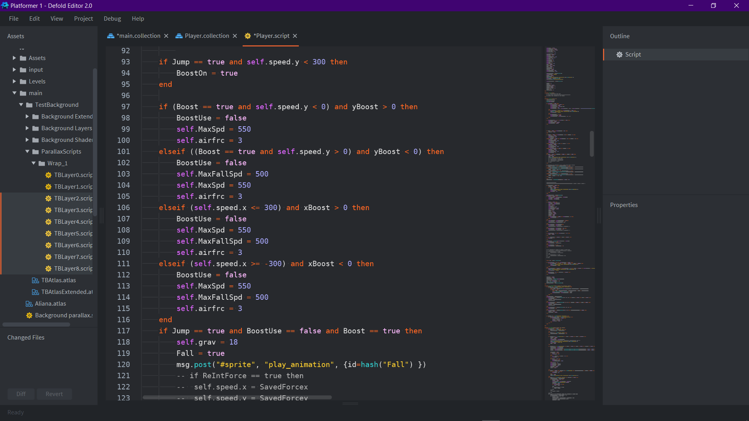(These here all set the boost changed values to their original once the movement of the Boost has reached a low enough number- here set to 300 so that the player does not completely have to reach a standstill before they regain control of their character again)

Development Key C: Fixing Tile Glitch and Wall Jump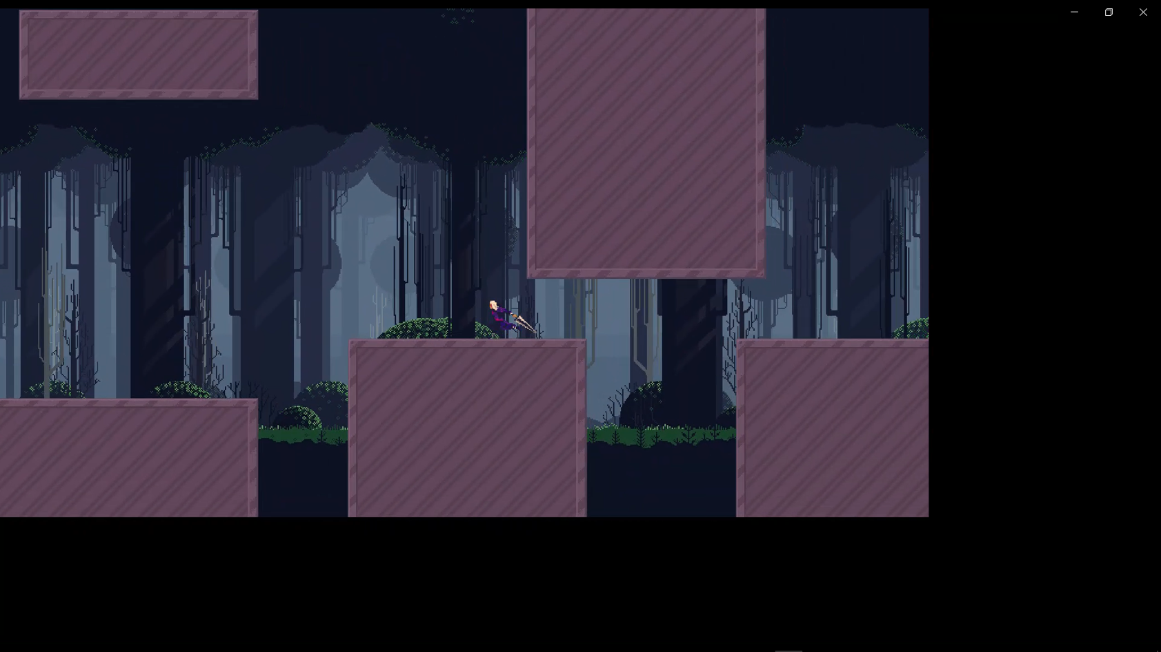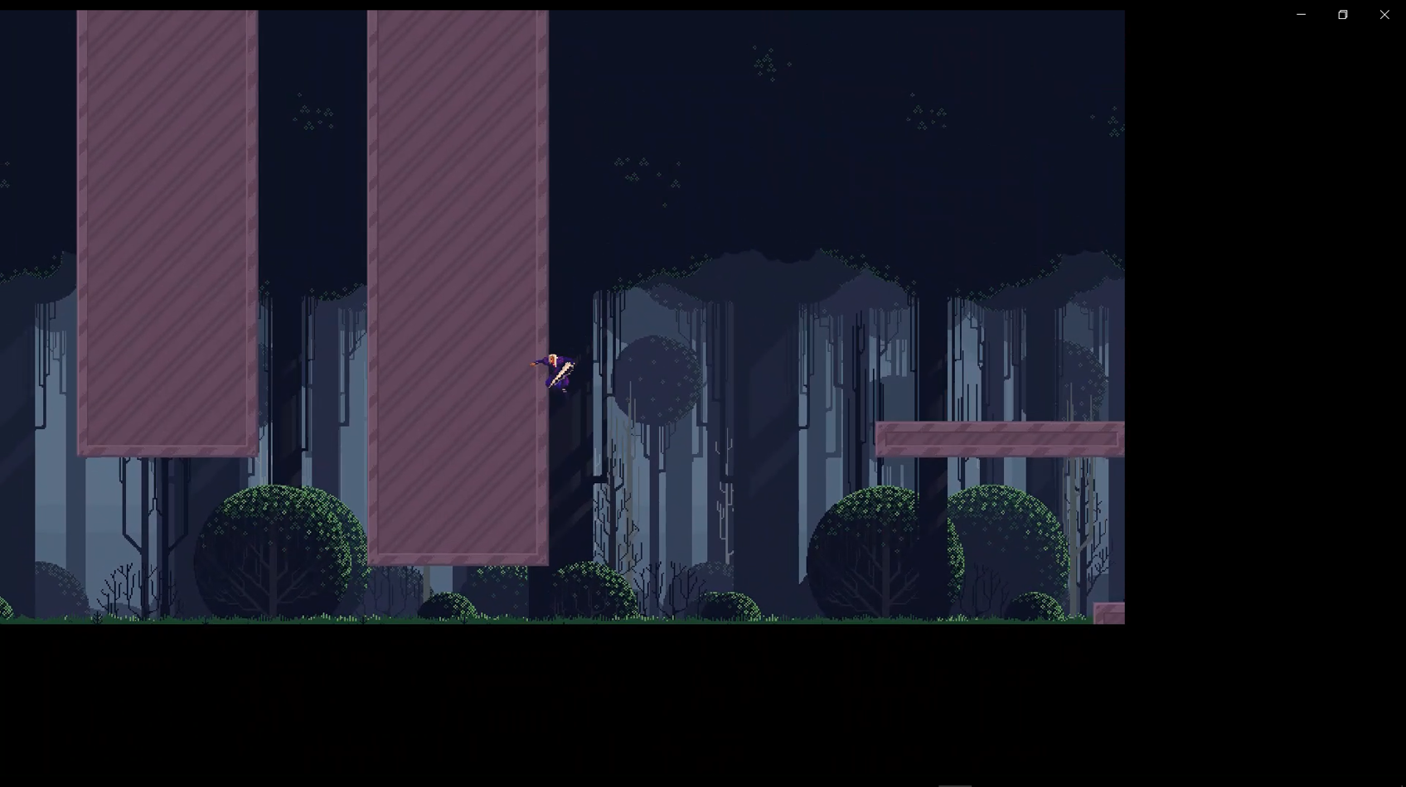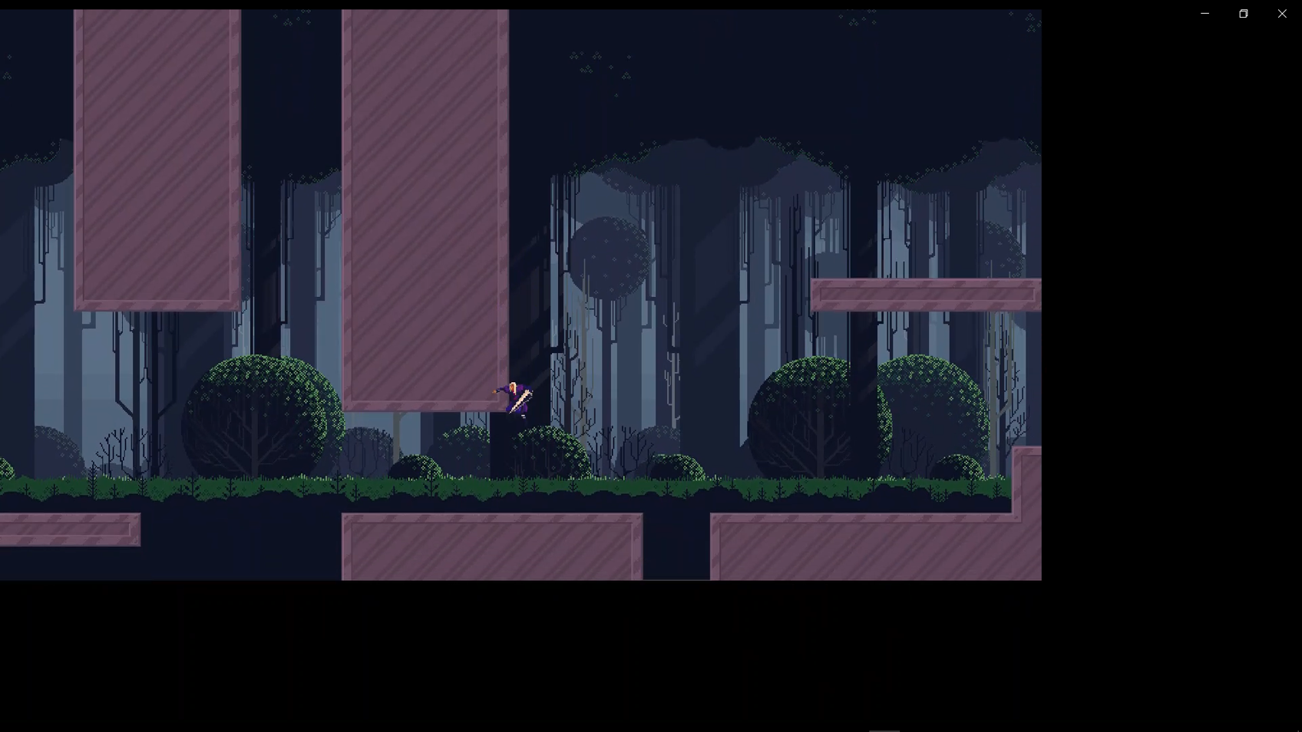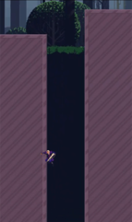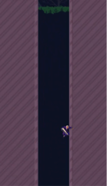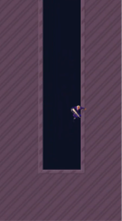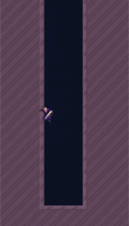

<https://share.vidyard.com/watch/zhja8K6ugdZ2MnnuUQ71qa>?

This section has been the hardest part of the project by far, due to the multitude of bugs that the wall jump caused along with the plethora of different variables required to make the wall jump work. For the total functionality of the wall jump it has 15 variables that only pertain to its functionality along with another 10+ variables for it to interact with other functions. Fixing the ground collision’s however, was an exceedingly challenging task as well and it was required for me to even be able to work on the wall jump, this is because the collision issue resulted in the player being able to “stand” on the sides of walls where two tiles meet. This resulted in a glitch where the player could jump up on and scale walls indefinitely as shown here: <https://share.vidyard.com/watch/7r1gjqy6aowTwwAmfjH6AN>?

I needed to fix this glitch as I wanted to have a wall slide: where the player can hold onto the wall and after a certain amount of time slowly slide down it until they fall. However, with this issue the player would just slide until they reach the top of the next tile. To which they would then stand up in mid-air. Fixing this issue was built off of creating a multitude of extra protruding collisions on the player to simulate an extra layer of ground/ wall detection.

Fixing The “Trip”

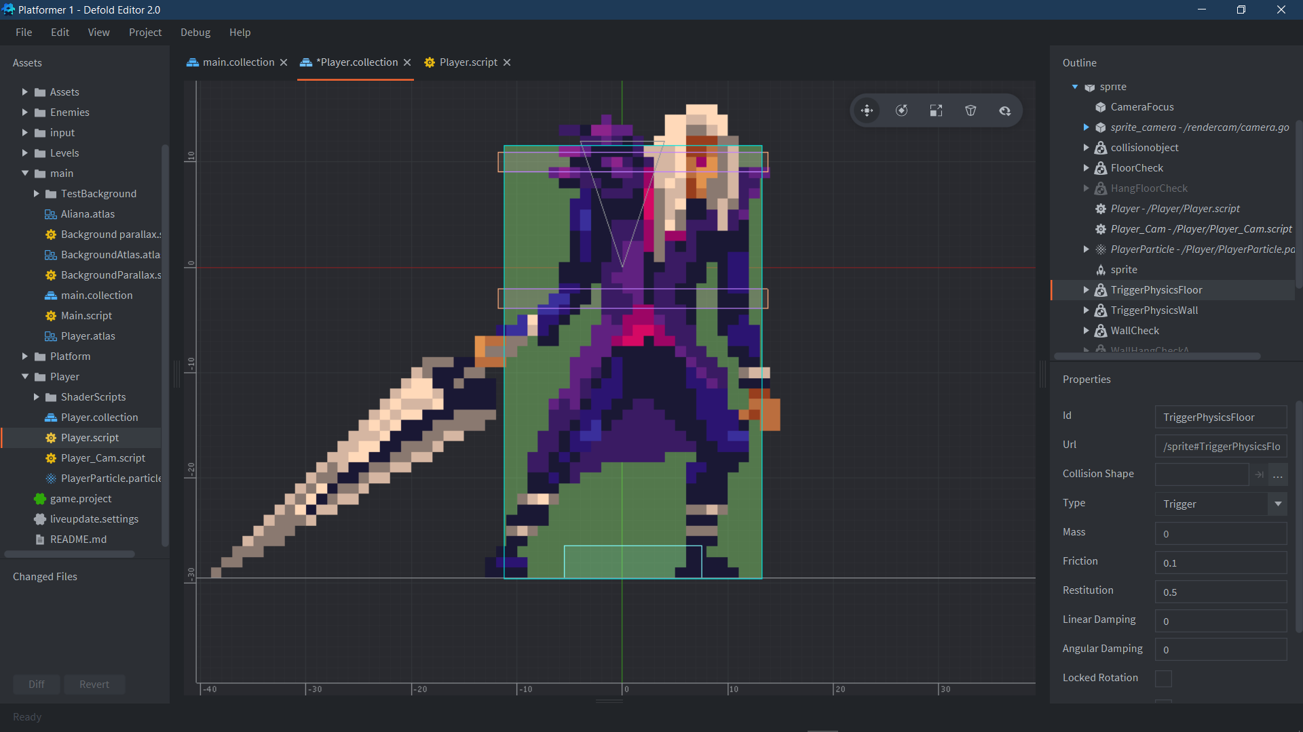

These collisions would check for if the player has hit the wall at a certain height on the character, so instead of simply being a wall collision at its feet it would also require a wall collision at its midsection to register the wall, this fixes the running issue of the player tripping up- however creates an issue for mid-air wall collisions, as hitting the ceilings or clipping the platforms from the side with your feet resulted in the player clipping inside of the platforms.

*Collision function*

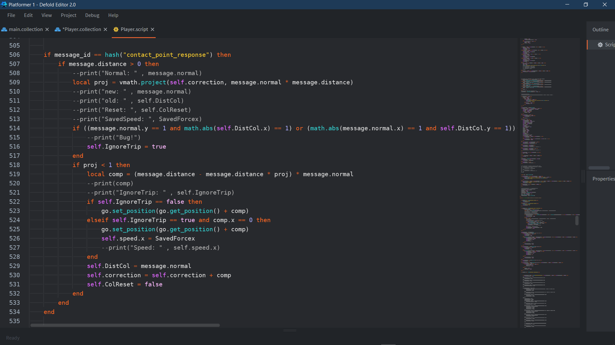

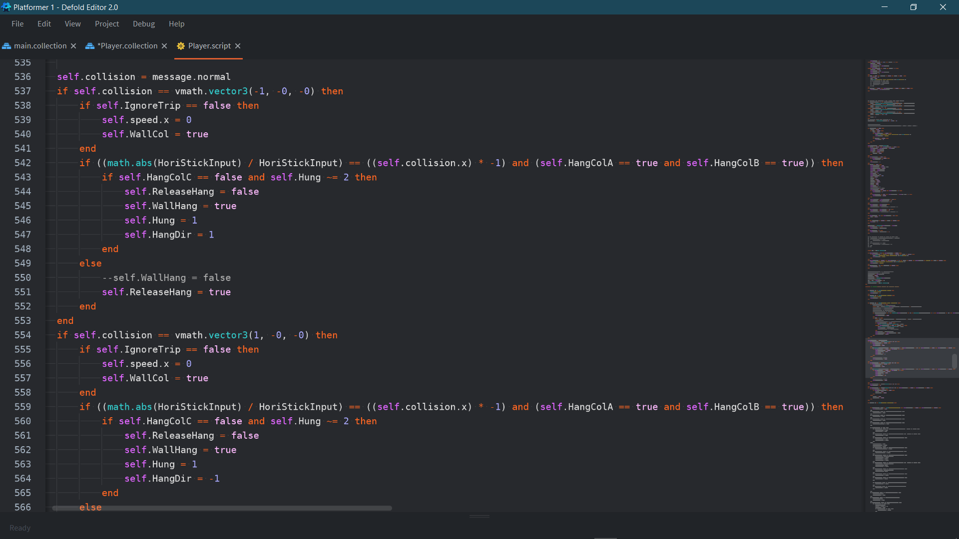

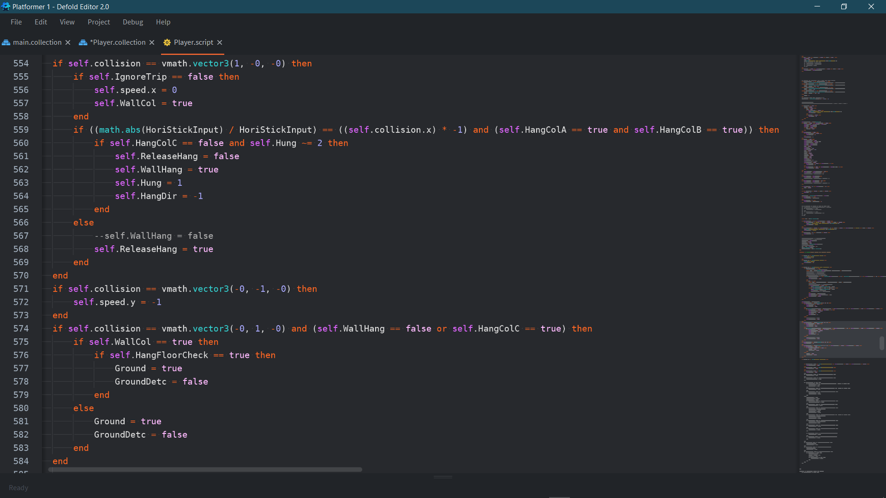

*Update function*

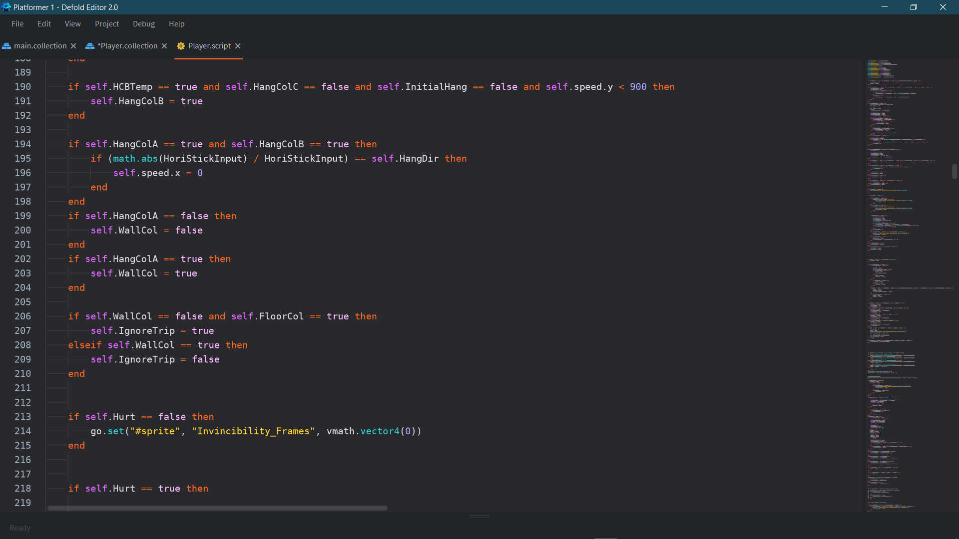

I had to heavily revamp the prior collision code to be able to fix this issue. First by using the two colliders I had introduced before I set their collision values to variables and set the variable to ignore wall collisions condition. Using this variable “IgnoreTrip” I first stopped a wall collision being read from bringing speed to 0 if IgnoreTrip is active. This doesn’t completely solve the issue and temporarily made it worse as now speed isn't being limited the player can slowly fight against the correctional displacement and slowly inch themselves into the wall, to circumvent this I set another IgnoreTrip condition which accounts for the actual Player Collider collision box and set it accordingly, here I now use this value to ignore the displacement when the player would usually slip, however only ignoring the displacement in the x axis, as I would end up falling through the entire stage as soon as this condition is met once. The reason this can work is because gravity gets turned off as soon as I touch the ground; originally the displacement would bring me just above the ground before rendering, enacting gravity again- this resulted in me falling too far inside of the ground before the collision script could run on the next frame- which caused the issue. Now with my fix, this gravity on and off issue gets ignored until the player reaches a cycle where gravity does not pull it too far down and correction does not push it too far up. All these positional changes all happens between frames which made this an extremely challenging task to diagnose the main cause of, however after a lot of researching on Defold’s collision mechanics and becoming more apt with using the colliders and collision system I was finally able to fix this issue.

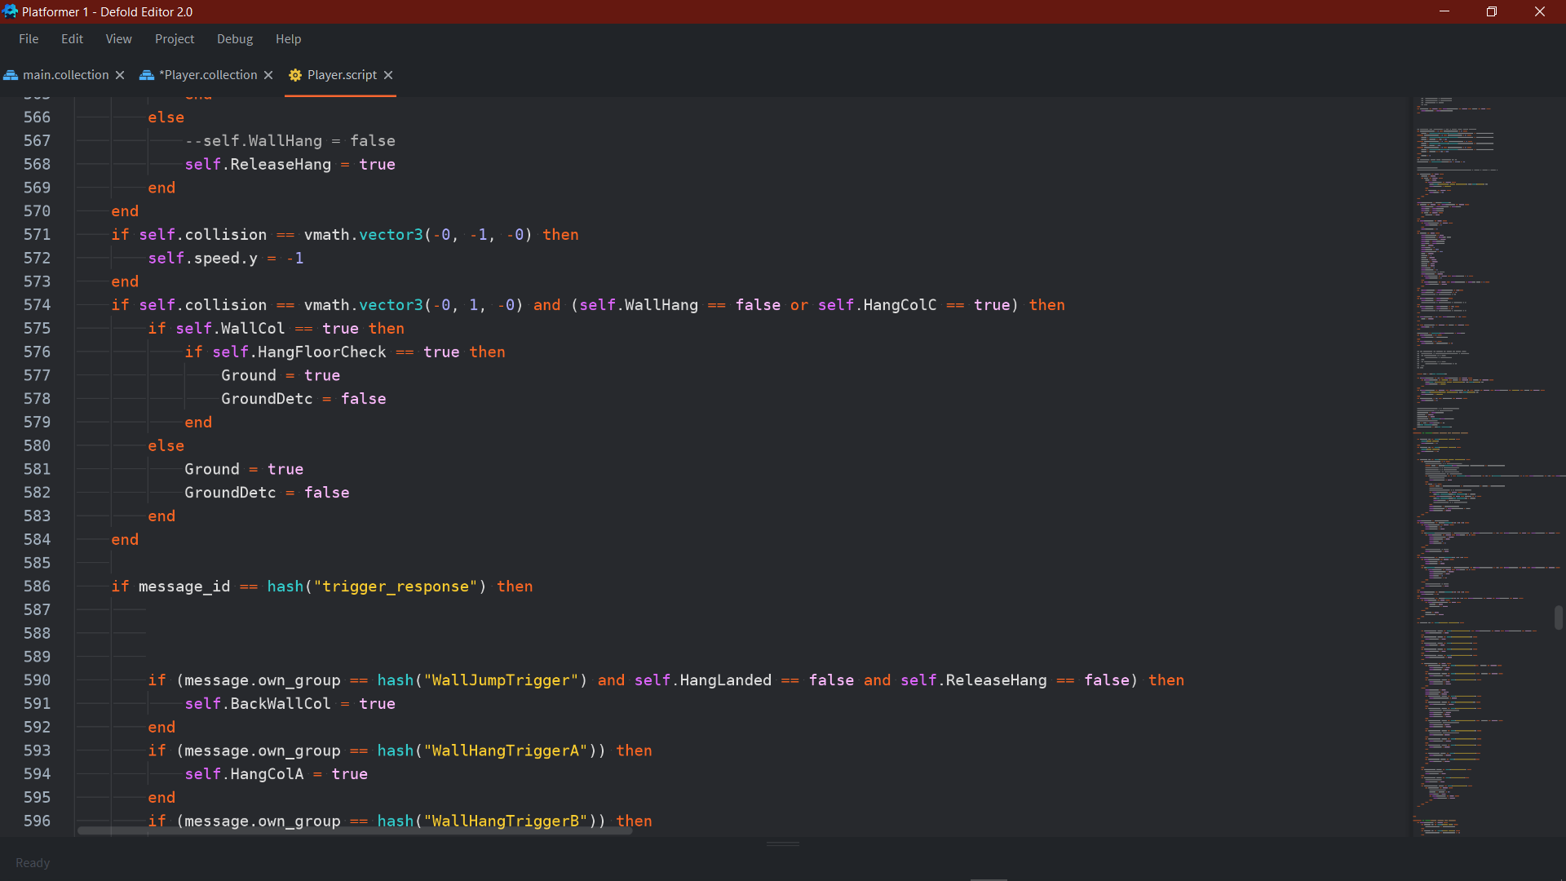

Referring to the image of the player’s collision boxes fixing the wall clipping was a quite simple fix coming off of fixing the trip issue. Simply using the blue collider at the feet to turn off floor collision whilst in contact with a wall solved the issue. This was so much simpler due to not only the colliders already being created and me already being familiarised with them, but also from the floor collision code not directly impeding movement, but setting the Ground variable to true which results in these corrections- so only a simple extra condition was needed.

Creating a Wall Hang and Wall Slide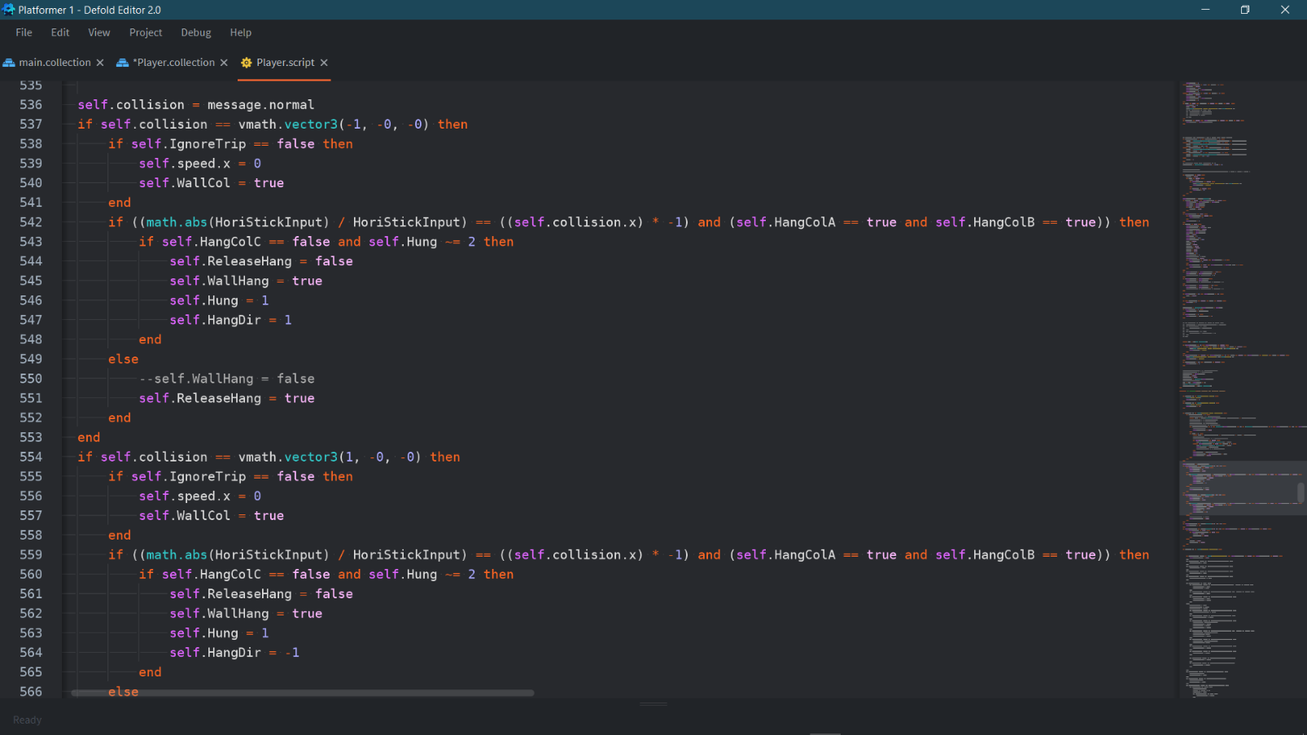

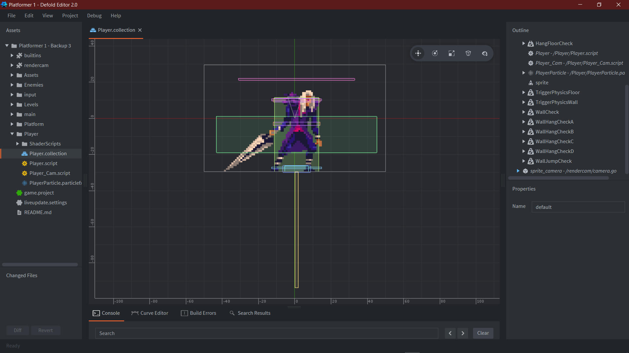

Now I had fixed the issue with collisions I now had no way to scale up walls, as I had been exploiting the wall glitch to traverse my expanding test world. So first I got started on sticking to the wall when holding the direction, the wall is in. The rest of the collision code shows how getting the direction the joystick is being held by using the vertical value divided by its absolute value to get either 1 or –1 and then testing it against the direction of the collision, it also requires a set of Hang Collisions A (Thin Bottom Rectangle), B (Thin Top Rectangle) and C (Thin Long Under Rectangle) to be true, true, false respectively before the wall hold can activate. This selection means that the wall player must be connected to a wall longer than one tile and it must be more than 64 pixels (the height of Collision C) above from the floor to be able to activate. This stops the player from annoyingly sticking to walls they are trying to jump over and only allows them to hang on to walls that are designed to be used to wall jump from. Once the condition is fulfilled it sets a plethora of variable values such as HangDir for the direction the player is hanging in and Hung being used as a counter to see how many times a player has connected to the same wall (to stop them hanging on the same wall multiple times). This code is then repeated for a vector input of (1, 0, 0) with opposing values just so that the player can hang on both left and right sides of walls.

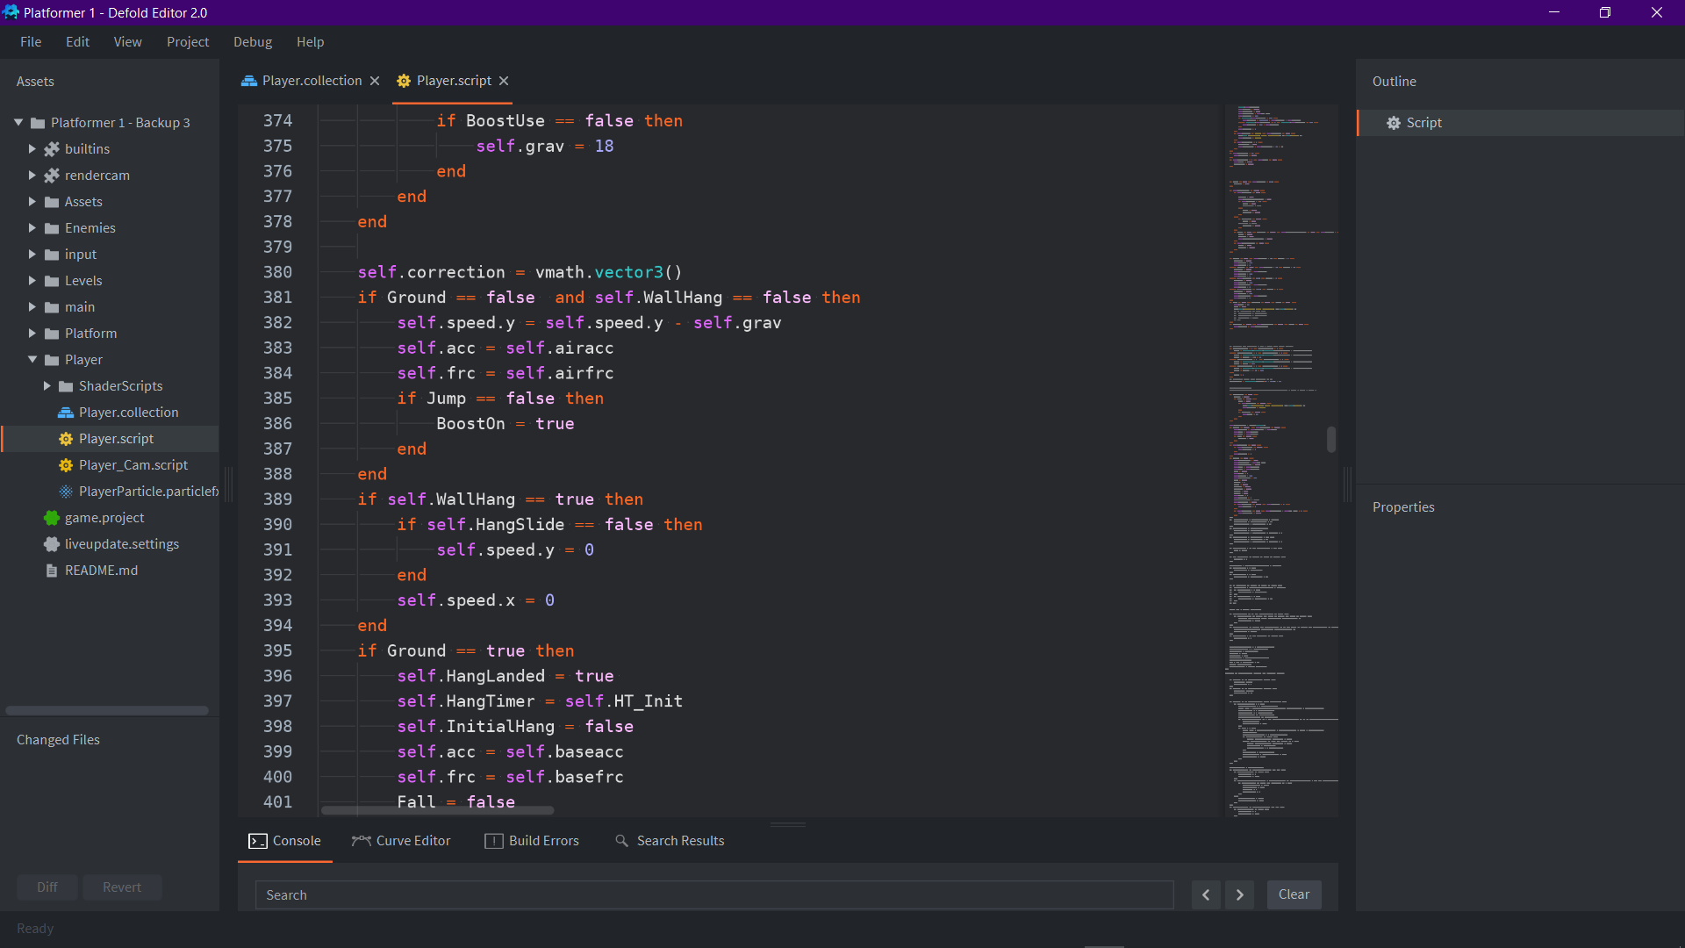

Here the WallHang variable is passed into the update function to keep the y value at 0 as long as the Hang Slide variable isnt true. It will keep the x speed at 0 to make sure the player cannot merge into the wall. This gets the player hanging still onto the wall but I wanted to reduce the opportunity for stagnancy to build in the game so set to make the player start to slide down slowly after a brief period and then fall all together to make wall jumping in quick succession feel more required.

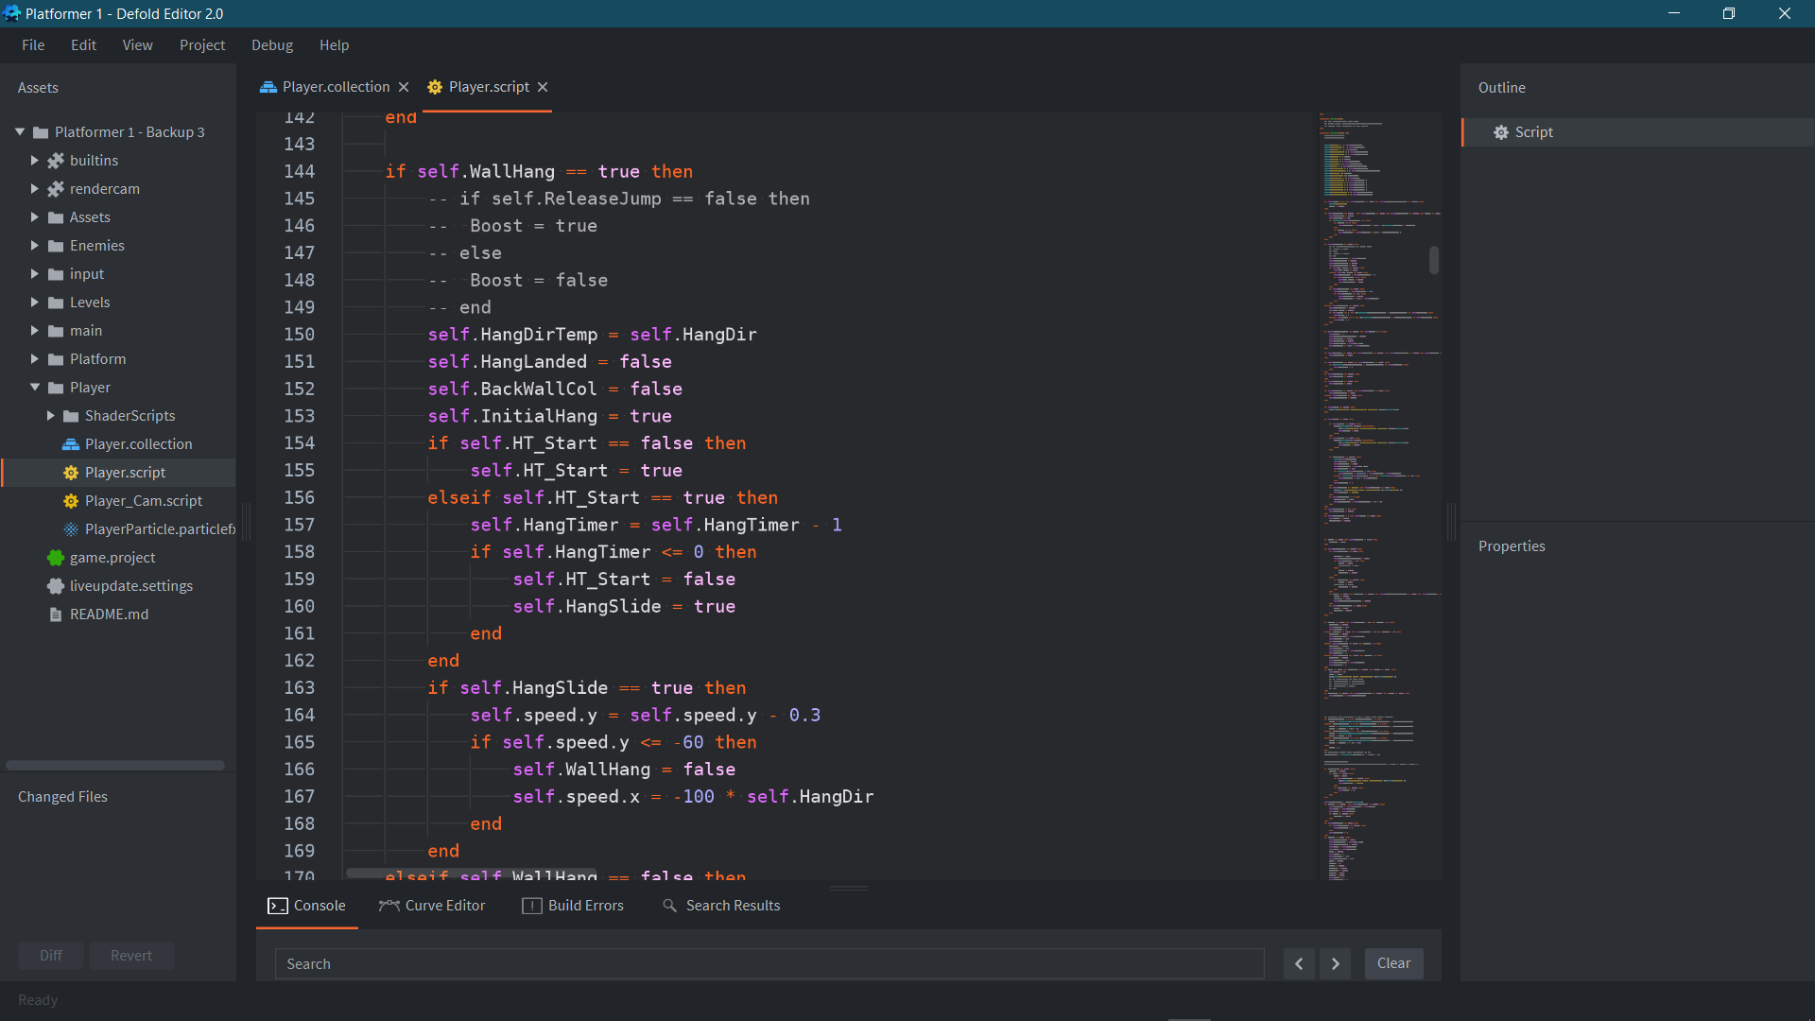

Here the WallHang variable is used to set a multitude of variables such as a temporary for the wall jump, a check to see if the player has landed on the floor after performing a wall hang and other wall jump related checks. Once the hang has been initiated a timer starts and is depleted by 1 every frame. Once this timer hits 0 HangSlide will be set to true, this causes the player to slowly fall with an acceleration of 0.3 until they reach a vertical speed of –60, to which they then end up in a free fall and are slightly pushed from the wall. This pushing from the wall was required as using the Hung variable the player can be stopped from Hanging back onto the wall once they have been pushed off. This achieves two things; it achieves making the player unable to hang once they have passed the set time limit and disallows the player to push off and connect back onto the same wall more than once- meaning they must wall jump alternately between walls to be able to scale to higher heights.

Creating the Wall Jump

Creating the Wall Jump is so far, by far the most difficult part of creating the project- even with the amount of defold knowledge that I have amassed up to this point, the wall jump resulted in the highest number of glitches resulting in clipping into the ground. Switched gravity and incorrect forces. To start developing the wall jump I began with the idea of using my already programmed boost and using that to act as my wall jump. This use case proved to be very efficient in terms of the movement, as it was already a feel that I had tinkered with and in line with the current gameplay. However, it resulted in the Boost requiring to be heavily revised with multiple additions to make it work properly.

The main goal to achieve with the Wall Jump was to make the boost work in the opposing direction when attached to the wall (so that the player can hold on the wall and jump in their intended direction without needing to time the jump weirdly) and to let the player use their normal boost after using the wall jump, as if they were jumping from the ground. I also wanted to add another repercussion for sticking to the wall for too long so had the extra goal of removing the extra boost once the player goes into free fall. With the main goal set out this is how I started.

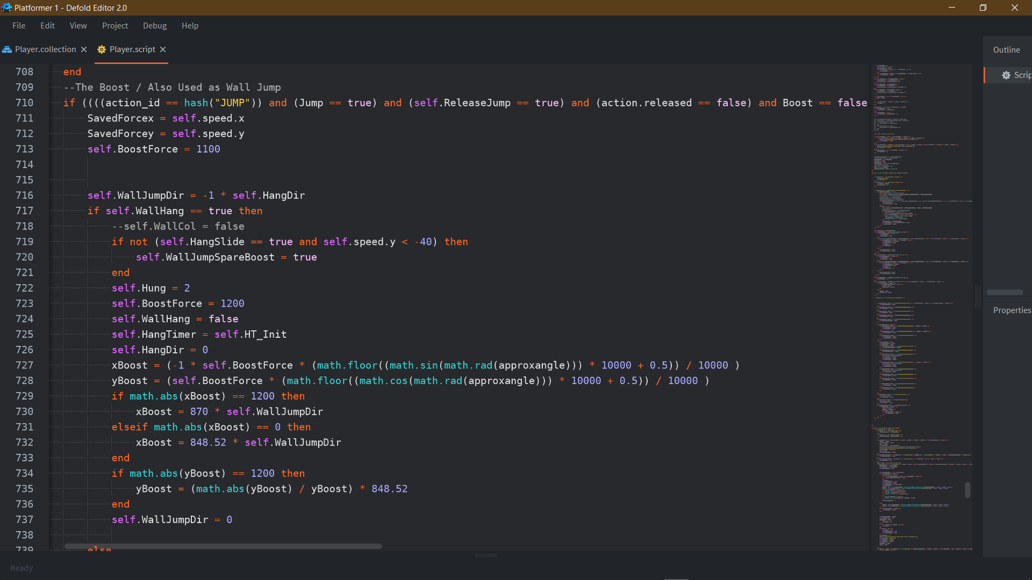These were the main changes that had to be made inside to the boost script, if WallHang = true then it takes on a completely different process. First if the HangSlide has been active enough for the player to reach free fall the variable controlling the extra boost gets set to false and the Hung Value is set to 2- this stops the player from hanging onto the same direction they just jumped from- this does cause the issue of the player not being able to wall jump off from one platform and hang on to a separate one if they are on the same side as each other, but it can also be seen as a positive meaning as the level designer I have more control over when the wall jump should be used to traverse a specific obstacle and when it shouldn’t be. For the wall Jump the boost force given to the player is slightly increased to allow them to cover more distance, this makes gameplay sense as a wall jump is made to cover larger horizontal and vertical distances than normal jumping, at the trade-off of being a tool limited by world design, it also makes thematic sense as the boost itself is a mid-air ability, whereas the wall jump is pushing from the wall- so obviously you would have more propulsion on off the wall than from mid-air. The x force is also multiplied by –1 so it works in the opposite direction to that of where the controller is being held. The if statements at the bottom stop the player from jumping straight up or down from the wall as this does not make thematic sense and from a gameplay standpoint, puts them in a difficult position to reach the next wall to wall jump from. They simply set a completely up or down joystick input into a diagonal one in the correct direction for ease of play. This however does not fully circumvent this issue as if the player lets go of the wall by accident (say pre-emptively changing direction) they can still perform a straight up or down Boost, which although is misinput via player I feel I could add a short timer for the Boost to still work as a wall jump when just leaving the wall, as it would result in a more intuitive gameplay feel.

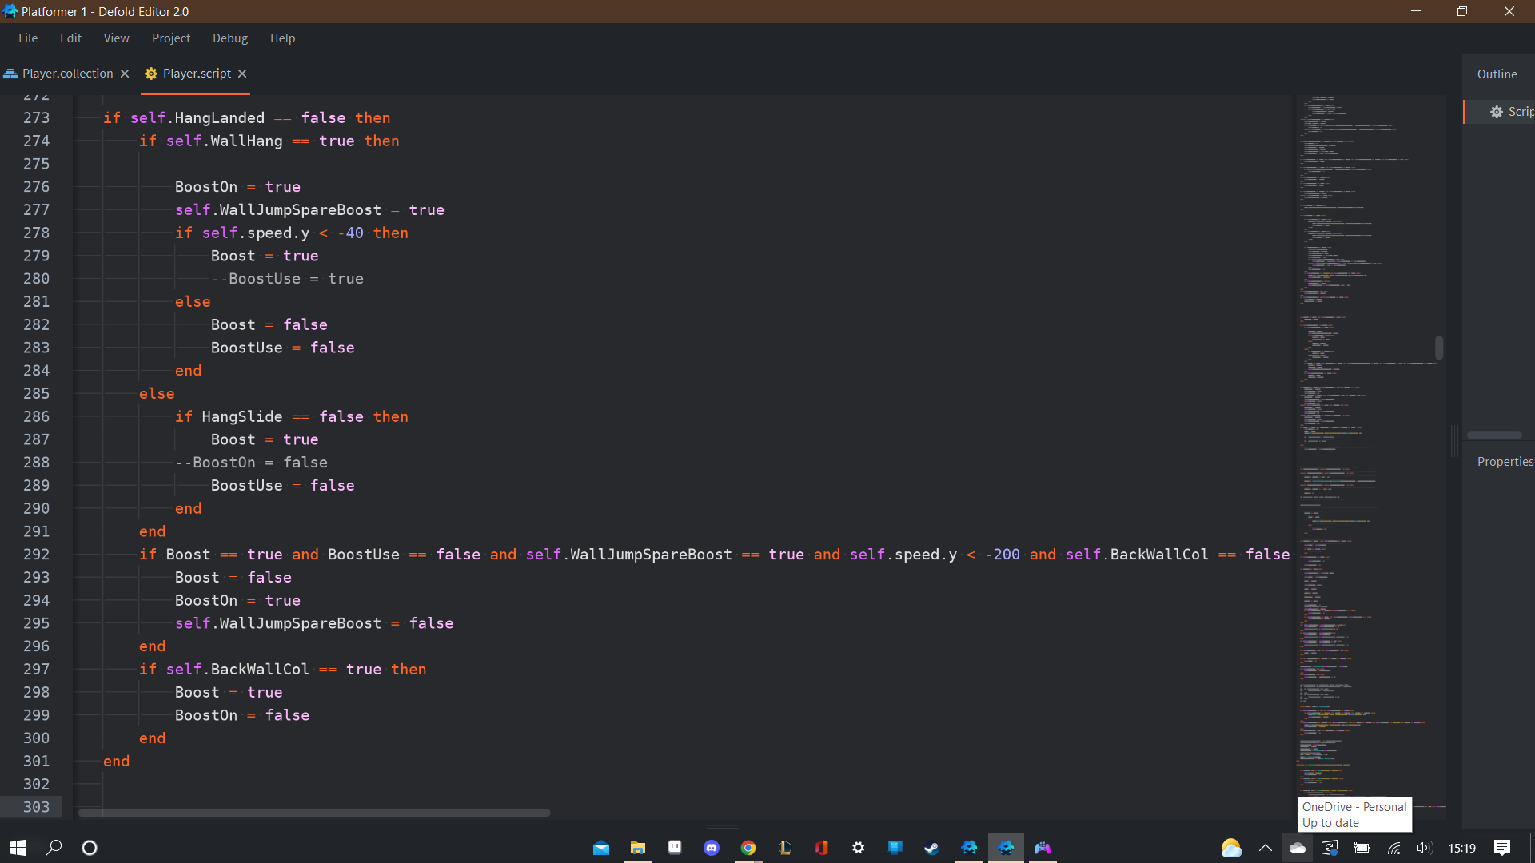

This code here controls the allowance for the first and extra boost that is given for the wall jump: when the player initially hangs on the wall the spare boost is always set to true. The way the boost works is that it can only activate if the Boost variable is false- as this means it has not been used yet, therefore the wall hang set Boost and BoostUse (the variable used for when the Boost is currently active) to false, although this is automatically switched off once the speed values connotated to the boost reach a certain point- due to the boost being interrupt by wall collisions it simply acts a “second line of defence” to make sure it is properly set. Without this it caused an error where the player was not able to move away from the wall as the motion connotated to holding the joystick right is disabled if the boost is active. Next the Boost is disabled if HangSlide is false- while WallHang is false at the same time- this means the player is in free falland loses the spare boost- achieving my extra goal. The code following is just the condition which allows the spare jump to be used- it is only active if the initial boost has already been used and limited to when the y speed is –200, so that it cannot be instantly used, I decided to do this to make movement after the initial boost more important, and to limit how high you can scale single walls, this just means I don’t have to make walls too obscenely high before they cannot be scaled with a single wall jump + boost combo, allowing my level design to be slightly more compact.

The inclusion of BackWallCol conditions is an extra collider (the large lengthways yellow rectangle) which stops the spare boost from being used if the player is in close enough contact to move to an opposing wall with basic movement. Although on the surface this may seem counter-intuitive to my aim to make my game play as user intuitive as possible- this limit forces the player to use the opposing walls in sections that may be possible to clear using a single wall. This achieves both my wall jump requiring you to switch between walls to be justified and the same aim as my limit on my second boost- allowing me to make more compact level design which can force the use of wall jumps without needing any extremely out of place tall platforms.

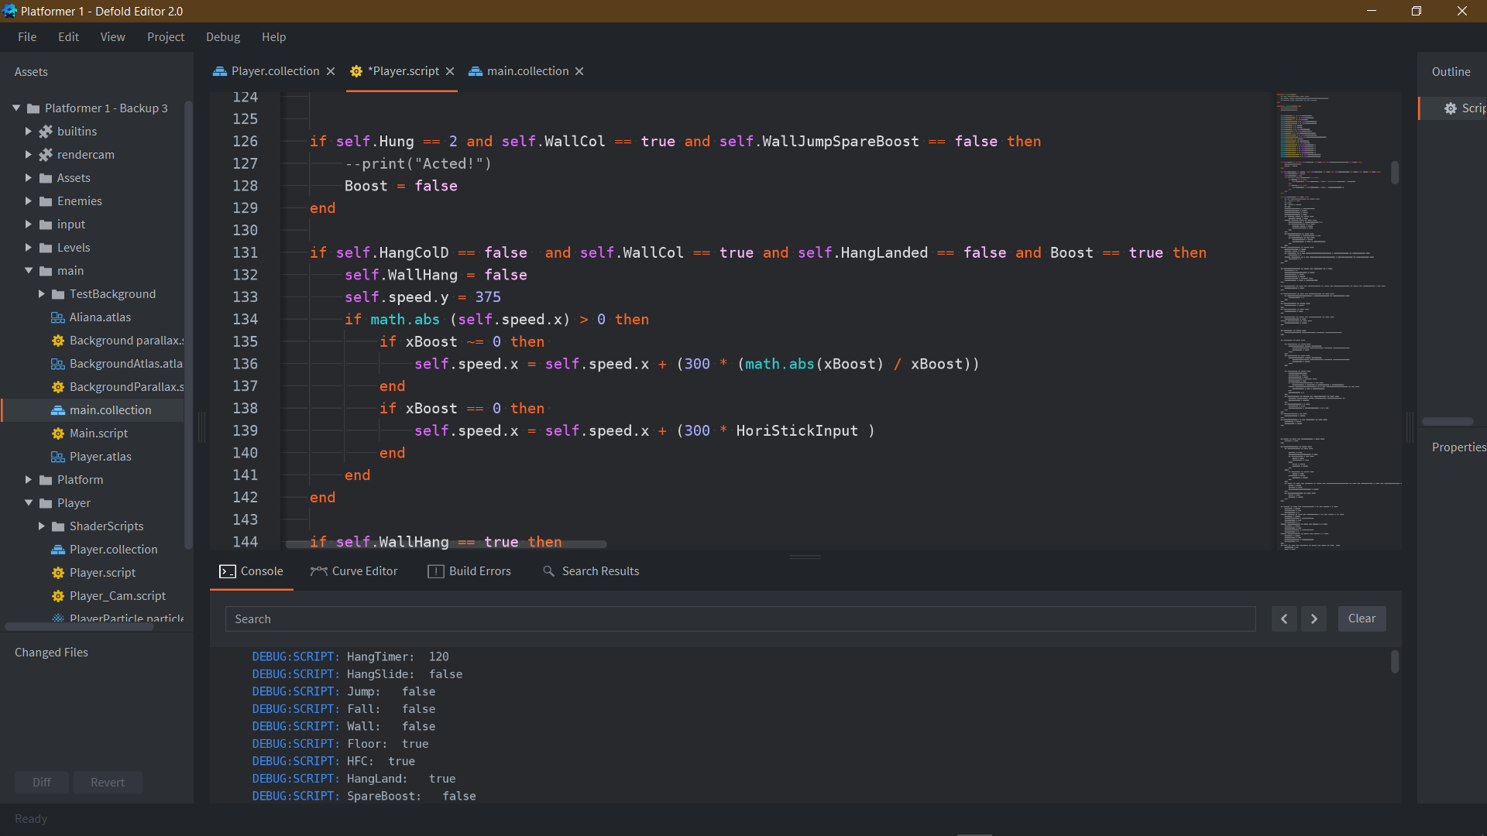

This code here introduces the use of the fourth wall jump collider (Midsection purple bar) and is used to make wall jumps between limited gaps easier- what it does is if the player wall jumps into the top side of a platform (so right near the top but not on top of it) it gives the player a small boost in their y velocity and an extra boost in their vertical speed set in the direction they are moving in. This addition was not a pre-planned target I had in mind but more of a reactive addition due to feedback I received from play testers and myself also. I found that performing wall jumps close to a ceiling result in the player bumping their head on the ceiling and being unable to escape out easily from the scenario. In this way I made this scenario much easier to escape from and made wall jumping slightly easier as the accuracy required to reach platforms became much more forgiving.

Here was an idea given to me again through external play testers. To make the wall jump slightly more forgiving on single walls it was suggested that once using the initial wall jump and spare boost if you boost back to the same wall, you should be able to wall jump off from it whilst being in free fall along the wall. This was my attempt at adding it however this code has not seemed to result in any changes to the wall jump functionality. I may return to amend this later but I am currently satisfied with the wall jump as it has achieved all my main targets.

Wall Jump Inconsistencies

Even though the wall jump is all functional at current. During its development process it amassed a myriad of different bugs and glitches.

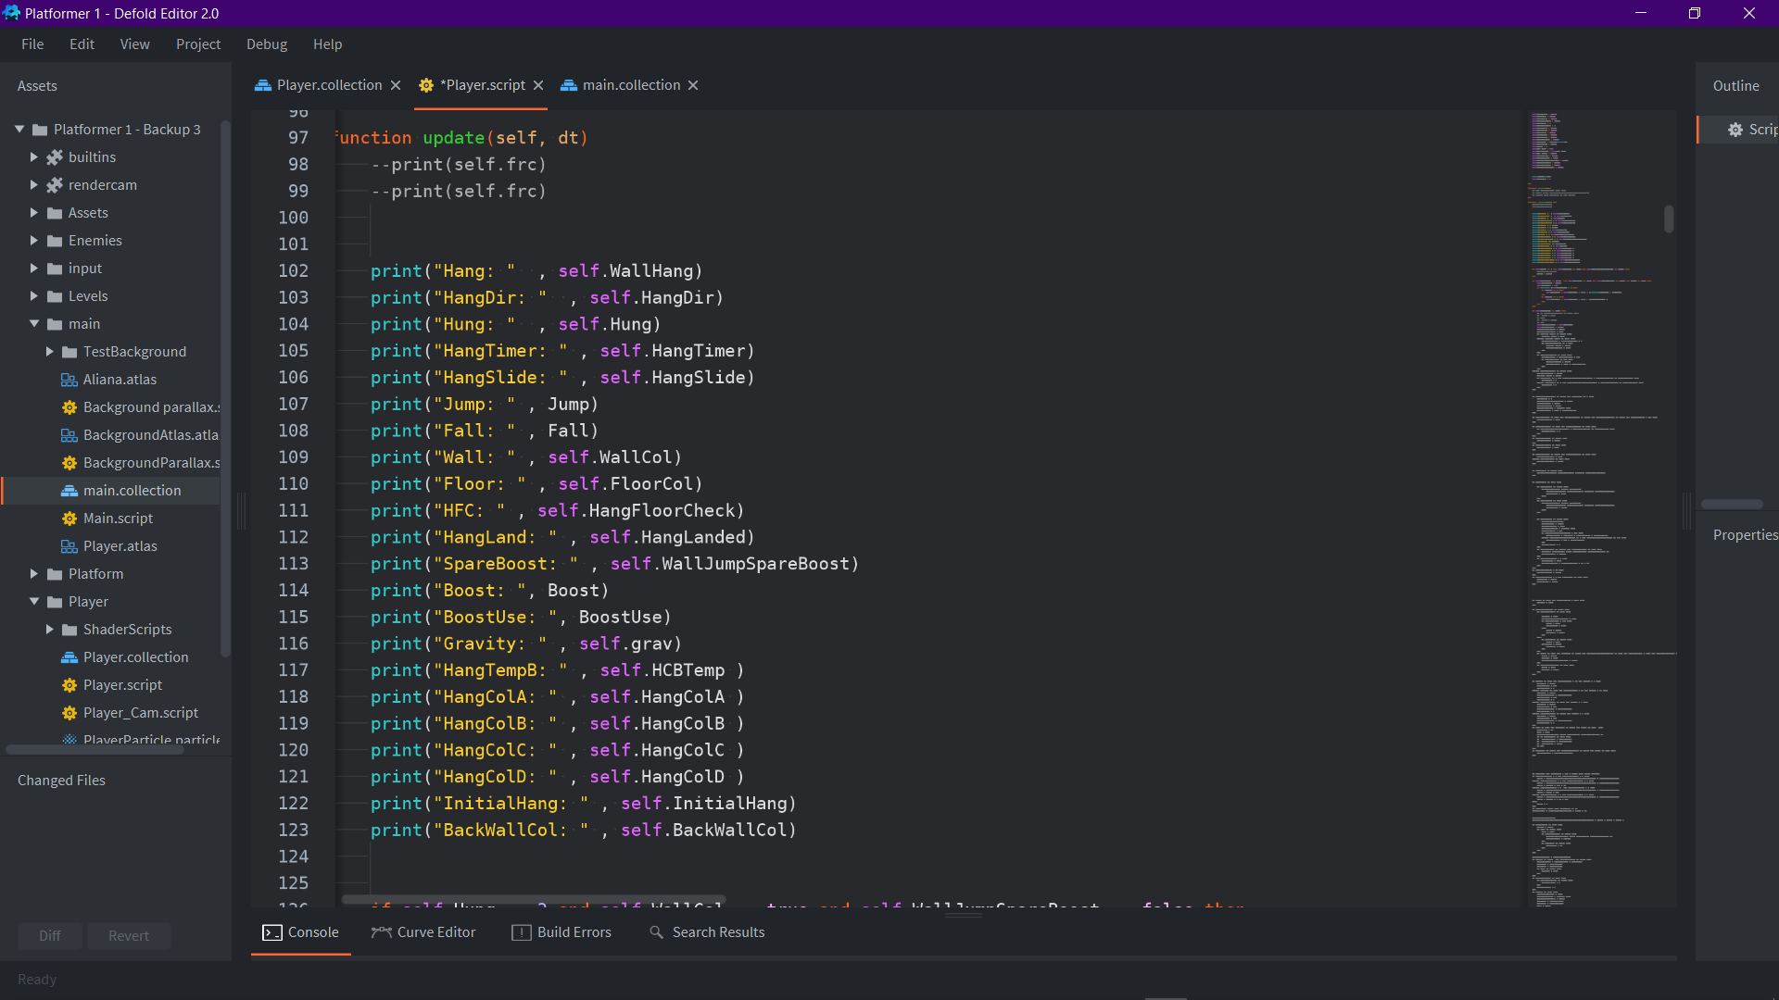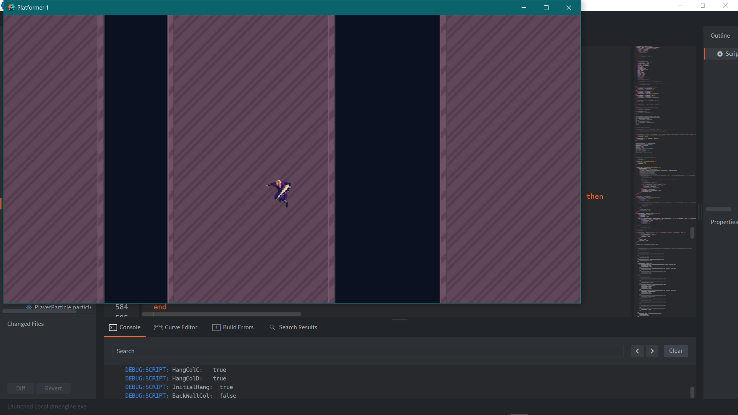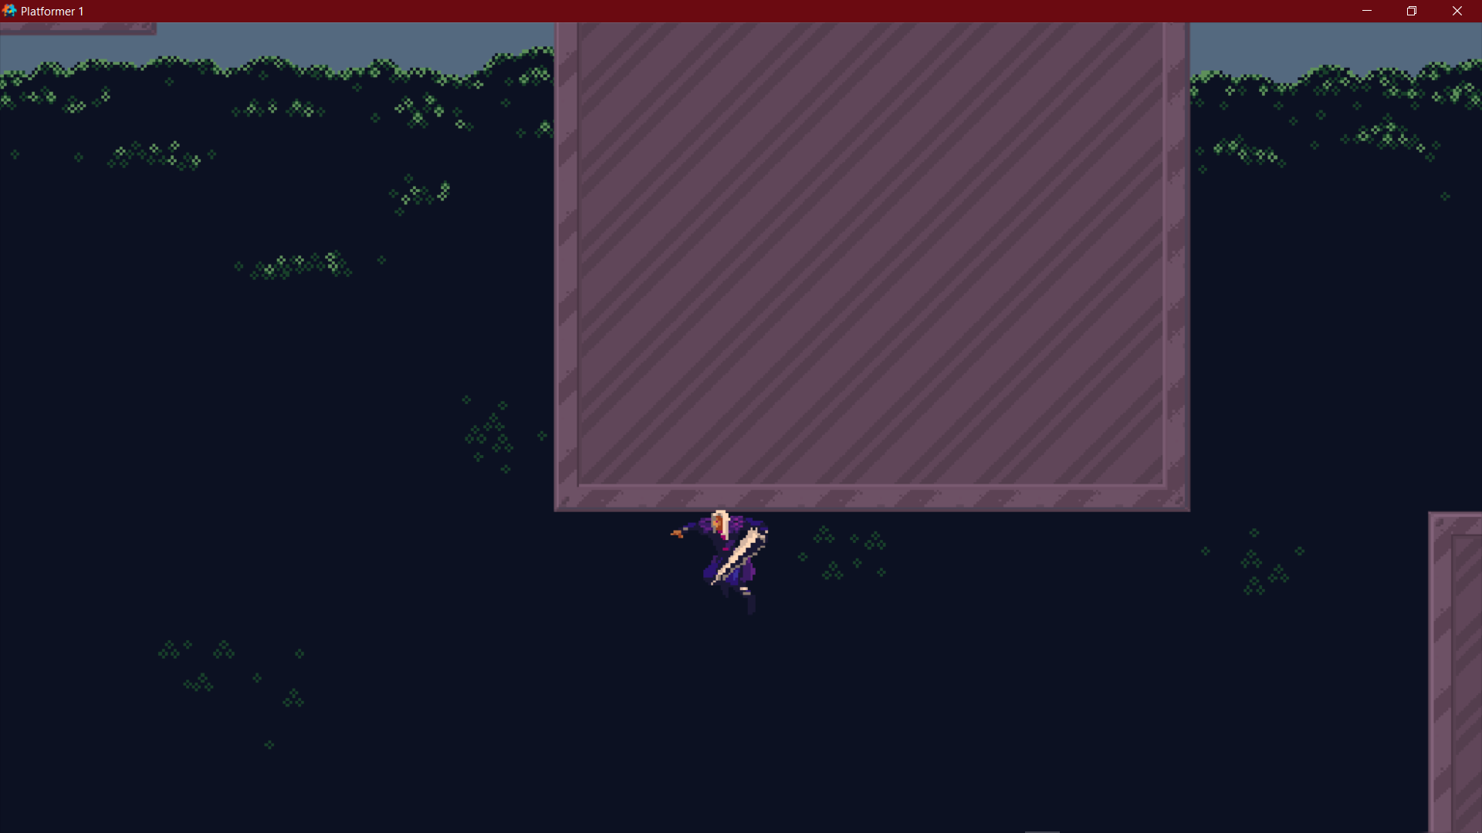

Here are all the variables I had to have tracked constantly at the same time to be able to differentiate and solve all the separate issues. To understand the bug causing the player to clip into the ground you first need to understand how collision works. When a collider is registered as colliding it only registers the collision once, to save processor time. This means that if a variable is set using a collider but switched off while the collider is still connected the collision message will not be re-read and re run to set the variable to its true state until the collider leaves and re-enters collision. This format of collision reading causes problems like this- here if the player were to boost downwards and hit the top of another tile the variable Ground would be briefly set to true before other checks kick into place to fix it before the player motion is adjusted, however the wall colliders to check for wall collision are slightly longer than the actual player collider- this gives the condition for the boost to run as normal with wall collisions active even though the players basic collider hasn’t read that it is colliding yet. The problem here is that for the boost to work it sets the wall collision variable to false so that x speed is not limited to 0. So now we are put in the scenario where the WallCol is false although the player is touching the wall, and since the boost gave a ground collision response for a split frame whilst the wall colliders were read as inactive- this cause the IgnoreTrip condition from earlier to be called, hence allowing the player to walk freely within the tile space until leaving and re-entering.

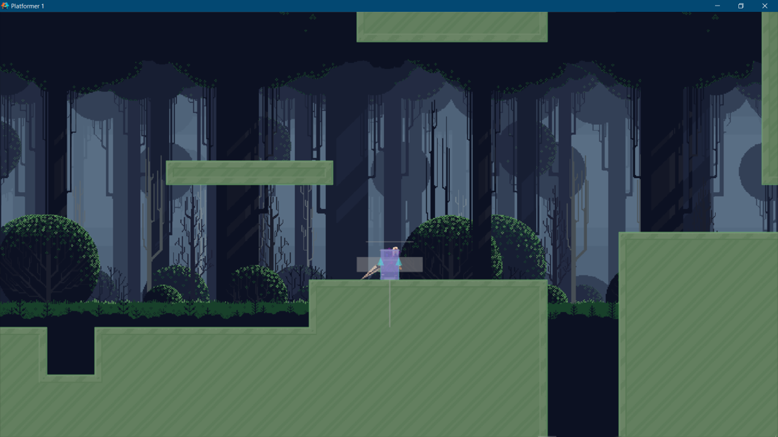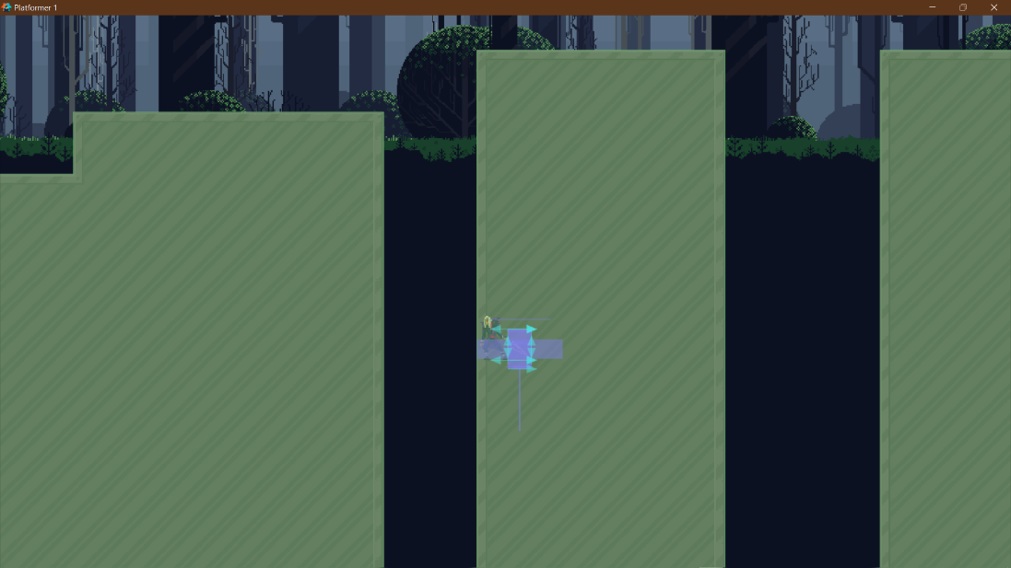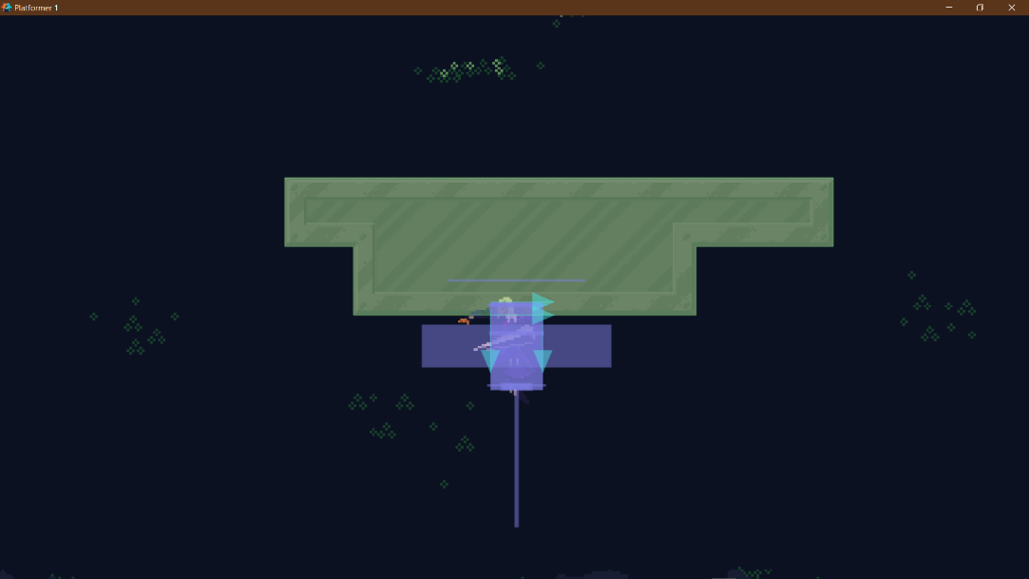

Solving this issue in particular was extremely difficult to understand due to it being caused by sub-frame changes in the project- which can go undocumented in the console even with all the print functions. It is notable however the usefulness of the debug mode featured within defold- giving all collision interactions and showing bounding box (kinematic collider) collision ray casts. The main function of the debug mode however was not the main contributor to solving the issue- more so the instability of Defold’s debug mode makes it run at a considerably slower frame and update rate- this resulting in some physics calculations being exaggerated (such as my jump quadrupling in height) and frame specific glitches (such as the wall jump glitch) being much easier to consistently replicate and “read”.

Wall Jump: Play-Testers' Feed-Back

My main goal for the wall jump was to make it as intuitive as possible, as is the aim for the project as a whole. After mapping the Boost to the same button as the jump I have been testing the game by only telling the users what buttons to use and leaving them to understand how to work things such as the joystick-controlled boost and the wall jump- after implementing this the testing became much more useful with critical feedback. By black box testing the wall jump I have found that a lot of people can quickly learn how to use the wall jump without any prior explain of how it works and needing to hold the opposite direction that you are planning to jump in. In this way I feel as if I achieved being able to make an intuitive wall jump as many testers that I have randomly chosen/ been approached by in my sixth form have been able to easily pick up the functionality of the wall jump in seconds of picking up the controller. Another factor that I was happy to document was that many players did not notice the automatic extra boost given when close to the top of a platform- and when pointing the effect out to them many of them responded with it being a natural feeling to play the game. This along with many positive comments on the movement of the game feeling fluid and "solid” has given me a strong basis to work from.

Development Key D: Implementing an Enemy

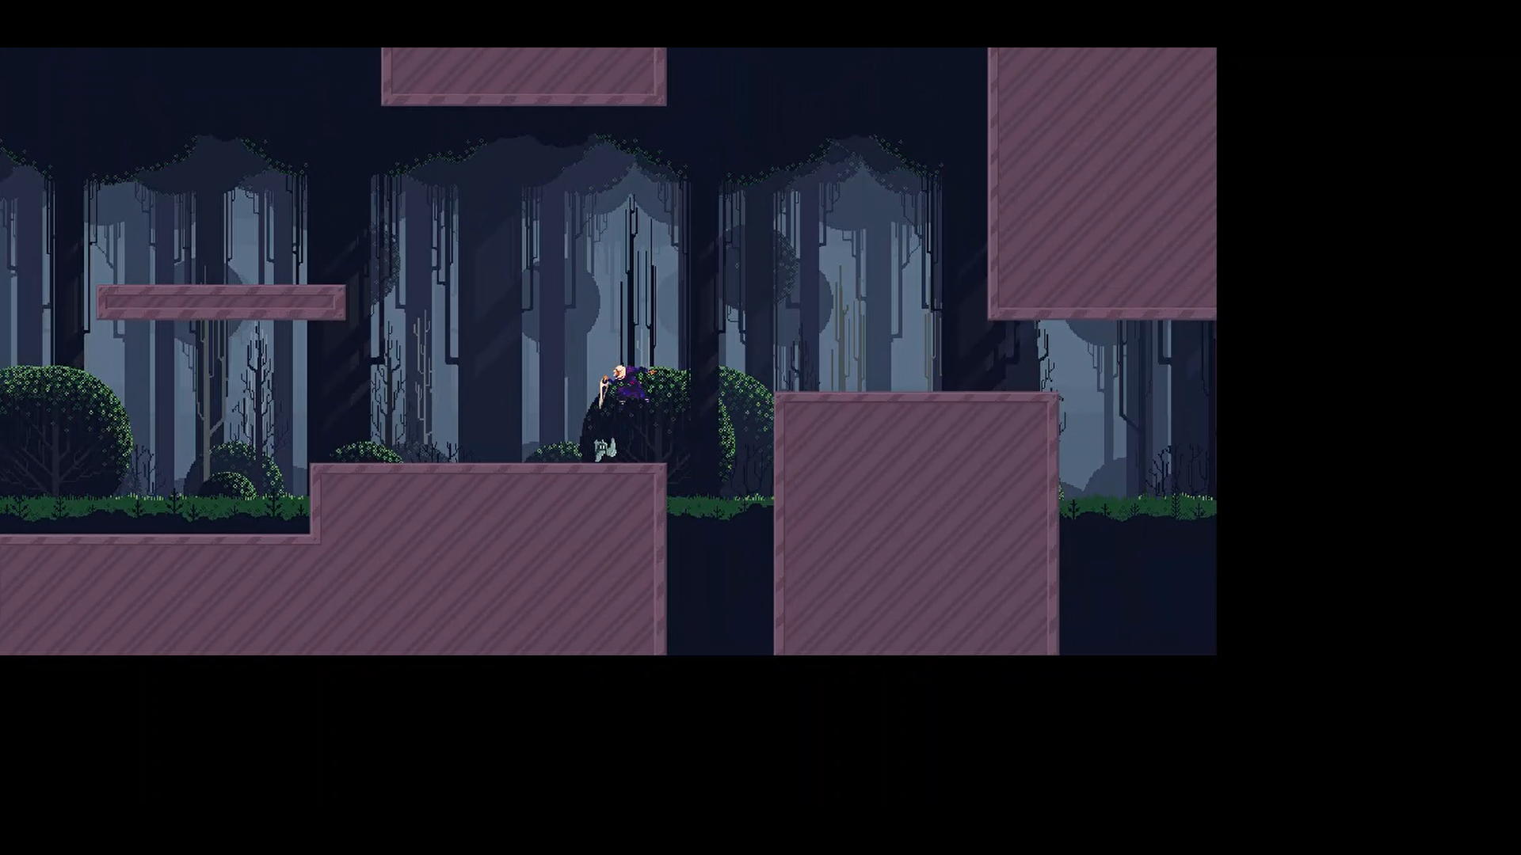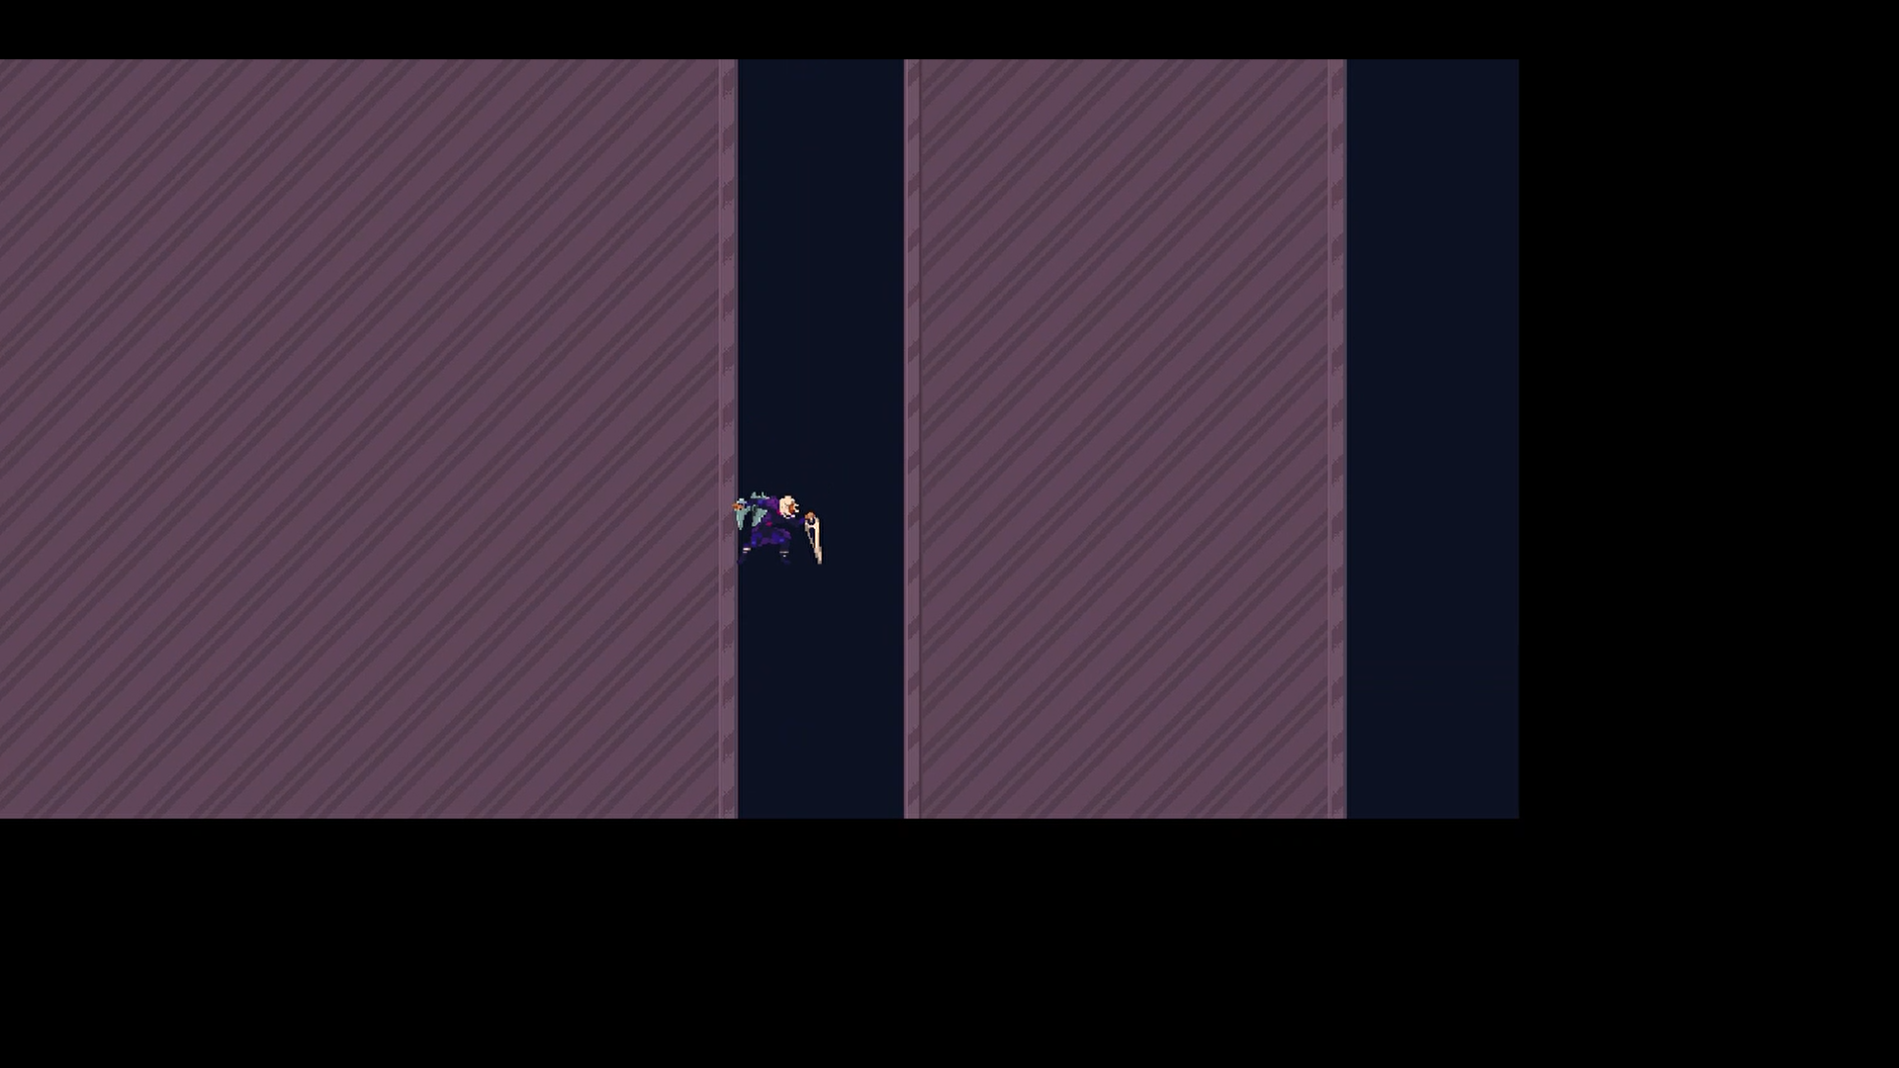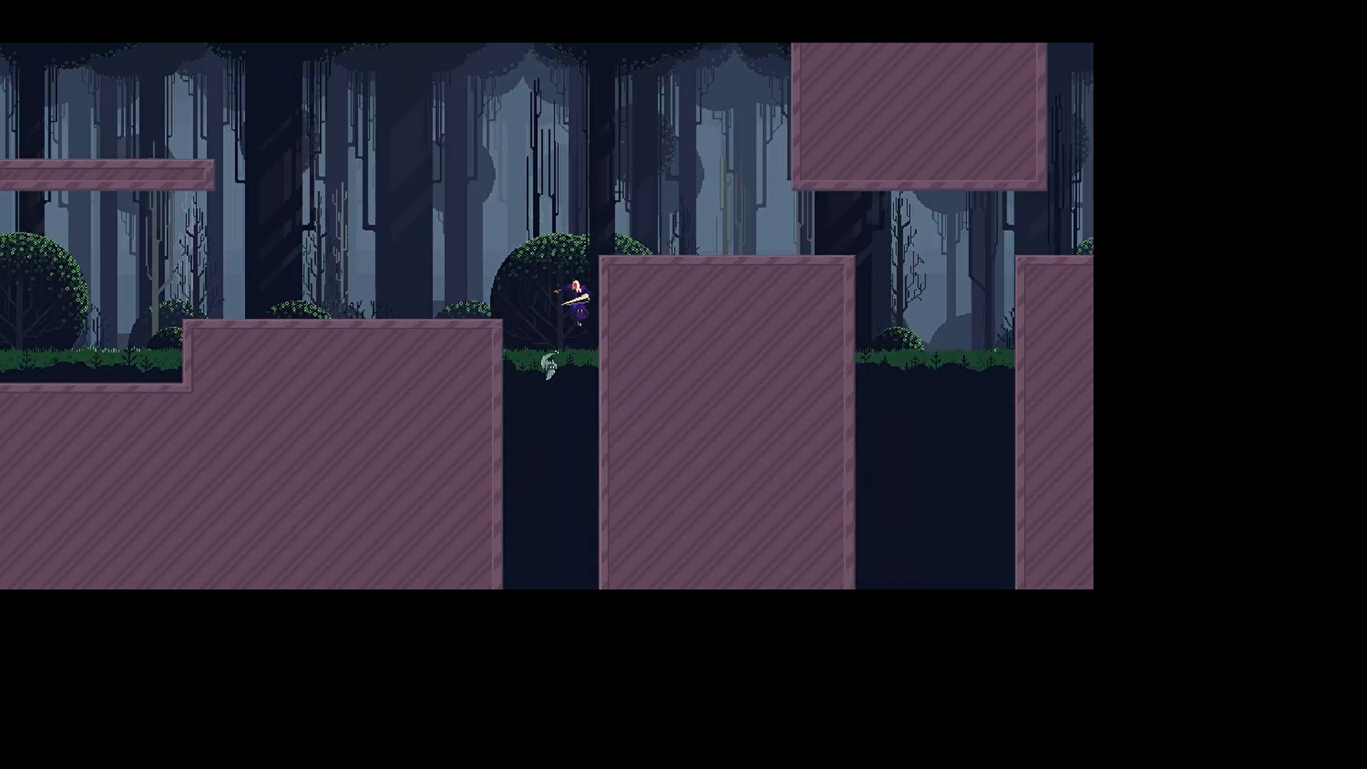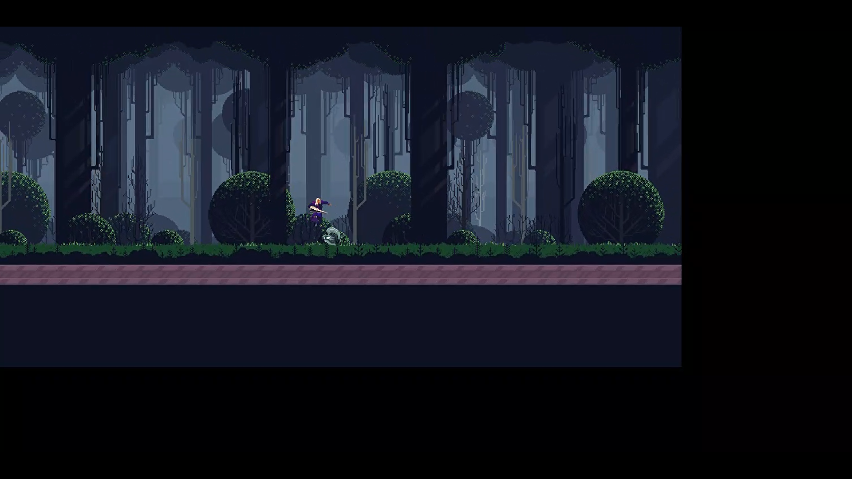

<https://share.vidyard.com/watch/sHP6u9sh1BEscW2MWvB3Nj>?

Here I have developed a simple enemy which has a simple follow command and a single two-stage attack. It follows the player until it reaches within a certain range of the player- to which it will then attack with an extra boost to catch up to the player. It is currently quite fast- even faster than the players max speed and is very annoying to deal with on small platforms due to it temporarily stunning and knocking the player back. In its current state it is quite unrefined and has trouble interacting with the wall hang and is inconsistent in running its assigned animation.

Creating the Enemy

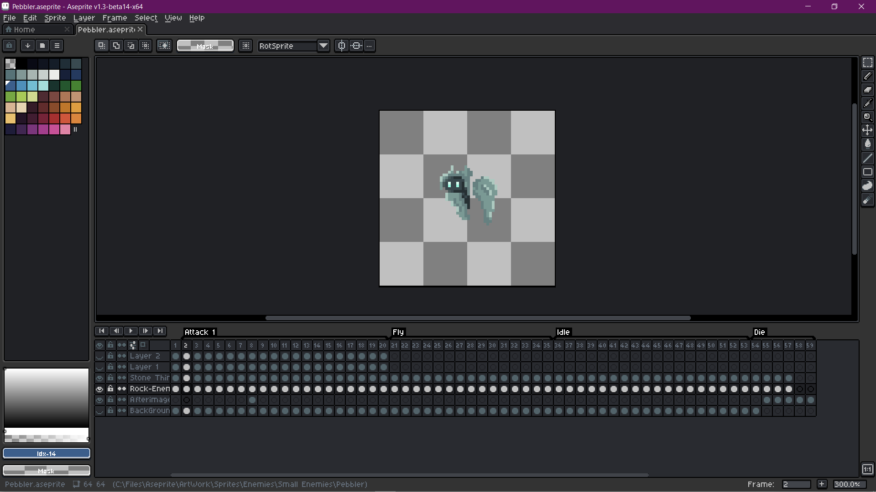

The enemy (pebbler) was completely created by me from the ground up with a simply attack, fly, idle and death animation. To import into Defold I had to split up each frame into a separate image file and then load them into an atlas (The image storing method defold automatically handles).

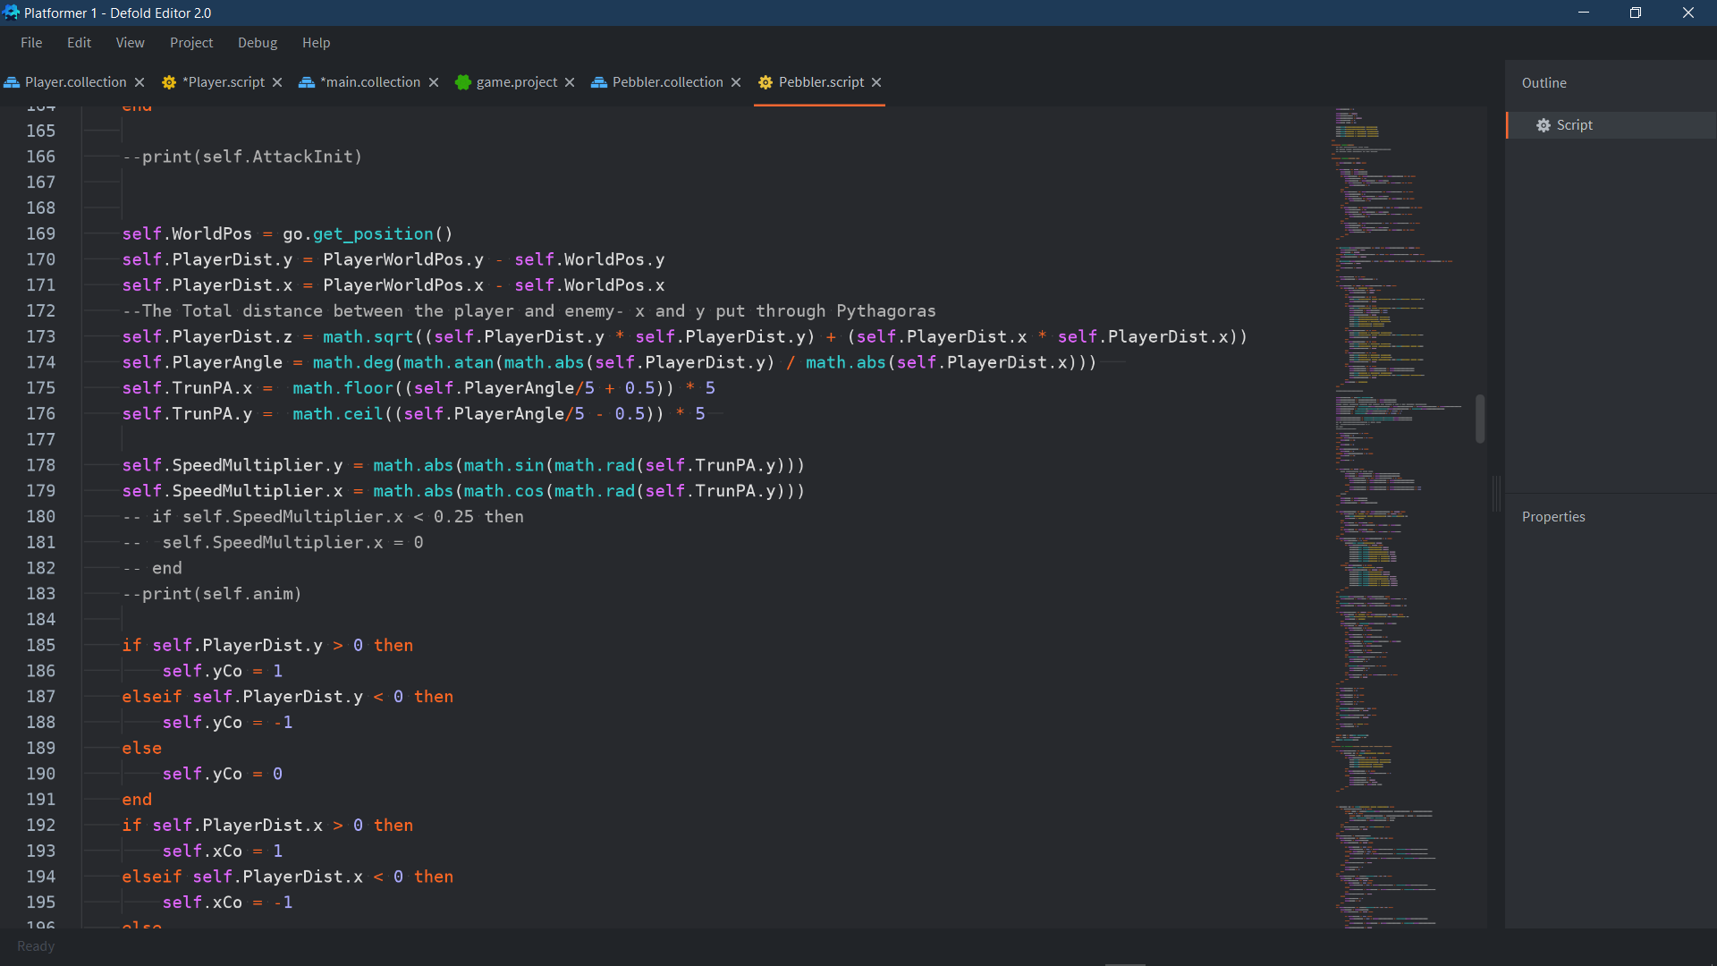

First off, since I wanted the enemy to just simply follow the player directly, I used a global variable holding the players world position and found the difference between the player and enemies' positions by using vector3’s. Vector3's are data types which can hold 3 numerical values at once- accounted for as x, y, and z values. In this case I modelled z as the displacement between the enemy and player using Pythagoras theorem. In this way I was able to save a lot of space and make data management much easier by storing related xyz values under single names. After finding the exact angle I set it to TrunPA simplifying it to 5 degree increments. Using these angle values, I use the same method I did with my player boost and use the angles to form multiplier coefficients to x and y respectively.

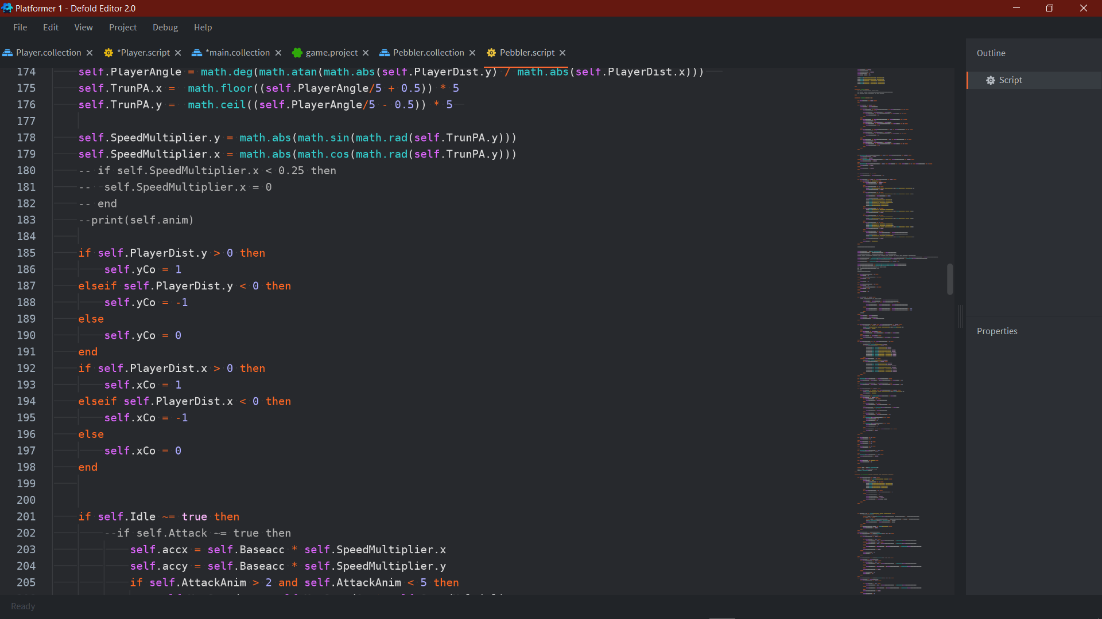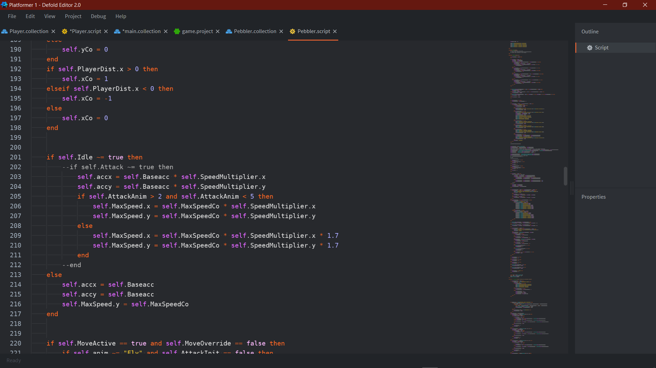

Here the first code just shows the direction being set in relation to if the x/y values between the player and enemy are negative or not. This method means I do not have to tamper with the direct angle outputs in the same way I had to for my boost. The next code here shows that when idle is false (not equal to true) the coefficients are used to set accelerations for x and y and Max Speeds for both x and y. The condition on attack temporarily increases their max speed by 70% whilst they are on specific attack frames.

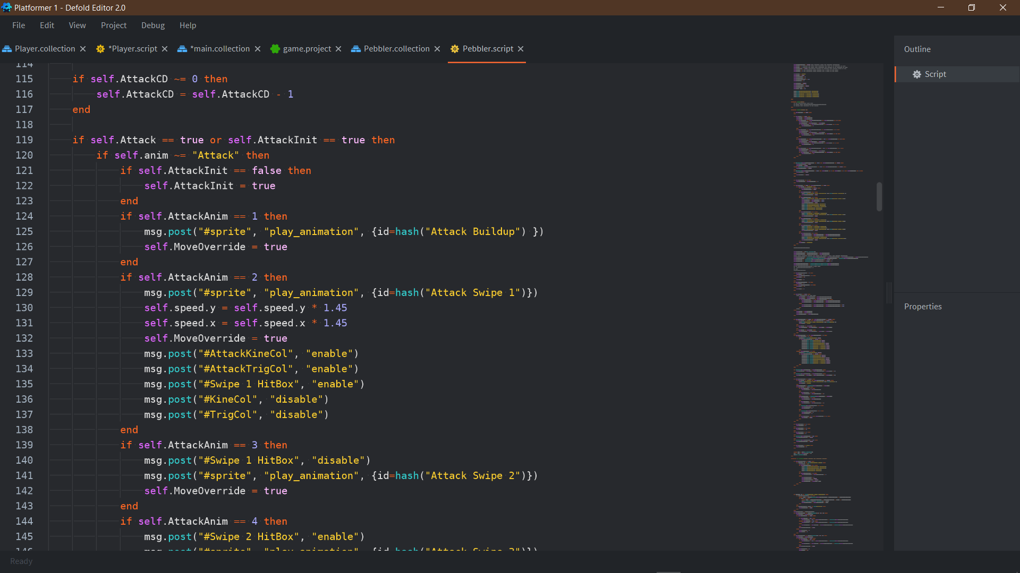

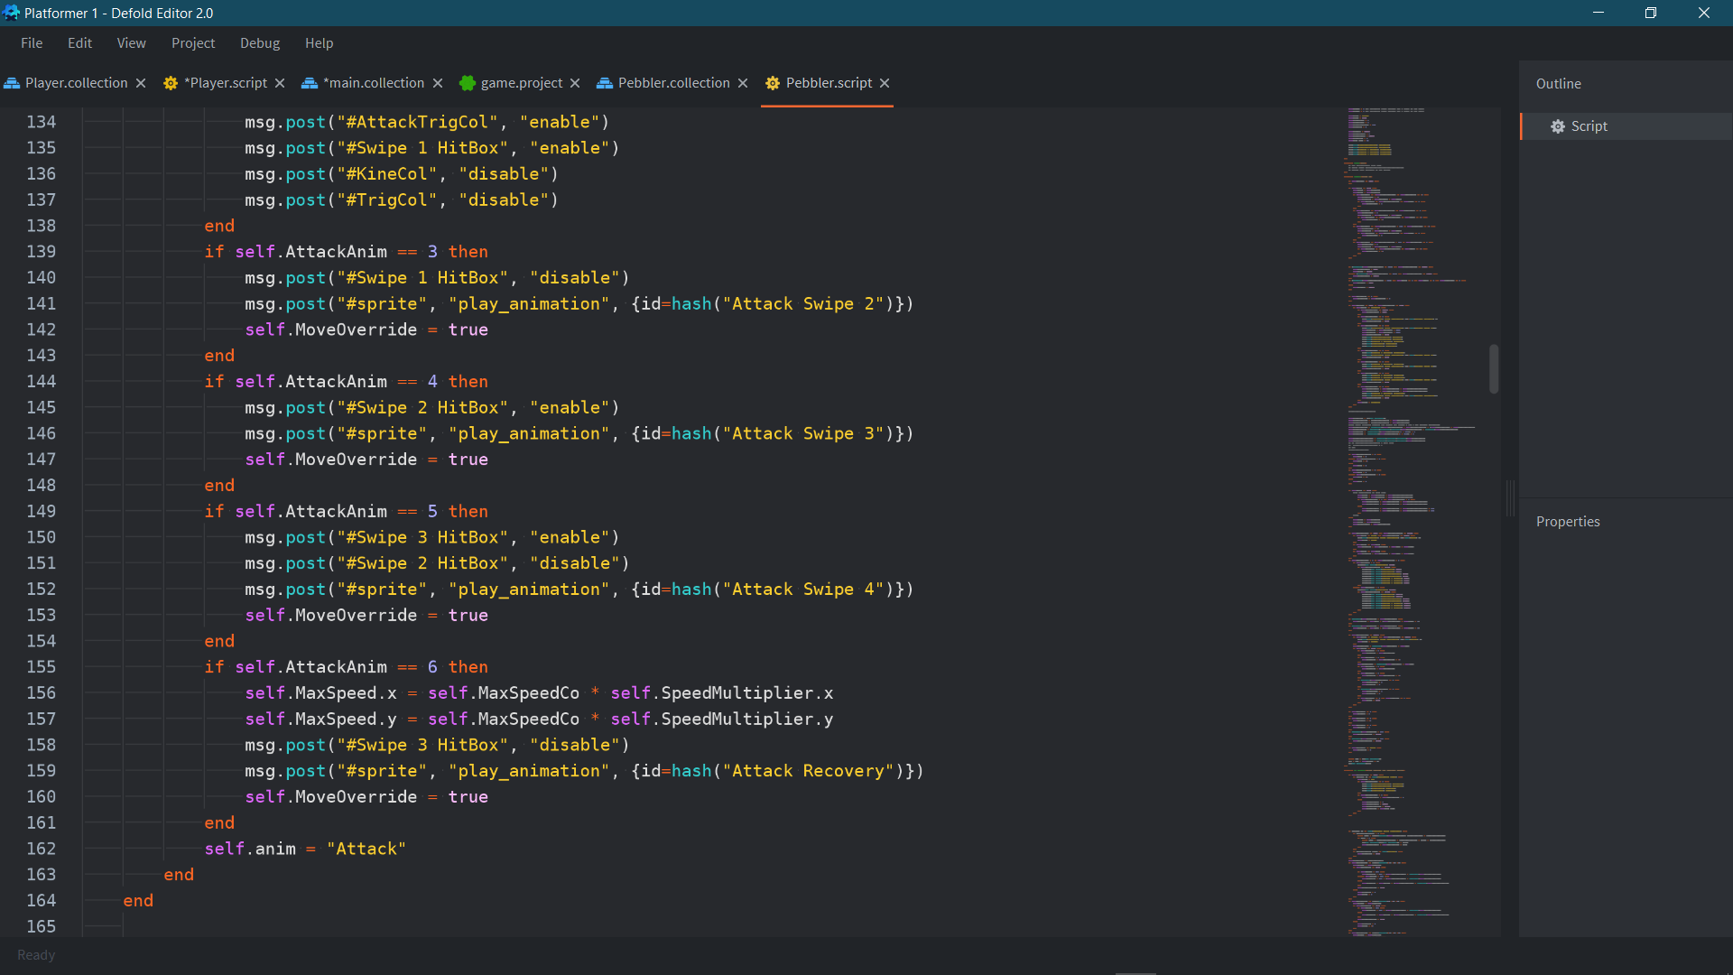

This code here shows the stages of the attack once the enemy gets in range. Originally this was just a single animation message but I have had to split it up because Defold cannot get the individual frame data from sprites- so I have had to split it up into mid animation key points. All on these key points it turns on and off the collisions damaging to the player accordingly to where the attack is on the sprite. The final if statement sets the max speeds back to their original after being increased by 70%.

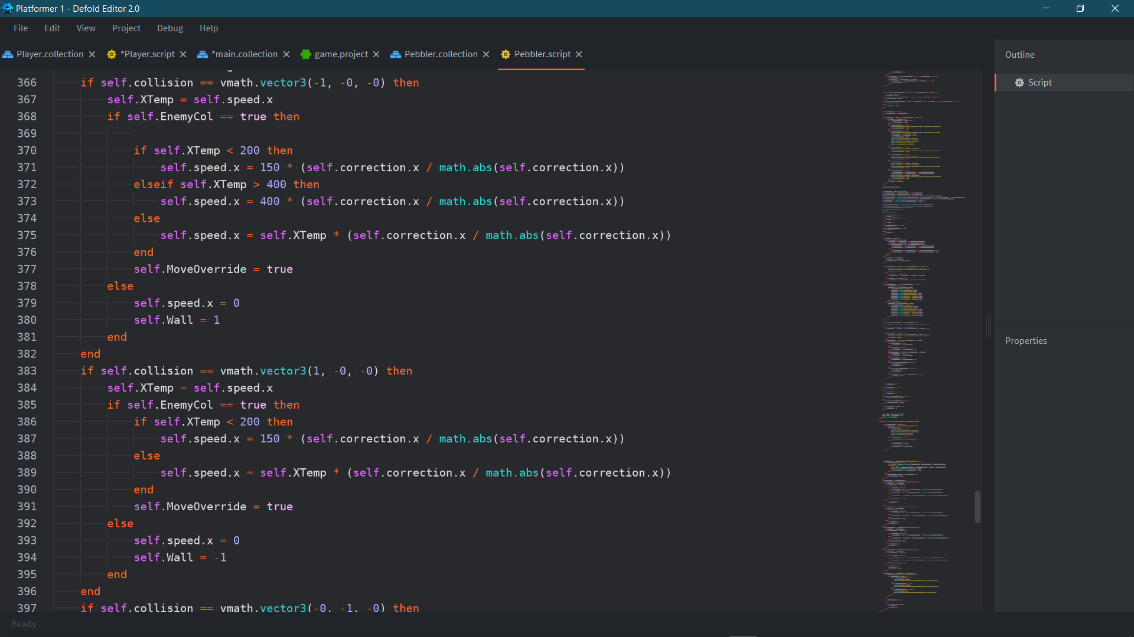

Running the enemy ran into an issue with when it collided with a wall it would still aim to follow the player, with a faster speed then its correction- this led to the enemy slowly pushing itself through ground collisions until it made its way to the player. To fix this I created a variable MoveOverride which was required for the enemy to follow the player and set it to true when the xCo/yCo variables (the variables that decided direction) were in the direction of the collision it was currently facing. I also added a protocol for if they collide with another enemy, this makes them bounce off of each other based on their force of impact. This was important as I specifically designed the enemy only use self-variables, such as so I could easily copy and paste or create multiple instances using a factory to place them throughout my level without impacting each other on a fundamental level.

Player-Enemy Interaction

Currently, since I do not have any health systems implemented yet, I have focus on the visual and gameplay interactions of being damaged. Currently I have an inconsistent stun and knock-up with invincibility frames with a blinking effect to visually convey this.

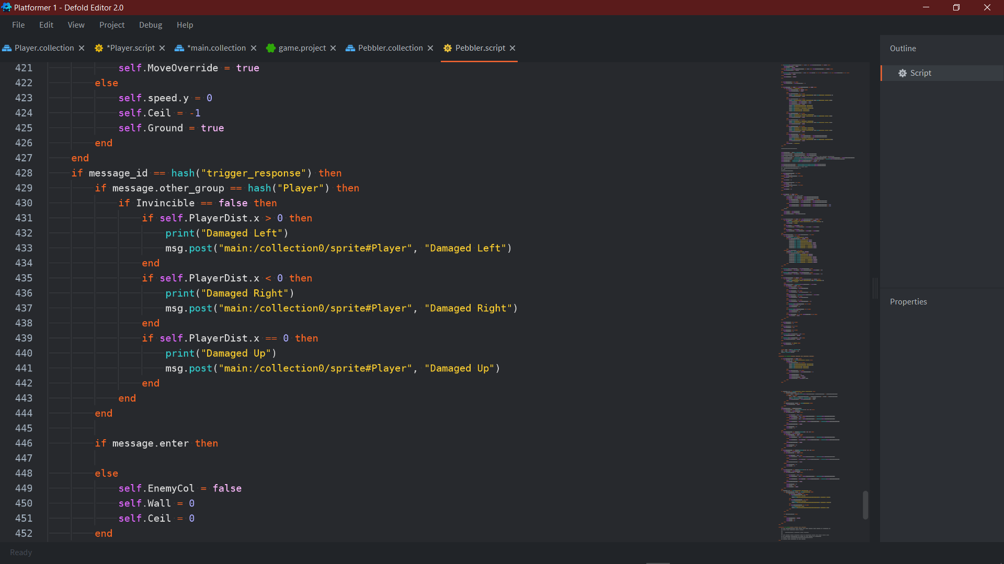

As I am planning to use multiple instances of the enemy throughout the level most of the interaction is handle on the player as there will only be one player script running at time in comparison to the potential multiple that could be running from the enemy. In saying that, I still have gotten the direction the player is being attacked in from the enemy script as it would be too difficult to get the player to track the distance of multiple enemies at once- even if it is just for the instance that they collide in.

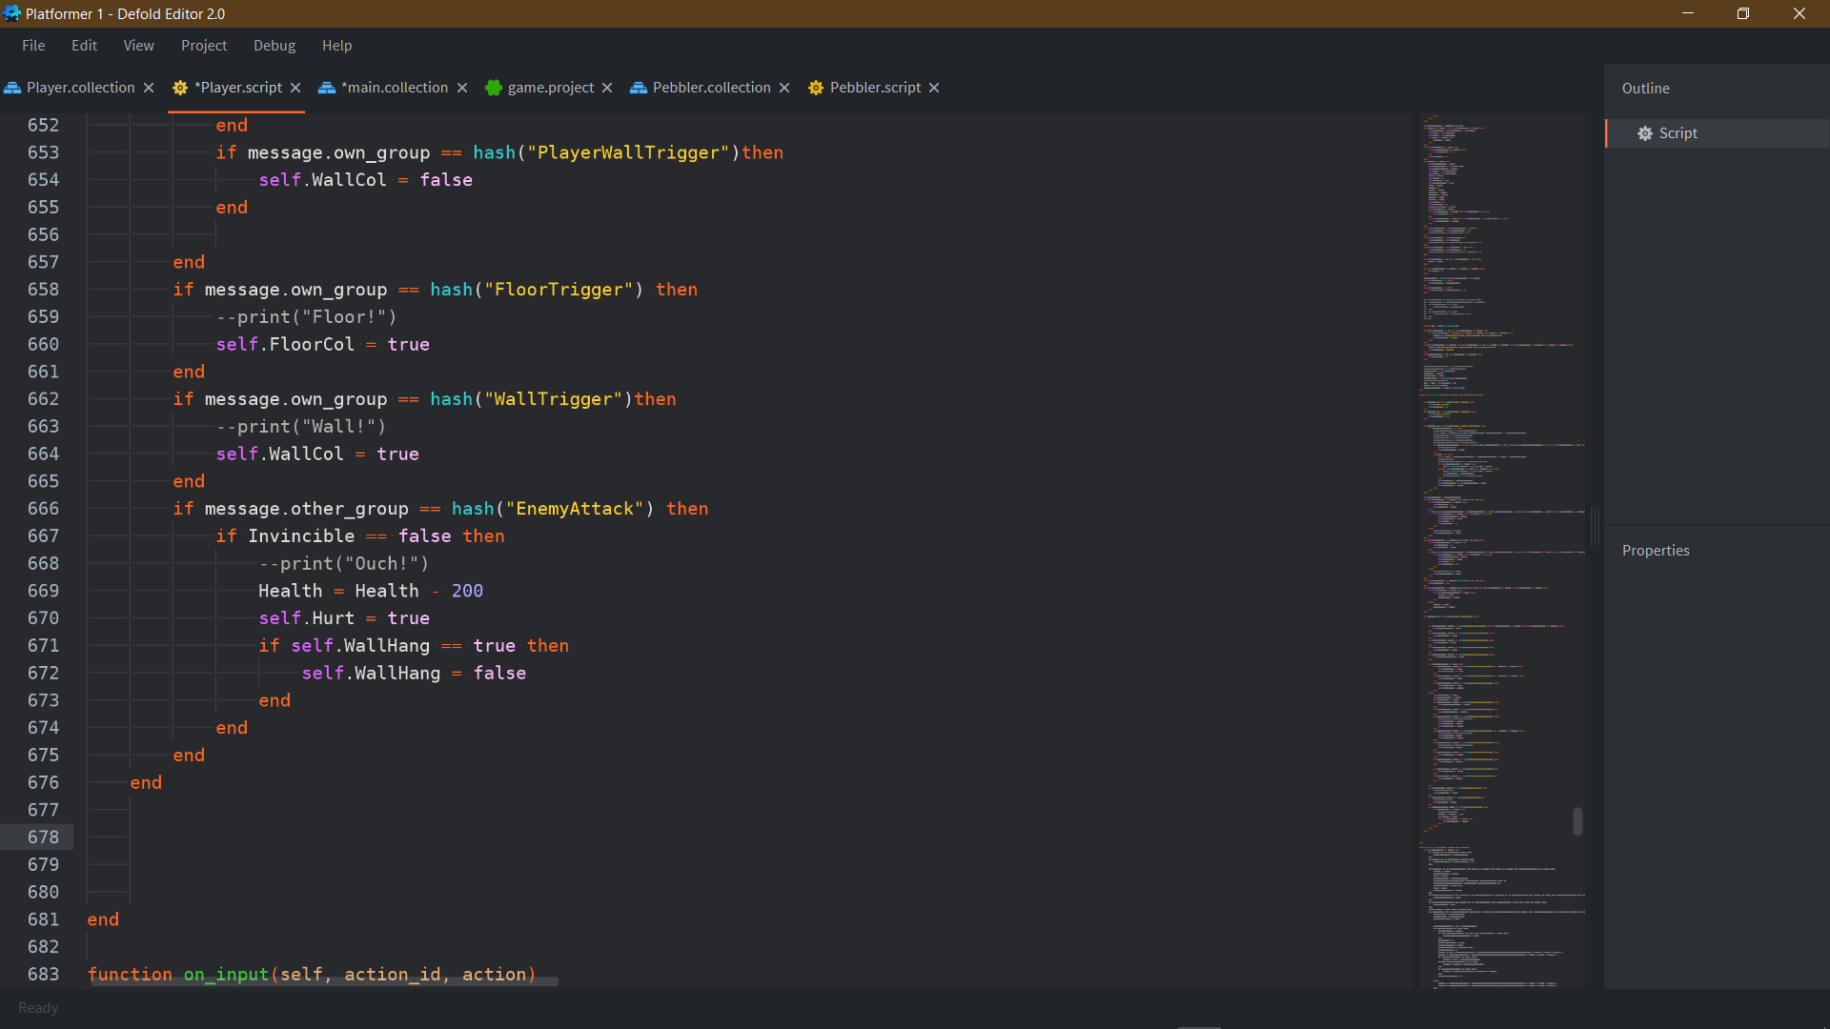

Player Side now: When colliding with the enemies damaging hitbox as long as it is isnt currently in invincibility it will be damaged for 200 health (health is set to 1000 initially but has no gameplay interaction and is just for behind-the-scenes indication) and sets hurt to true. I also tried to make it set WallHang to false so the player would fall off of the wall but it has not made a difference. Currently since I only have one type of enemy, I have not had any reason to differentiate between the types of enemy attacks there are, in future revisions however it would become vital and so I would have to change the name of the collider to reflect that.

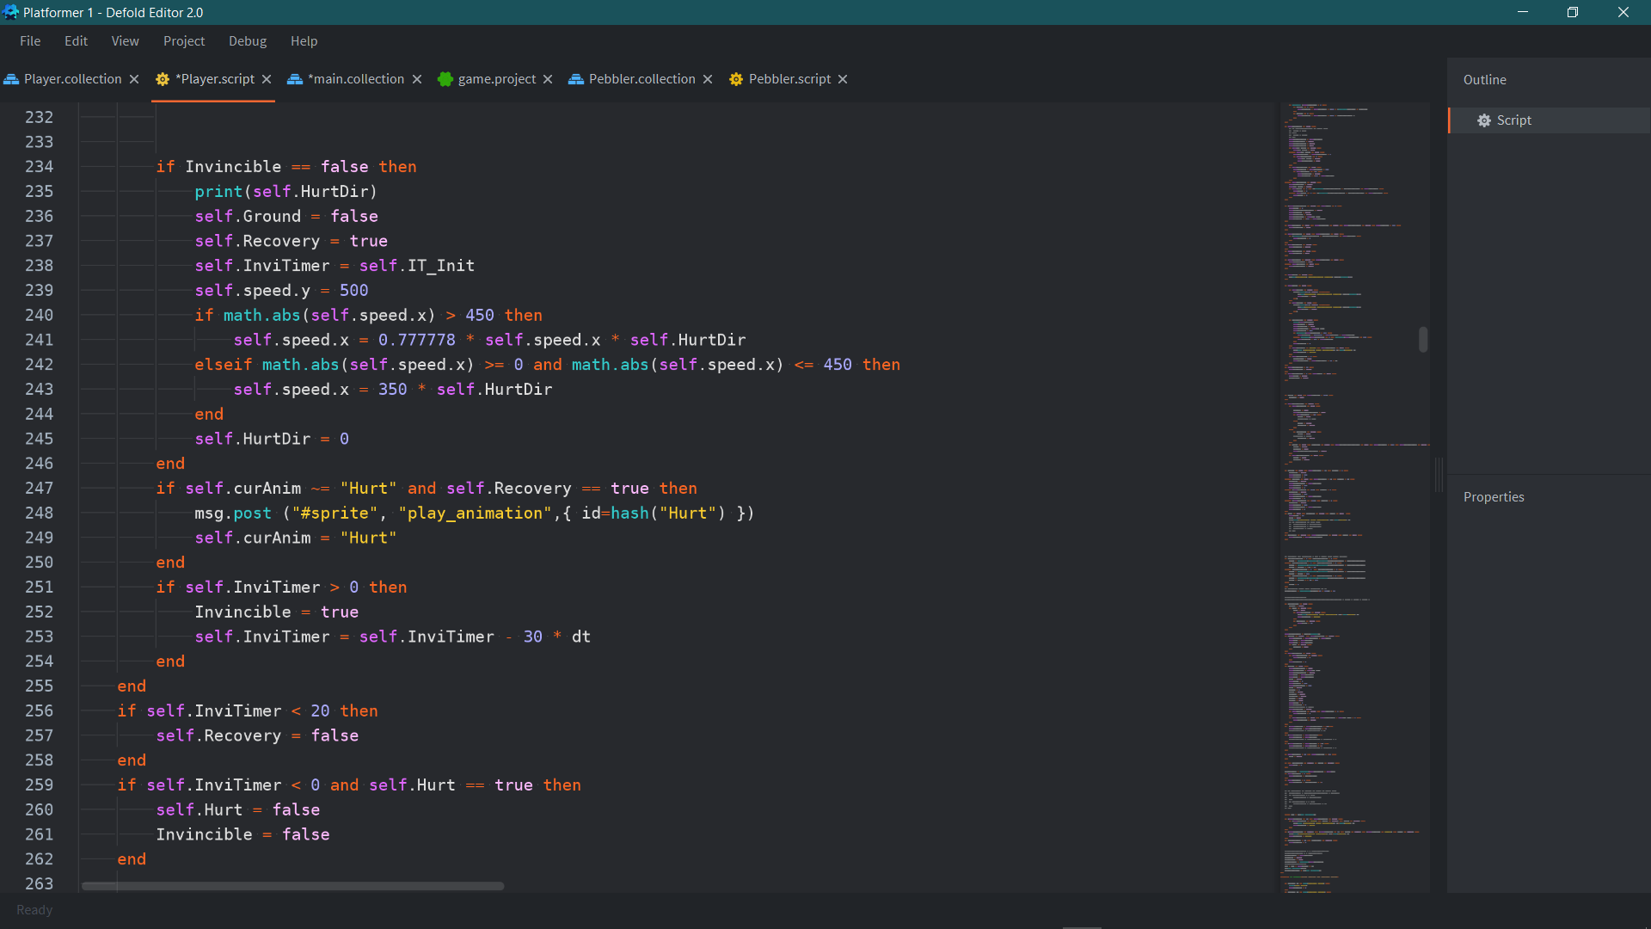

The script I have for being hurt is simple- when the Hurt variable is set to true this protocol runs where it sets a timer for how long invincibility is active for, the timer is reduced by 30 * dt where dt is delta (Δ) time, the change in time between each frame, just to make sure that it is a standard amount of invincibility between all devices regardless of lag or not. On the initial hit the player is sent in the direction that the enemy hit them at- proportional to the speed they were going at before (granted they were going at faster than at speed of 450). On initial it sets ground to false so that it can be boosted upwards by the damage- as usually only a jump is able to give the player any upward force, it also sets recovery to true- it will set it back to false once the timer goes below 20.

While recovery is true however all player input is disabled meaning the player temporarily cannot impact the movement on the player. This effect does not last for long however as the recovery timer is quite short and the recovery value is instantly set to false if the player hits the ground before the conditional time is reached, allowing the player to move instantly if they land on the floor. The recovery variable also controls the hurt animation and stops all other animations from playing whilst it is true (this is quite inconsistent currently and I will need to check over any missed animation statements).

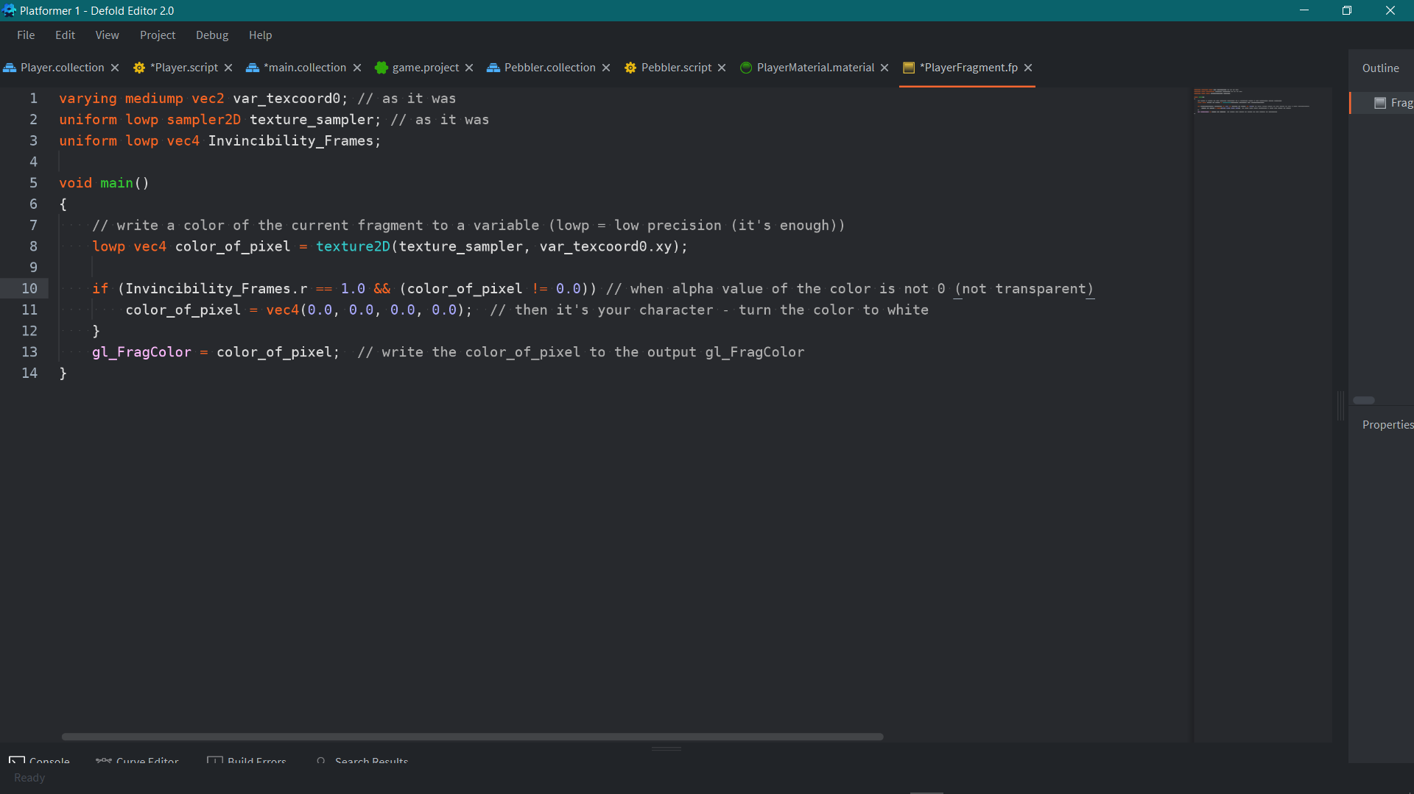

Now that the Hurt function has complete functionality, I had to learn how to make the blinking effect- and this required me to learn how to develop shaders. Luckily for me I was able to rework a simple shader from a tutorial to make the entire sprite invisible when needed- to learn this however I had to learn the syntax of OpenGL which is difficult to understand, even with its similarities to C. This was an especially useful experience teaching me about how materials in defold work and how to create vertex programs and fragment programs, and apply them to a material to be interacted with.

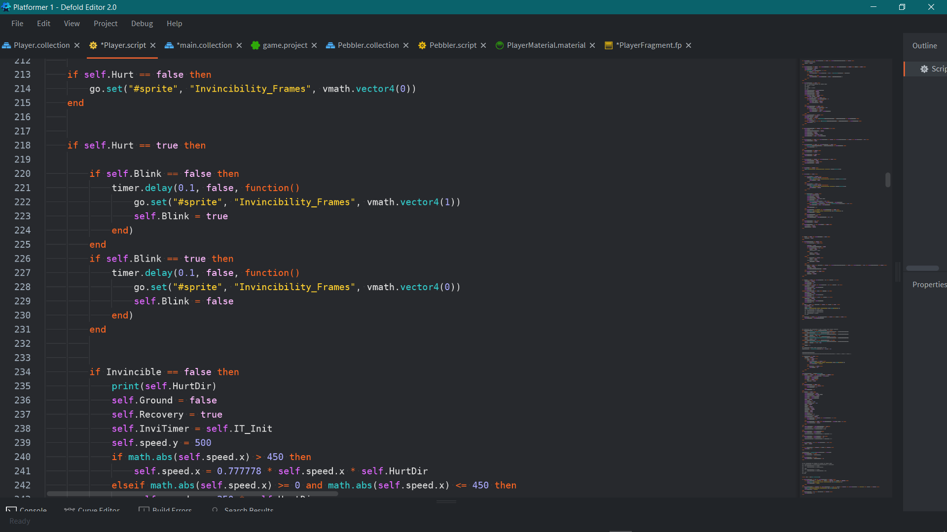

With the completion of the basic shader program, I was very easily able to set an on and off delay to make the sprite blink on and off after being hit to show invincibility, it is a very simple effect but is extremely effective at portraying its intention.

Development Key E Refining Current Features

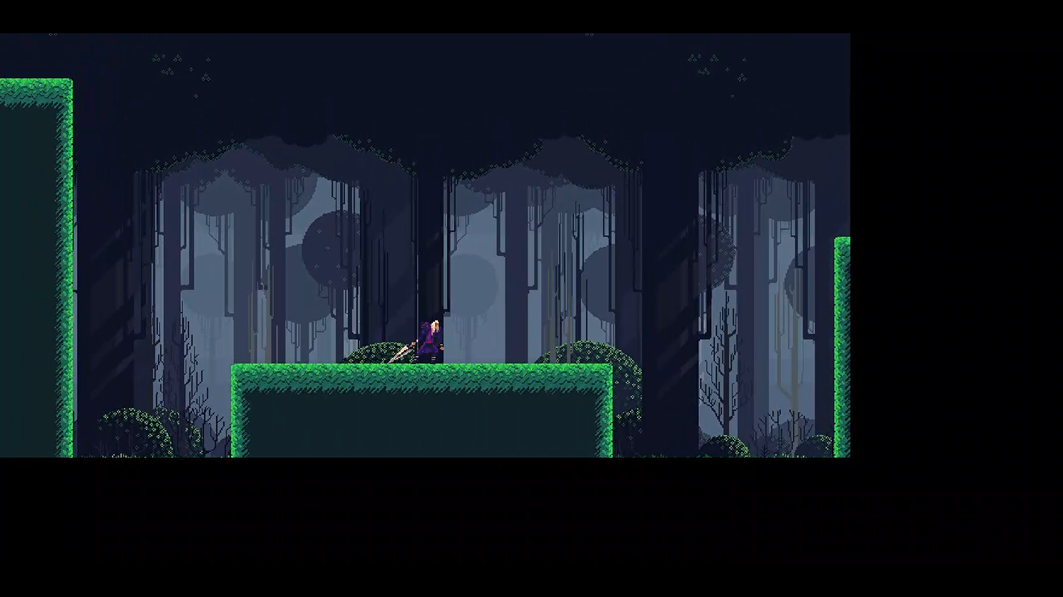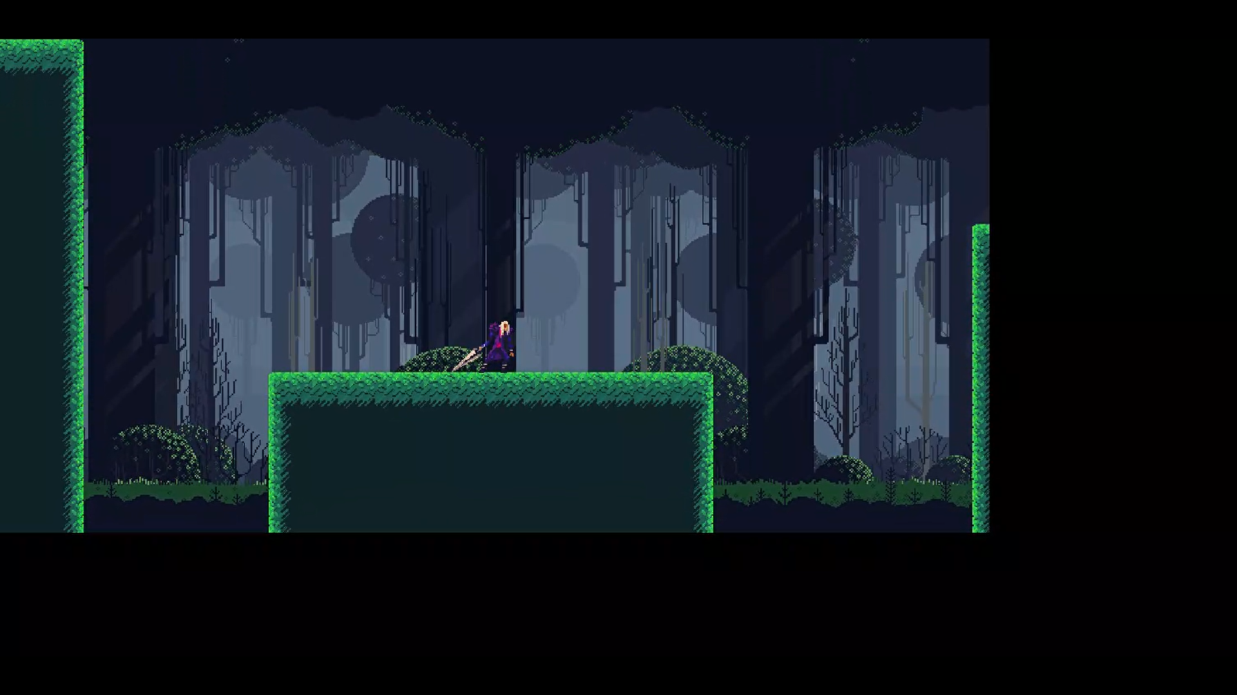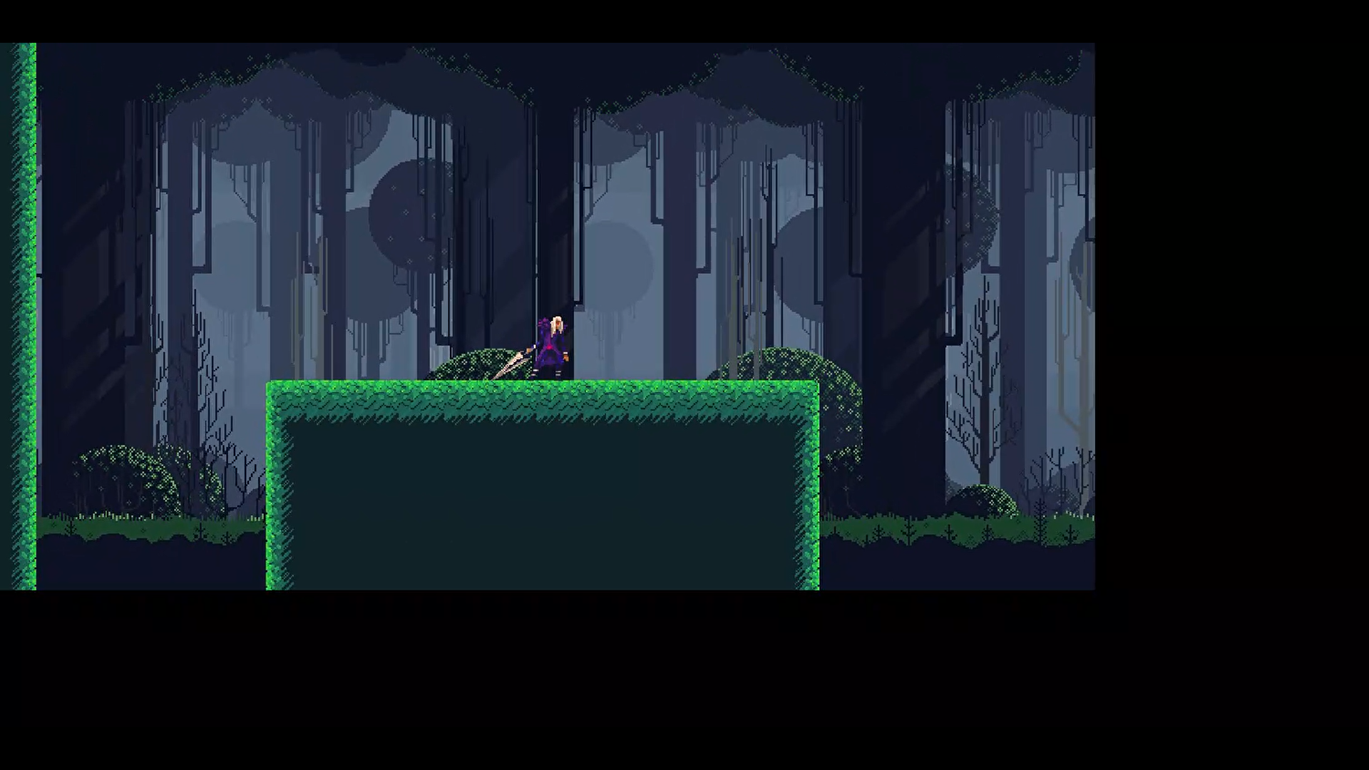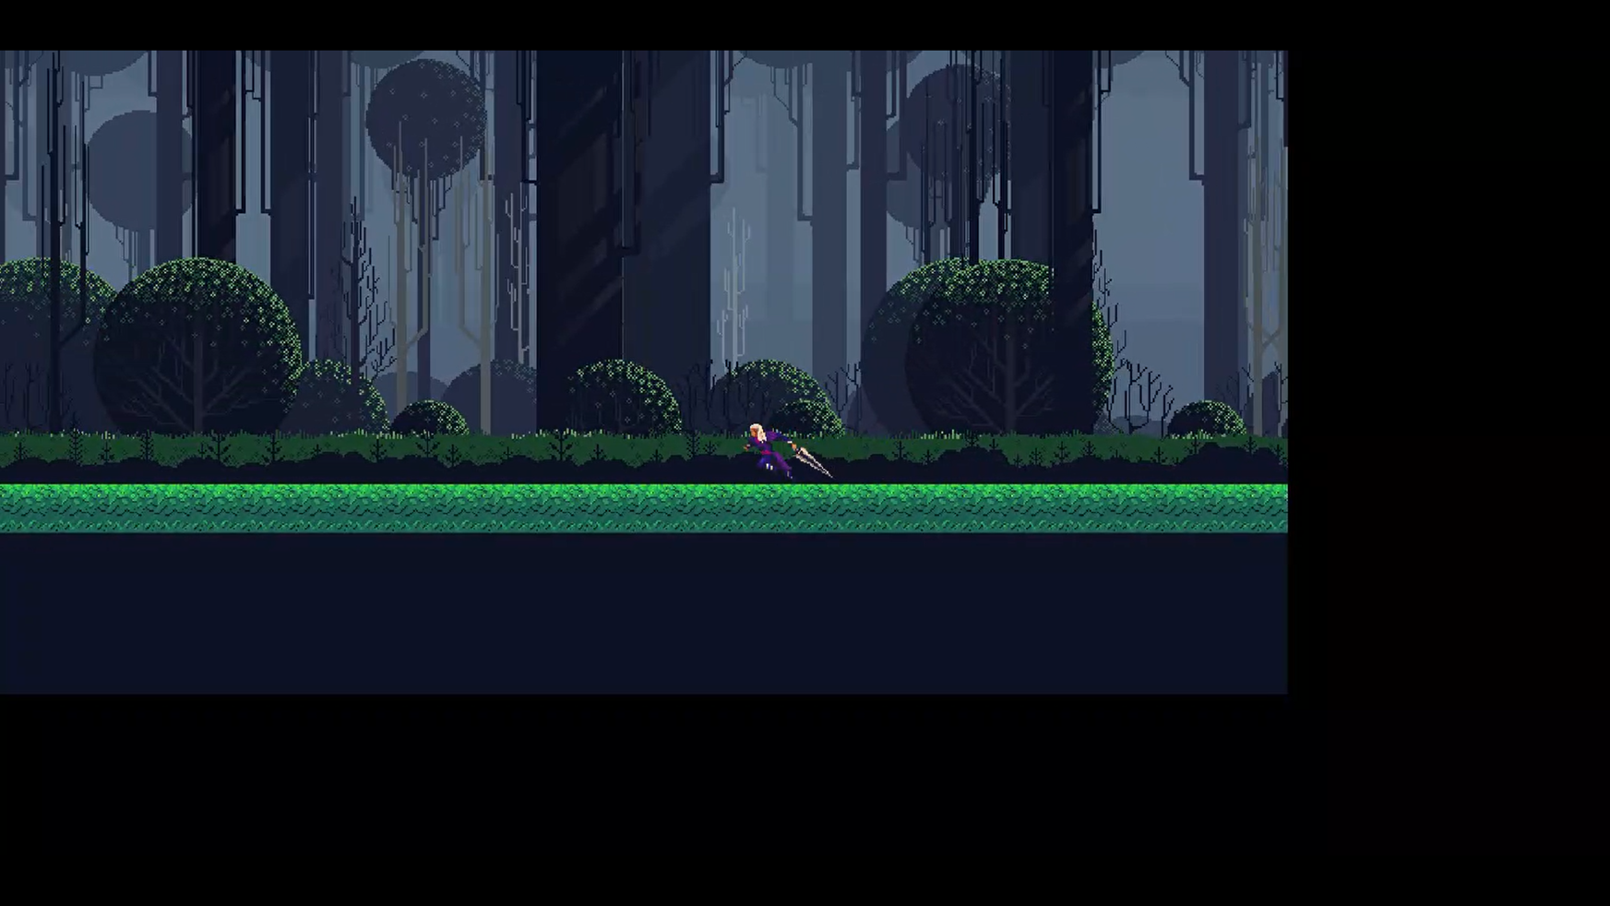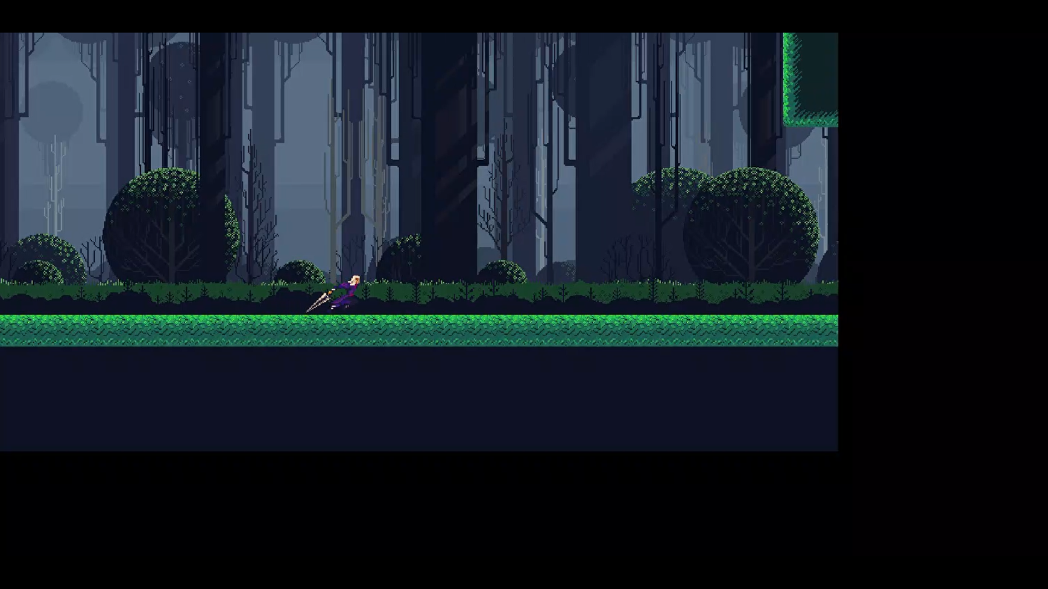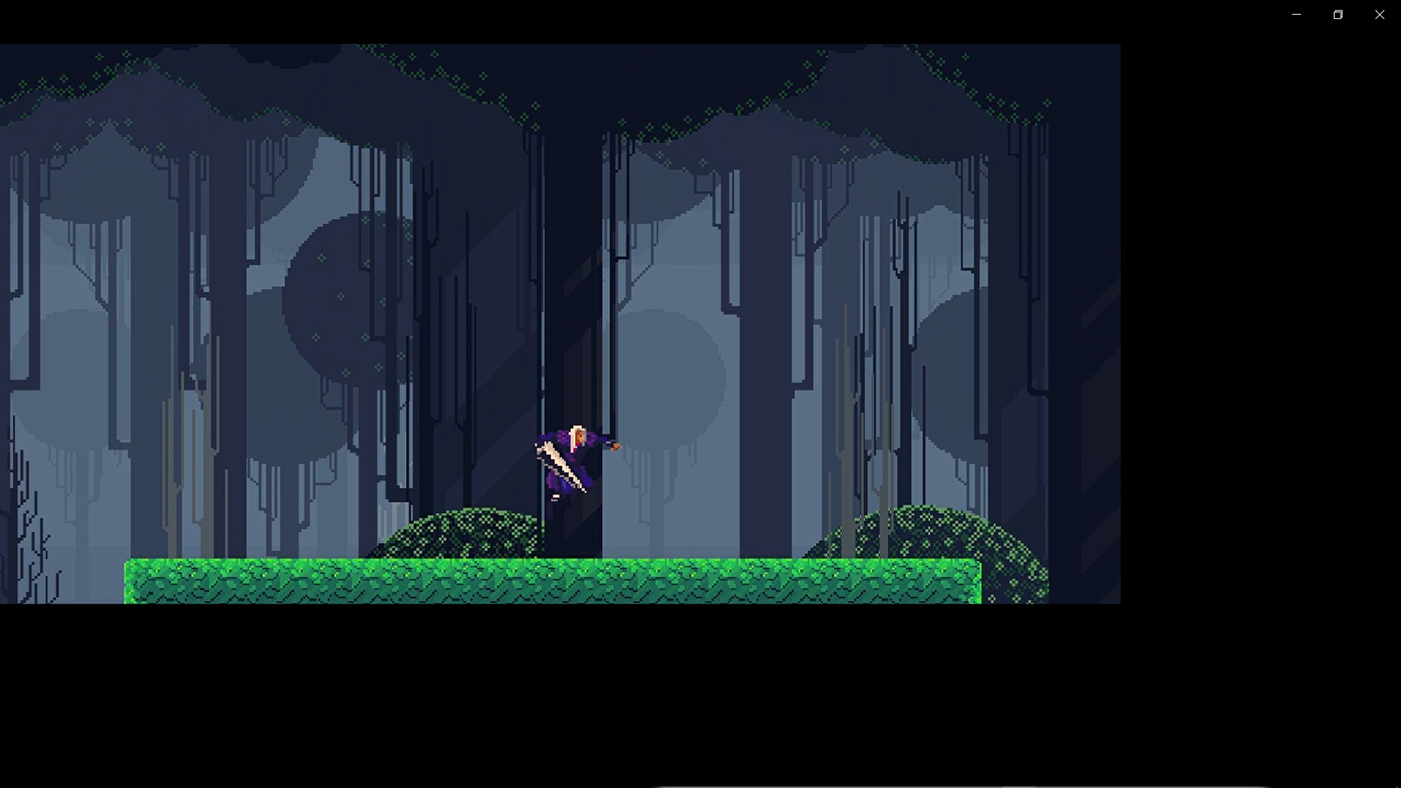

<https://share.vidyard.com/watch/GivkHvJTtxxW13xUgmb5P7>?

I have decided to go over my prior functions and features to refine them to a point where the game presents a nicer quality of use and to smooth out and debug previous issues that I had overseen/ forgotten about. I also had play tester feedback criticizing the amount of zoom that the screen undergoes, here I have slightly reduced the overall zoom of the game to keep the player clearer as some testers had issues tracking everything on screen once the screen reached full zoom. Although zooming in makes tracking everything on screen easier- it decreases the amount of time that the player has to elements quickly appearing on the screen or oncoming platforms, this inspired me to make a lookahead where the camera shifts forward in the direction you are moving in- many players said that the screen being more zoomed in with the lookahead was much more useful and easier to look at then before. I also added an upwards and downwards pan to the camera the player can use when moving still- this currently does not present any functional use case but can be used to just look around the level or to see a platform that is potentially out of view due to being above/ below the camera

I also replaced my old copper inspired tiles with another set of tiles I made. These grass tiles fit more in with the background I have used for the scene and make the overall project feel more polished. The jump needed to be slightly refined as through play testing many people could not intuitively grasp the concept of the variable jump, I think the main reason for this is that simply tapping the jump button gave the player enough height to cover most obstacles with the boost, so players would simply tap to use the boost as soon as possible. Here I have made the jump lose a large amount of force if the button is released before a certain time; this allows for mini hops to be used which can be useful for covering small gaps losing as little speed as possible whilst also intuitively teaching the player that holding the jump button has benefits, as they will not be able to traverse the map using light button presses, they are forced to experiment and hold the jump button. After making this change the number of players that were able to instinctively grasp the concept of the jump height being dependant on how long the button is pressed increased massively.

Polishing the enemy interaction was also something that was important to me as the enemy would make the player stick to the wall and would be very awkward for players to play around with. I managed to make the player go into a state where he bounces off of walls while in his recovery state- as well as bounce off the wall if they are currently hanging on it. This fixes the wall interactions that being hurt has but I have found that it makes scaling walls with an enemy on your tail arduous as the enemy keeps knocking you back down. This could be a future revision; I could make the player switch out of recovery state on colliding with a wall but that may cause more problems than it solves.

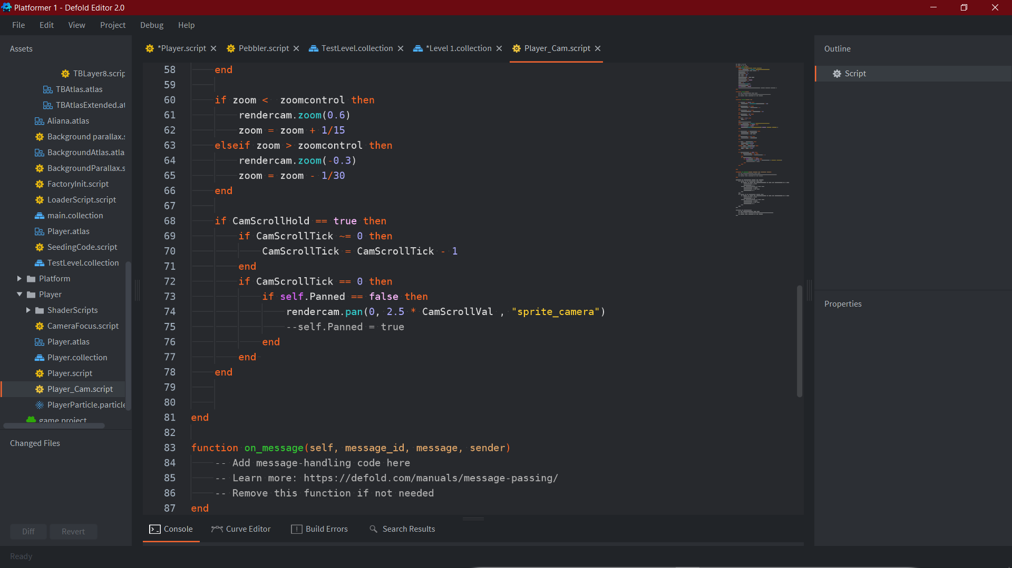

Here is the code for my pan- it works off of a simple timer that resets when the joystick isnt being held up or down. To get this to work I had to set a limit on how far the joystick could go left or right before it registers as being a left or right movement input as its unlikely to be able to consistently get the joystick up or down with no left or right bias.

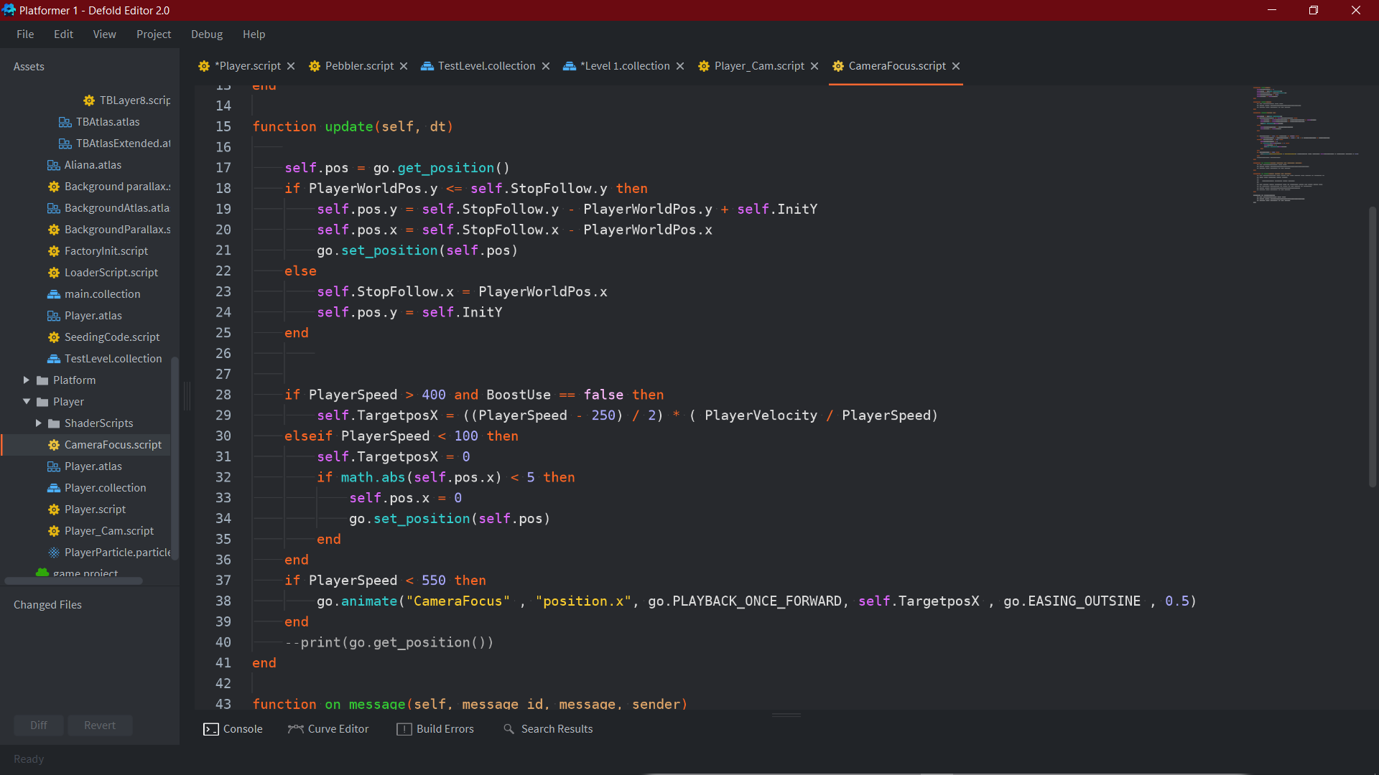

For the camera I have it attached to a game object which is placed slightly above the player, so that the player is in the centre bottom of the screen and not centre. Using this game object made it trivial to create a look ahead system. It uses the speed to calculate a distance for the screen to pan over by then animate by then uses an easing algorithm to smoothly pan over to it. As the animate algorithm is called every frame when the player reaches max speed the camera would move infinitely smaller distances towards its target position- to stop this I just set a statement to stop calling the algorithm once the player reaches max speed so the animation can end without being recalled.

The camera is also set to stop following the players y axis and stay still when it reaches below a certain point (where the background ends).

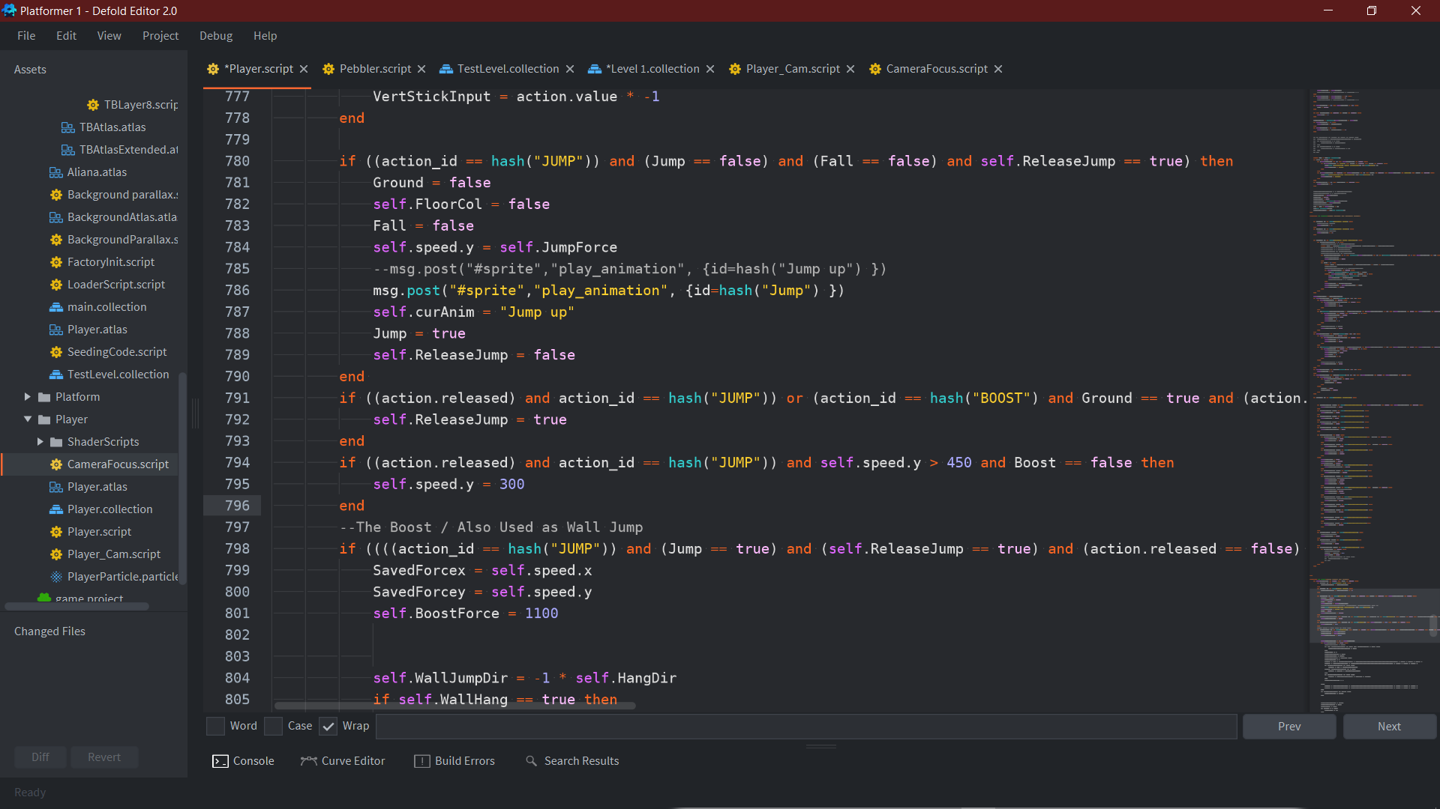

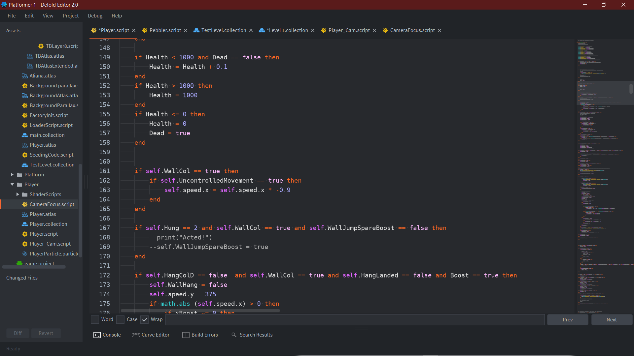

Adding both the wall bounce and mini hop were trivial, with the mini hop just reducing the force if the buttons released before gravity gets the y value below 450 and the bounce just setting the x speed 90% in the opposite direction.

Development Key F: Healthbar GUI, Death and Restart Mechanic

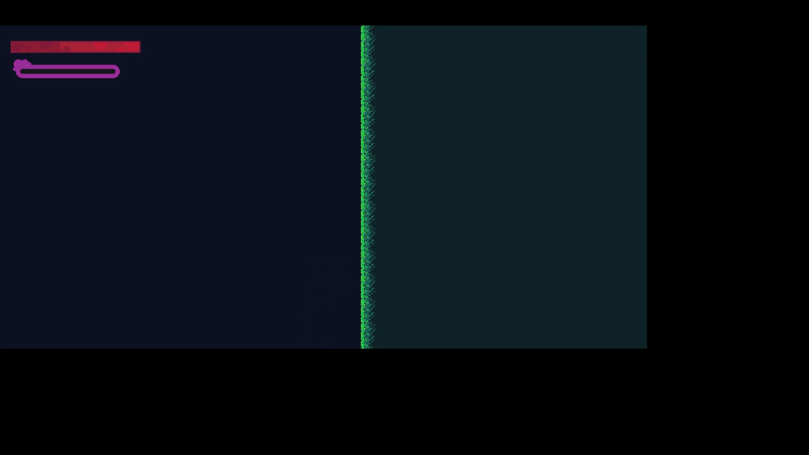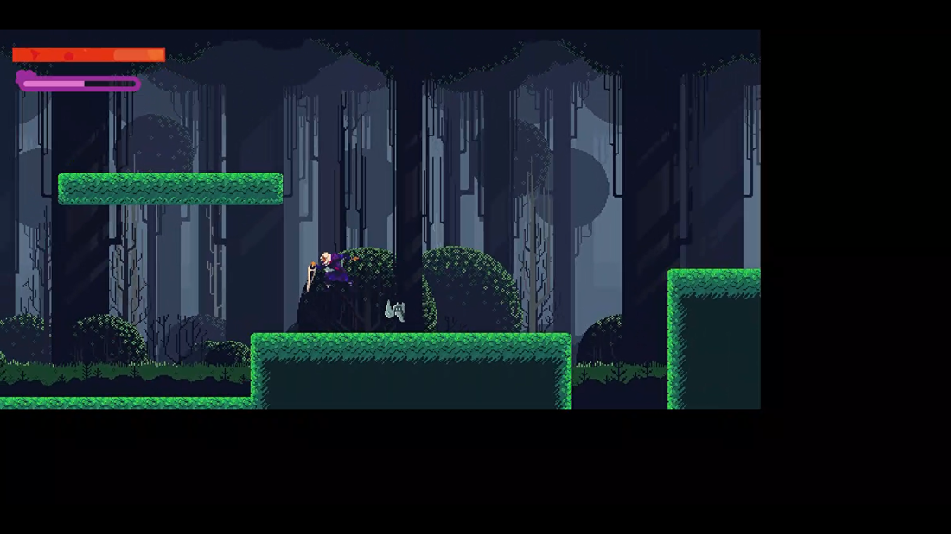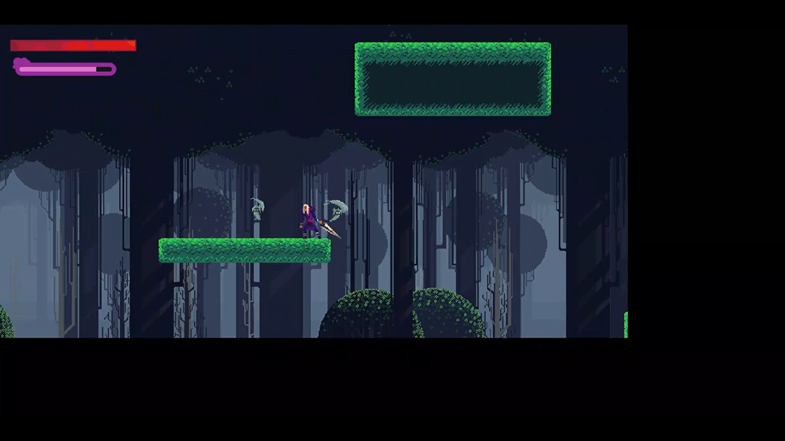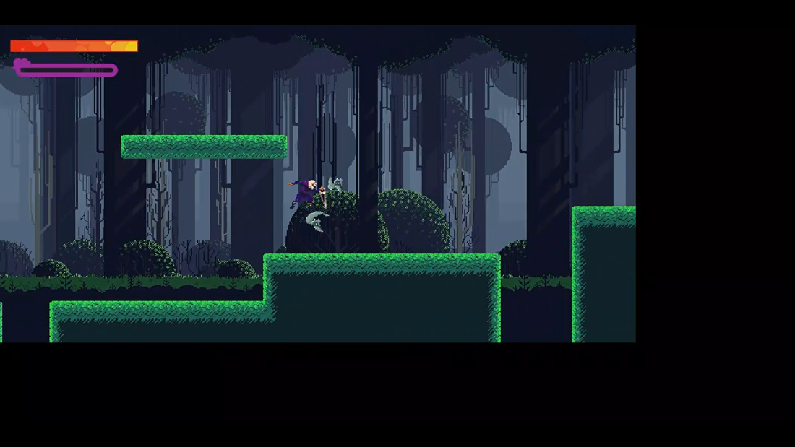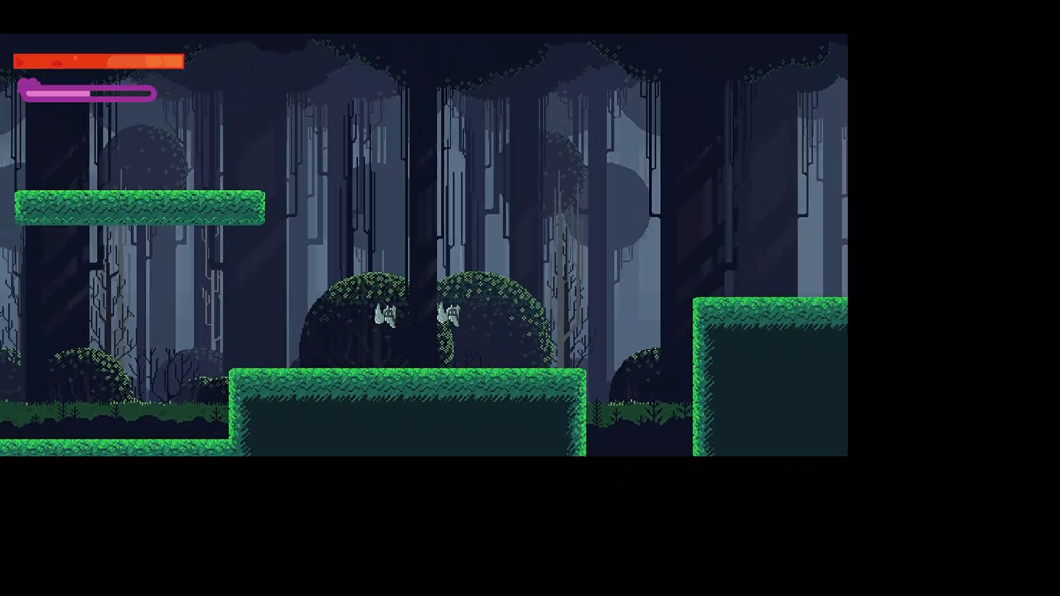

<https://share.vidyard.com/watch/MGdQZbVGc2SUonz8B513wJ>?

I have now decided to work on having a healthbar Gui and death protocol. With all my play testers within my sixth form many of them have questioned about what happens if you die. Therefore, I have decided to work on a death protocol to increase the response I get from players. First, I worked on the healthbar, and made two different revisions of them using different types of healthbar design- one which uses colour to give a “feel” of how much health is left- whilst the other is a basic block/ empty space design which is much easier to read. Visually the second revision is easier for players to understand but they prefer the visual effect present in the original.

Upon death the player loses all control of the player and the game scene slows down to 15%- shortly after a black death screen swipes down where the level will then restart and the swipe will clear to show the health bars once again.

Working on the GUI

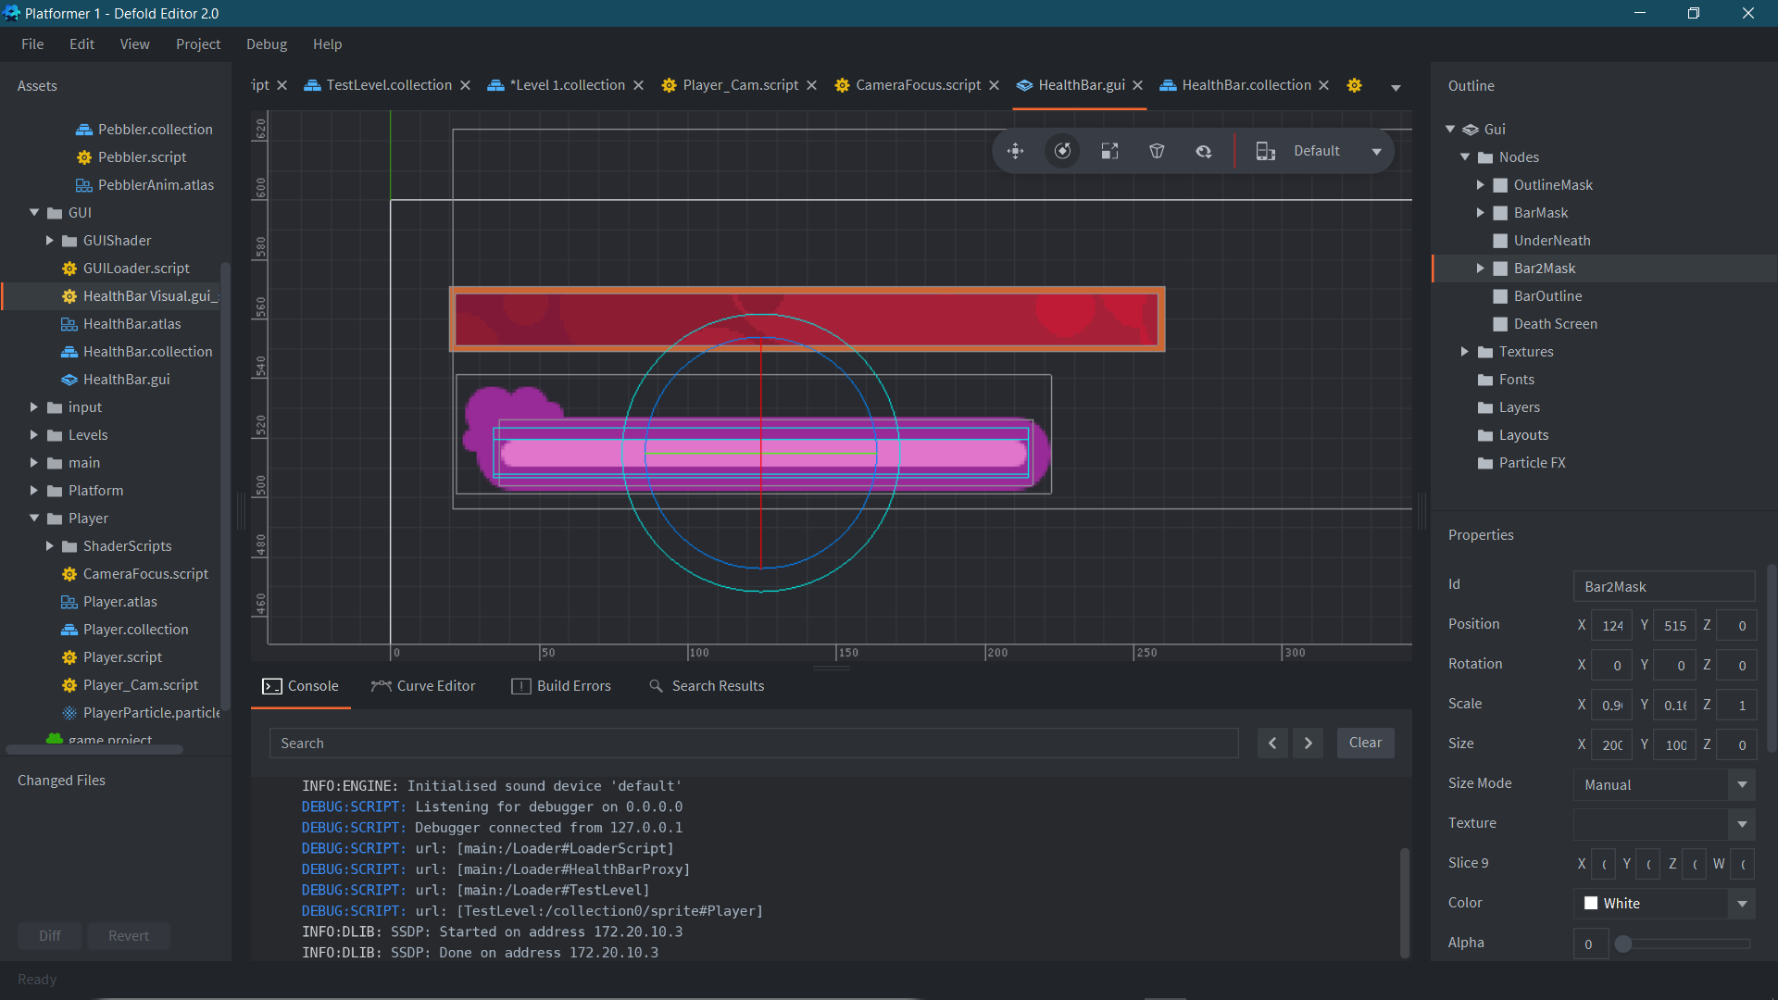

To get the health bars to work I had to take advantage of clipping masks. In the GUI component clipping masks are shapes that are used to specify where sprites can be rendered. They can be set to either normal allowing anything inside of the shape to be rendered or inverted where everything outside of the shape is inverted. For both health bars they use normal clipping masks where the sprite (node) is moved along away from the health bar in proportion to the amount of health the player has.

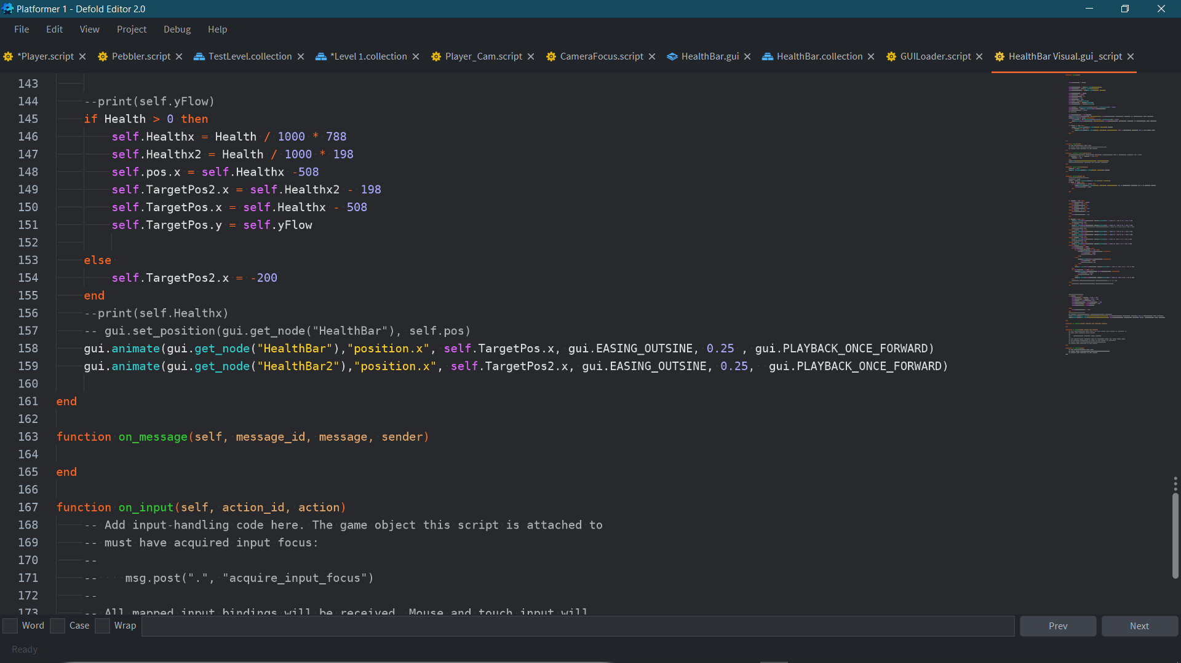

Here is the code for both health bars- simply setting the proportion of health to health bar length and animating the position of the bars based on these factors.

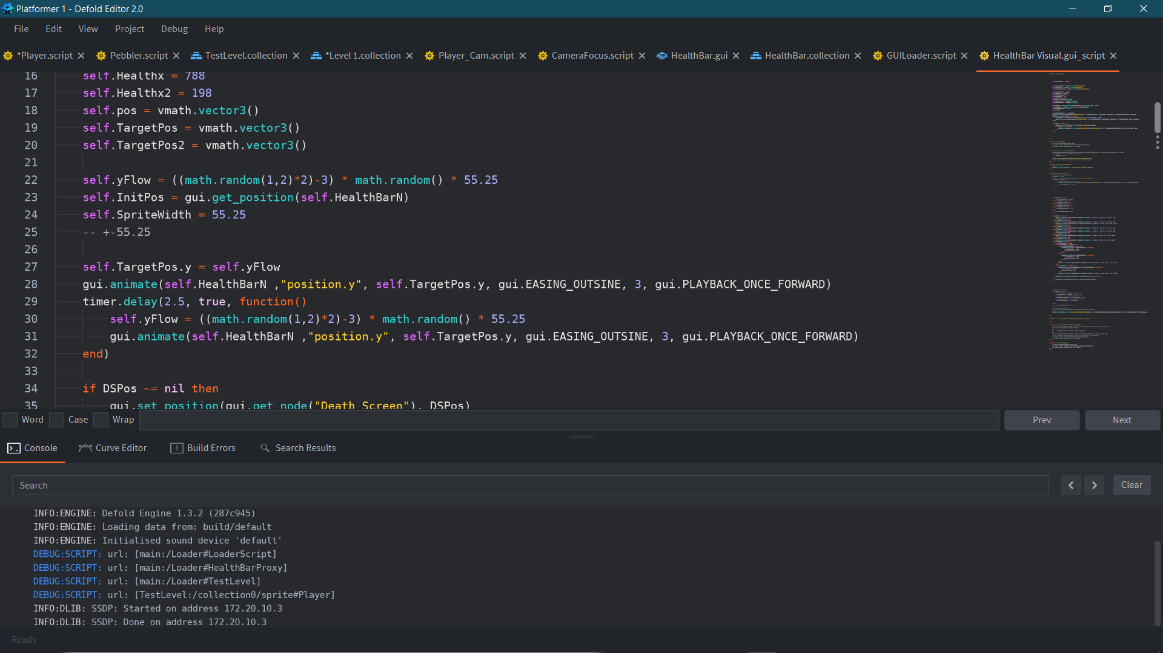

The original health bar by virtue of being a sprite much larger than the visual allowance it is given, has a function which randomly animates it across different y values- this gives the bar a nice effect of always moving- like the amount of energy or “juice” the player has left.

Player Health and Death

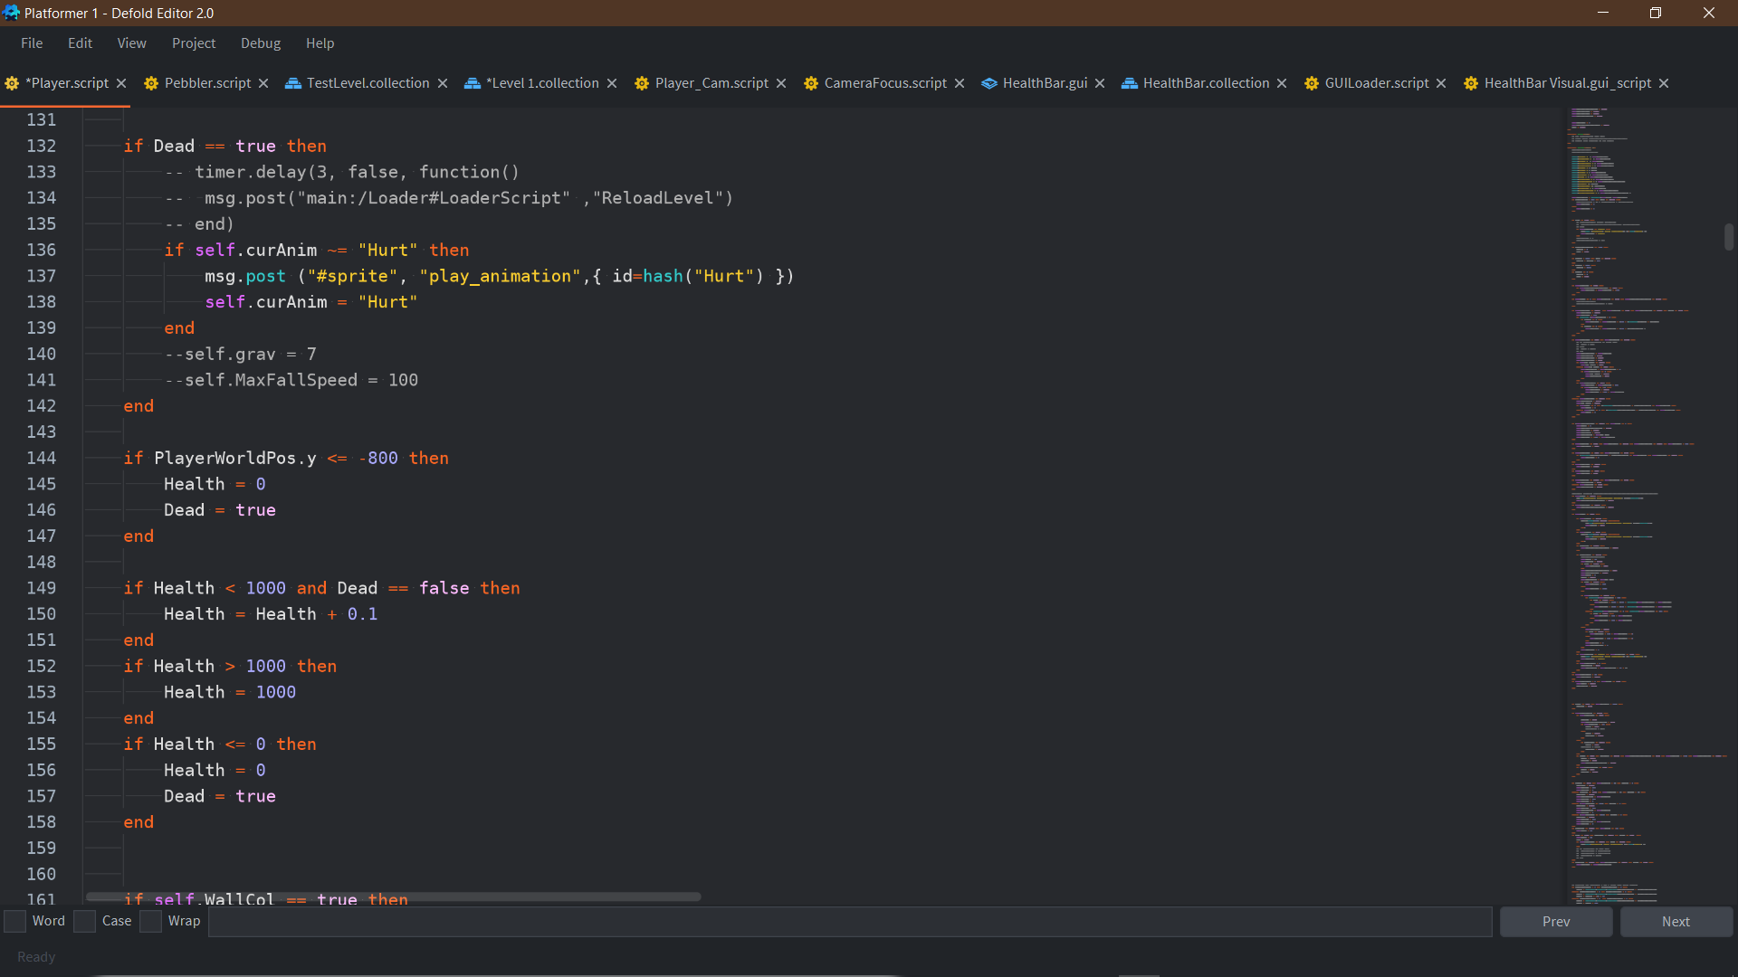

The health and death of the player is all controlled within this short function: the player is given a passive healing factor at a rate of 0.1 point per frame. The health will also be automatically set to zero if the player reaches below –800 coordinate on the y axis, this was due to many of my play testers falling off of the map and needing me to completely restart the project before they could play again. Once the player’s health drops to 0 the variable Dead is set to true.

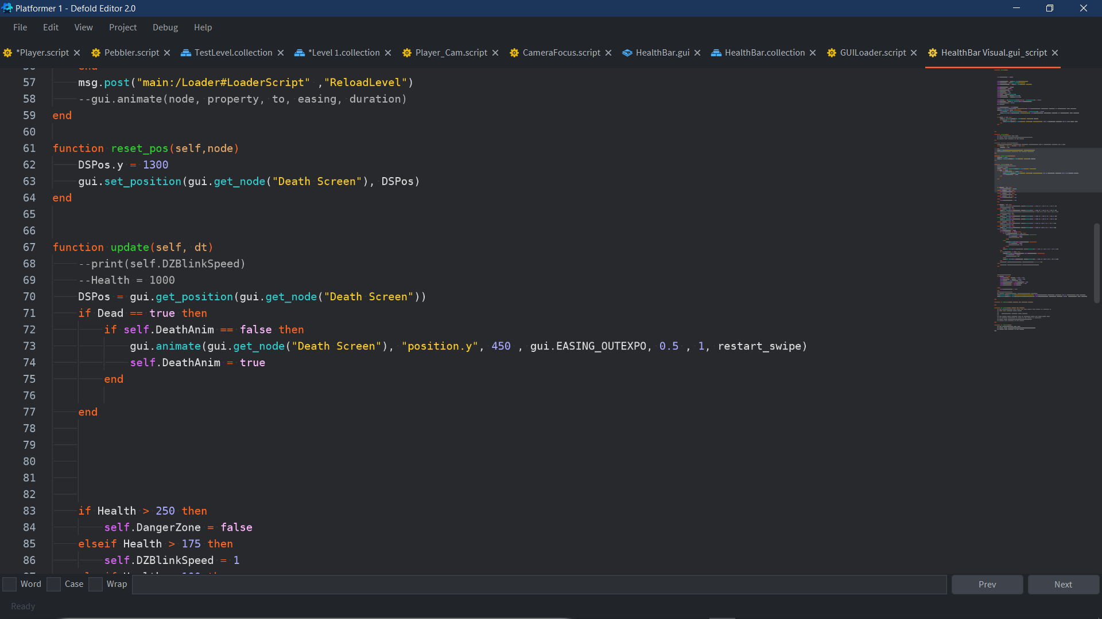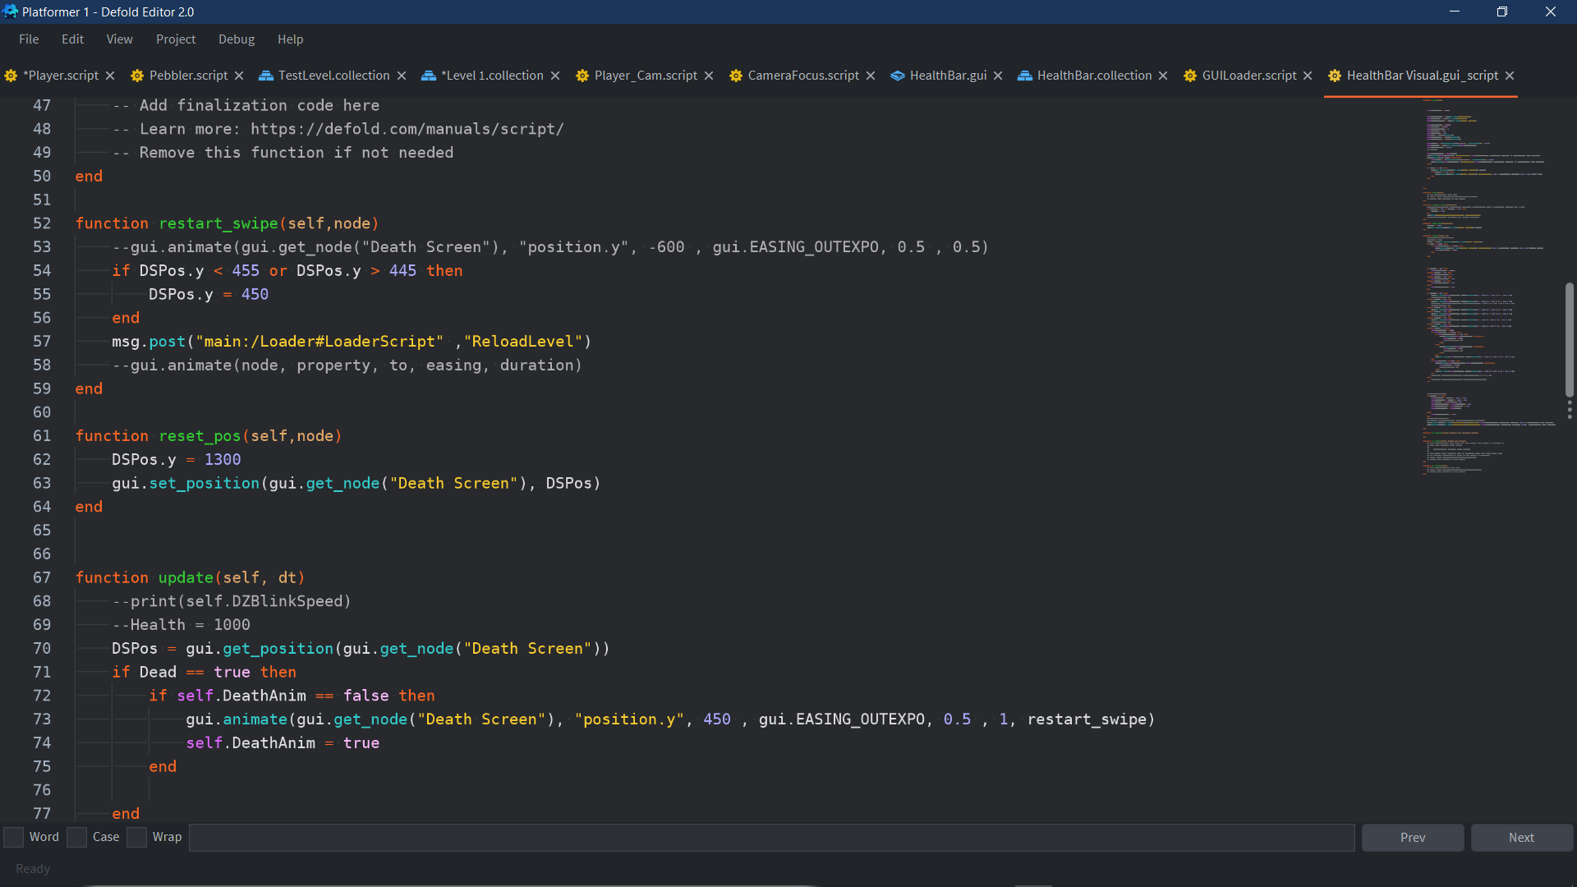The Dead variable is global so that it can be used to easily communicate between all scripts in the project. Currently it is being used to communicate with the GUI as that is what kickstarts the restart mechanism, however in future revisions it could be used to communicate with potential bosses- so they can react to defeating the player. Once the GUI reads that the player has died it plays an animation to swipe a black box across the entire screen covering it. Upon finishing the animation, it runs the custom function ”restart_swipe”. This function then sends message to a loader script to reload the level.

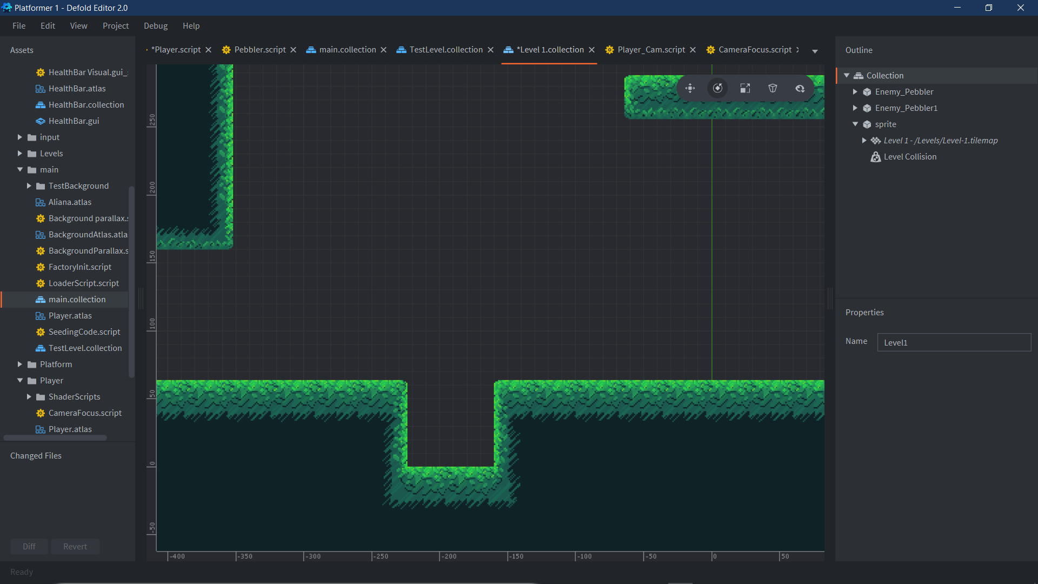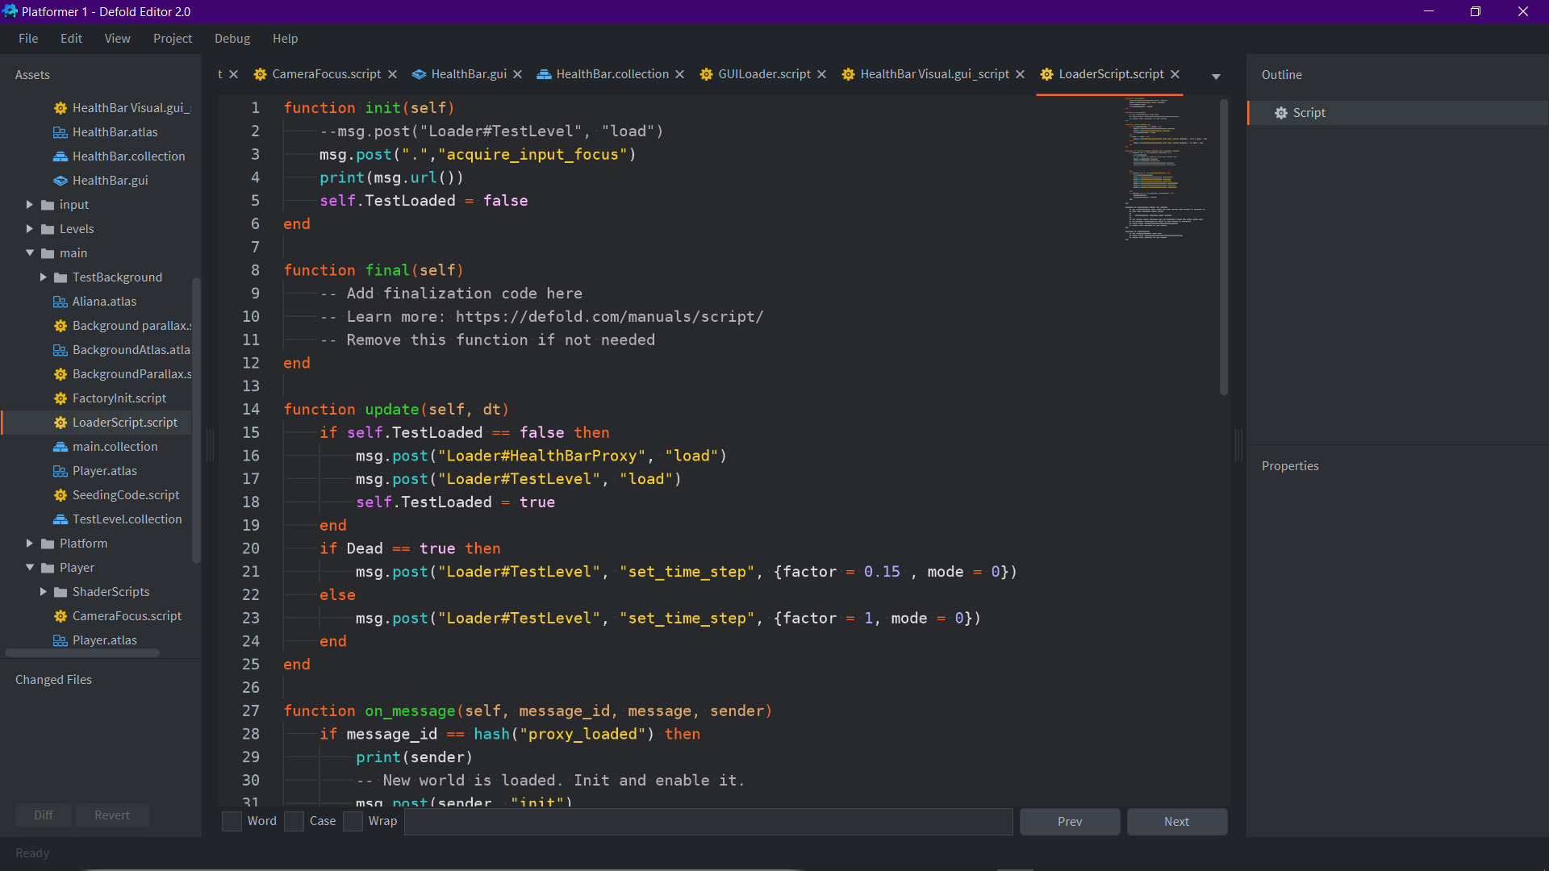

To make level reloading work I had to transfer the level and game world into a proxy, this is because proxies are treated as separate game worlds and can be unloaded and loaded at will- whereas the main bootstrap is always background active. To start this, I first had to split my main collection out into the Level world and bootstrap Loader. Upon splitting them up I had to initialise the game by loading up the entire game world, enabling and initialising the level to run, the code here does this by setting a loaded Boolean to false and letting the update function automatically load the proxies up.

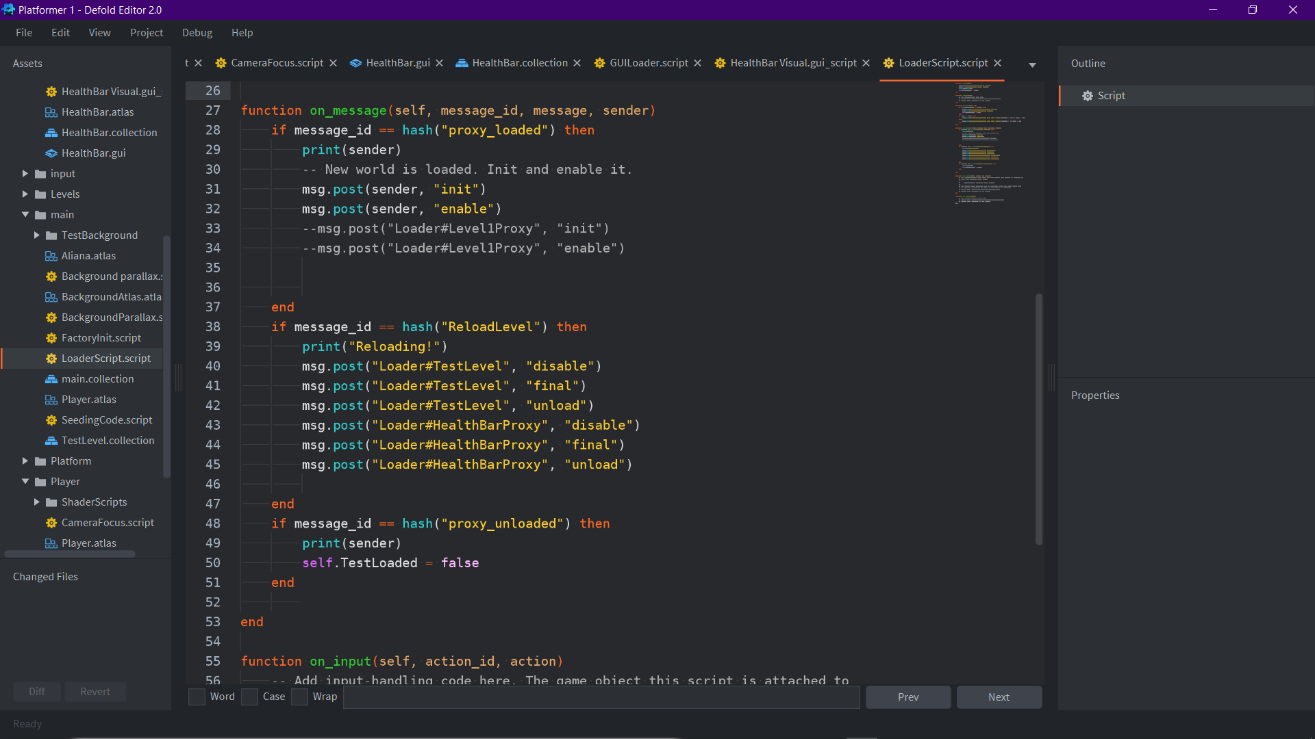

When the proxies are loaded, they send messages through to the console which the script uses to initialise and enable the proxies. When the message “Reload Level” is sent through to the loader script from the Gui it first disables and unloads the test scene and healthbar and sets the loaded variable to false- which automatically causes them to be loaded again through the update function.

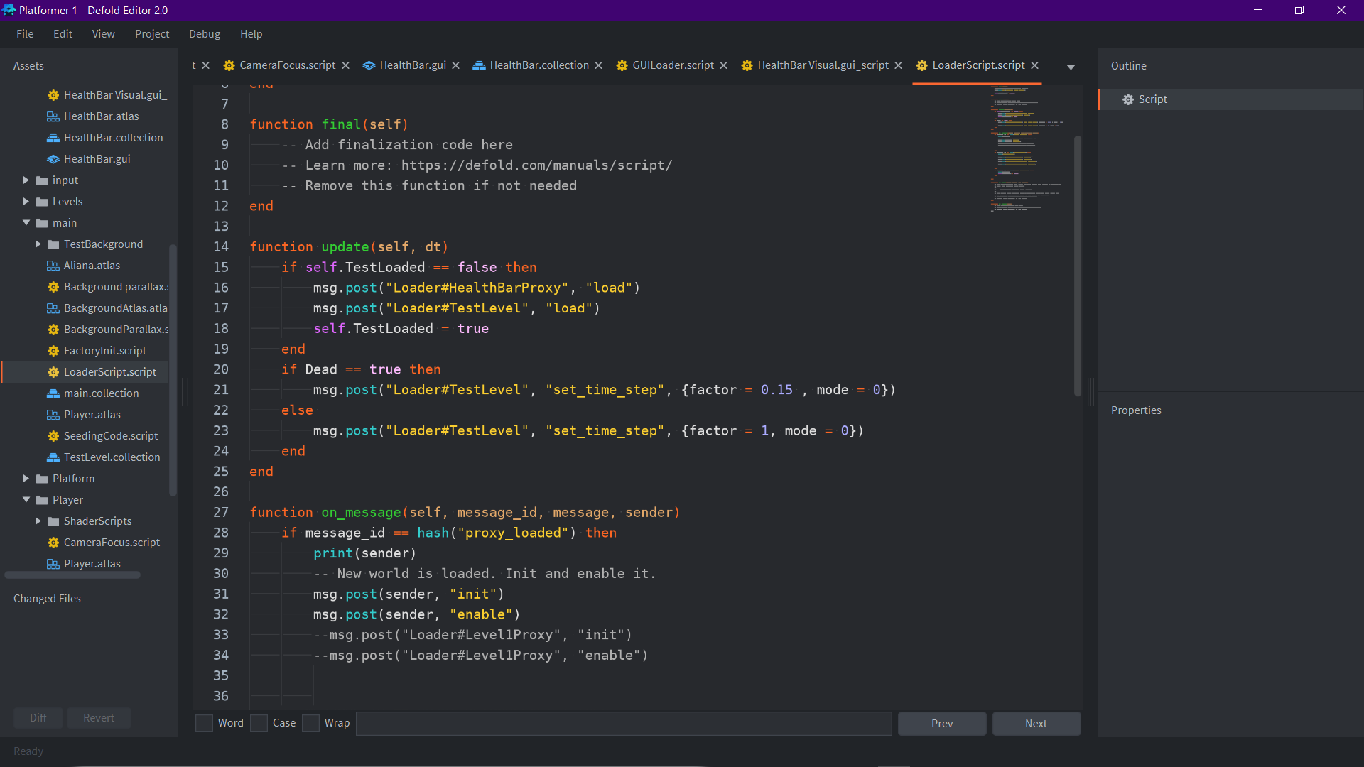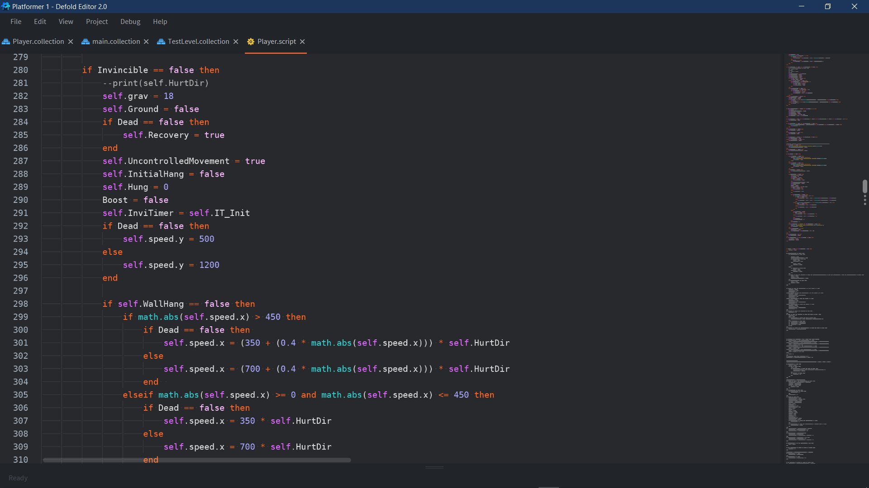

To get the slow down effect on death I simply reduced the timestep of the in-world proxy to 0.15 whilst keeping the GUI timestep the same, so it isnt affected by the slow in time. This effect is reverted when the player is brought back alive on reset. To exaggerate the knock-up on the player when they die the forces applied to them from being damaged are multiplied by two- this is because slowing down the time step of the proxy messes with the physics in such a way that the original force brings the player to a lower peak than when running normally.

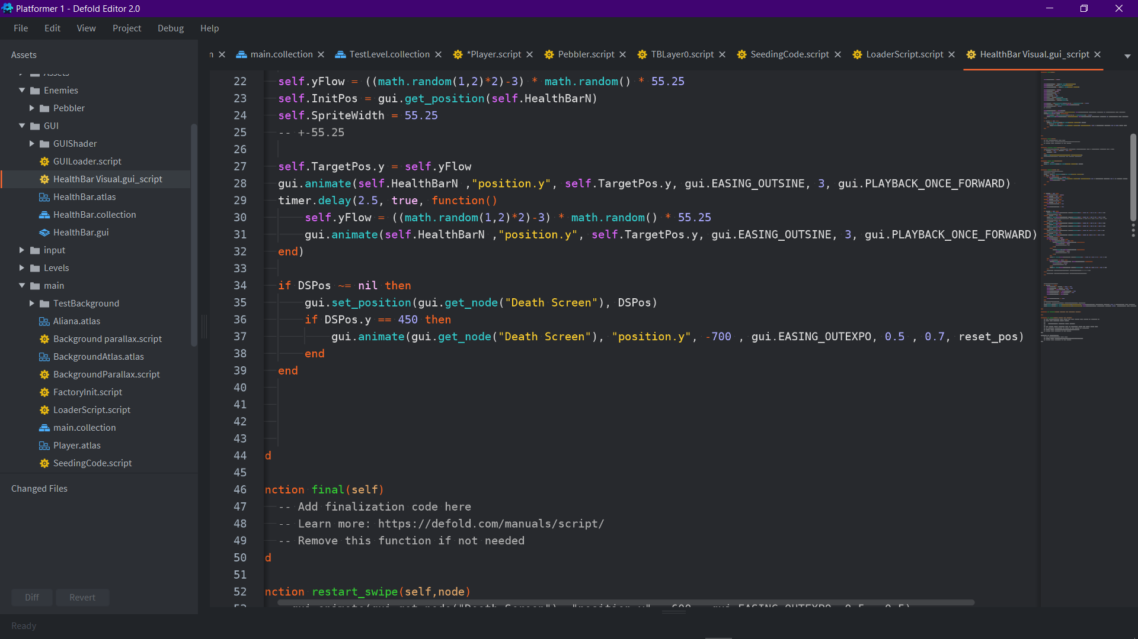The GUI uses the DSPos variable to set its position to where it was before it gets unloaded, so that it can save the state that it was in, here if the screen is in a state where it covers the entire screen it will play an animation which swipes it downwards from the screen. It then will run a function which resets its position to the original position it starts with on first initialisation. This is where I have managed to reach up to so far with the project, there are much more features however, that I have planned to implement. My next focus will be creating the attack of the character.

Evaluation

Focusing on the main view points

<https://share.vidyard.com/watch/6Sdsa1zKWmaUH8jE8A7QnK>?

This video is an excerpt of project gameplay, refer to here to see the final project (so far). It contains all evidence of program development and the current state of gameplay.

Complicated Player Movement

Player Movement

|  |  |  |  |  |
| --- | --- | --- | --- | --- |
| No | What is being tested | Expected Output | Pass/Fail | Timestamp |
| 1 | Fast Speed | The player starts slow and slowly builds up speed the longer they run for. | Pass | 0:00 – 3:38 |
| 2 | Player moves with Joystick | The player moves left and right in relation to the joystick, but only when it is held far enough in either direction | Pass | 0:00 – 3:38 |
| 3 | Player Boosts in direction of Joystick | The player has a boost that works in the direction of the joystick, and upon completion, allows the player to move normally. | Pass | 0:00 – 3:38 |
| 4 | Wall Jump | The player will have to jump alternately from wall to wall to be able to scale up higher, otherwise they will slide down a single wall. | Pass | 0:07 – 3:24 |
| 5 | Grappling Hook | The player will shoot out a grappling hook and be able to swing from platforms using the force the swing was initially given | Fail | N/A |

The Speed Milestone was fully achieved using an acceleration formula based off of the original formula from the classic sonic games. The player movement and boost direction have both been fully achieved simply using Defold’s hashing system to get controller input. These have been tested by simply running around in the game and using the boost whilst holding the joystick down in different directions. The Wall Jump has been fully achieved and was tested by holding on to walls and jumping alternately between each of them.

The Grappling Hook Milestone has not been achieved as I feel as if I have already achieved enough complex movement in mid-air and would like to focus more on ground movement.

The movement on the player was an especially crucial factor of the project as my goal is to make a flashy, bold, and skilful game which rewards the player for platforming accurately and dodging enemy attacks. In this sense I wanted to make a movement system which was intuitive to pick up but has room to learn about with specific intricacies and movement options which expand the player’s potential for being able to platform, reach areas and evade enemy attacks. I think that with my Variable Jump, Boost and Wall Jump along with their more complicated use cases such as Spare Boost, Mini Hop, and the Wall Jump assistance all work together to make a system which has enough complexity to allow for dynamic and fun to use movement.

This was not the only goal for the movement however, I also wanted to make sure that the movement of the player would be easy to pick up and understand without play testers needing to be explained how the different actions work: I wanted to make movement as intuitive and self-explanatory as possible. Through using multiple different play testers in my sixth form I learned that over-limiting the jump on purpose when tapped results in many players automatically pressing the jump button longer, in turn self-teaching themselves how the jump varies with how long the button is pressed. The decision to give the wall jump “backwards controls” worked beneficially as most players were able to perform the wall jump without any prior experience with my game’s movement.

Another Important decision for keeping the movement “simple with room for complication” is mapping the jump and boost to one button whilst using the joystick to control both movement and the boost direction. Using only two buttons for all of player movement makes input commands very simple for the player to learn as they can experiment easily through “spamming” the buttons. An example of this is players learning that the boost is directional by activating the boost while trying to move in a specific direction, and seeing that the boost isnt a simple double jump but a control set force in a direction chosen.

Overall, the Movement of my player has succeeded in achieving my initial ideas for how the player traverses the map and makes itself easily approachable to be learnt and experimented with.

Looking further onwards, I would implement more complexities in movement, for example adding a dodge, or a special move that gives temporary invulnerability in mid-air, possibly connected to the main boost in a way with a special gauge etc. I would find ways to make ground movement more dynamic as current movement options are all focus on increasing in air mobility, an idea I have to make ground movement more dynamic is a roll or leap, a long low vertical action which lets the user move faster on ground than in air. I would implement this by first adding a second collider to act as the player’s curled up form and switching between the two and then adding a strong x force whilst disallowing and y movement manipulation for the duration of the roll. I could also add slope collision effects by making the roll end slower if going upward and make it increase speed more going downwards. The input command for the roll would be movement with the joystick in a downwards direction whilst pressing the jump button, however if this makes player control too difficult it could be assigned to a new button.

Camera Controls

|  |  |  |  |  |
| --- | --- | --- | --- | --- |
| No. | What is being tested | Expected Output | Pass/Fail | Timestamp |
| 1 | Camera Follow | The Camera follows the player with a slight delay so it is not too rigid. | Pass | 0:00 – 3:38 |

My camera controls were never a main focus for the idea of my game, however after implementing different affects to the game it is clear how important good camera controls are to assisting the player experience with the project. The idea of zooming out the screen in proportion to the player speed gives the player a sense of immersion as the on-screen stimuli increases the more the player gets into the game and the faster they move around.

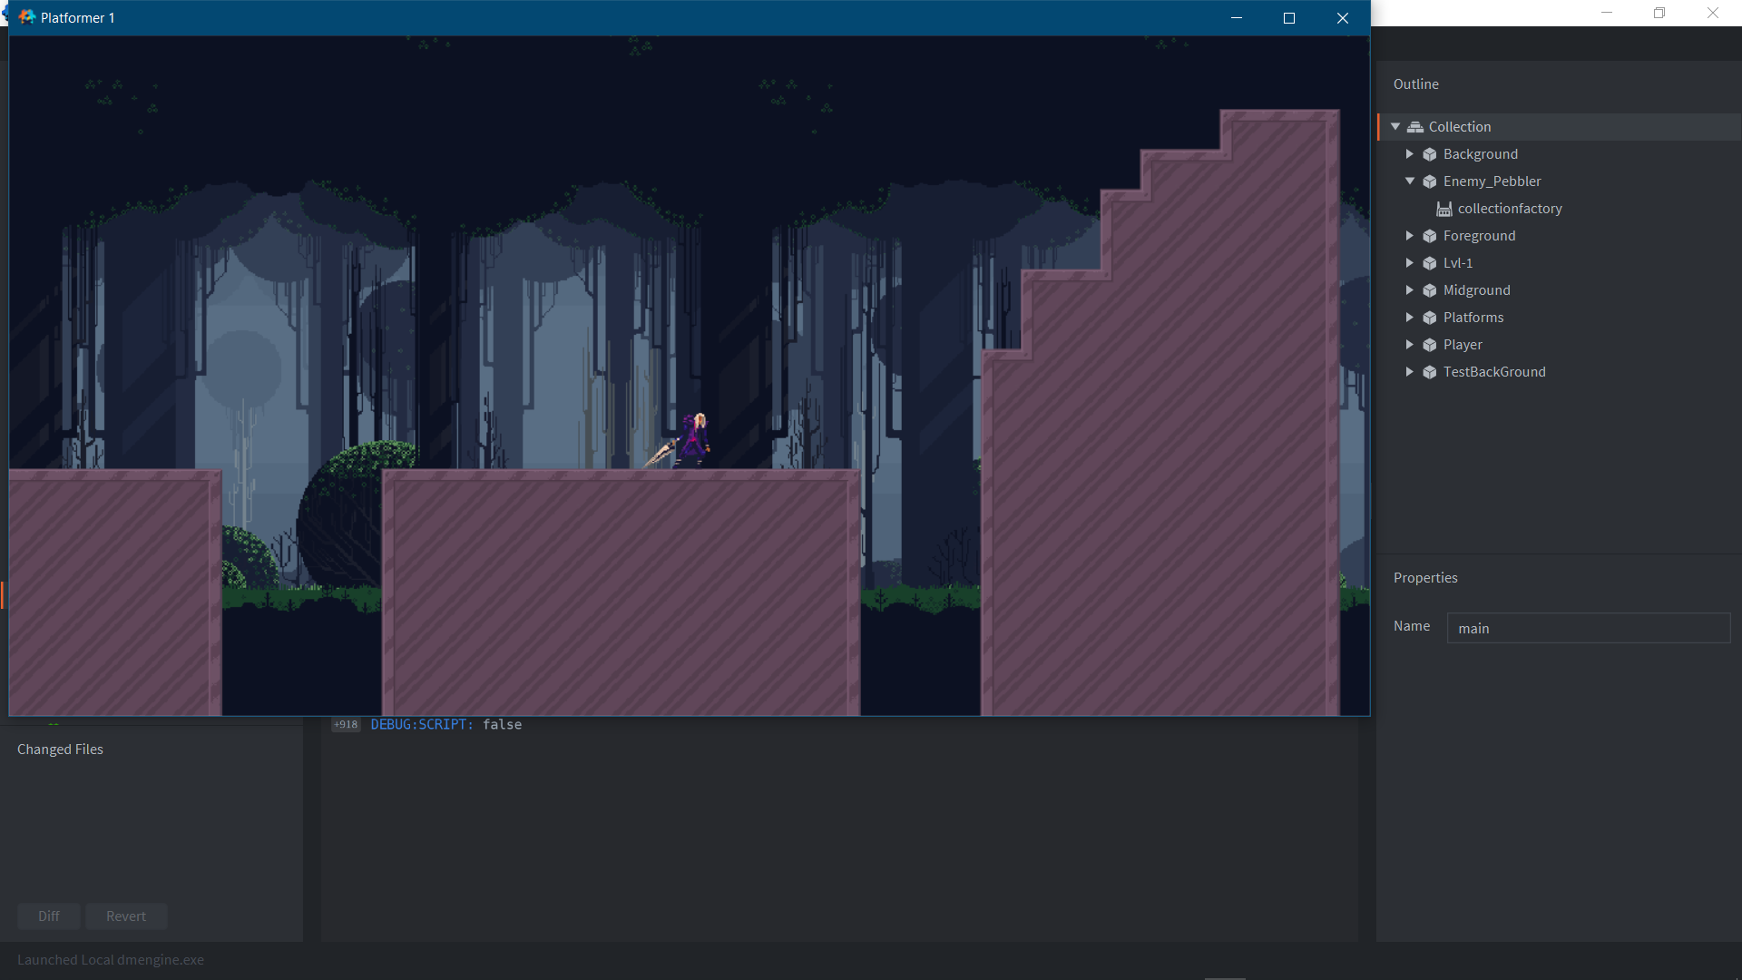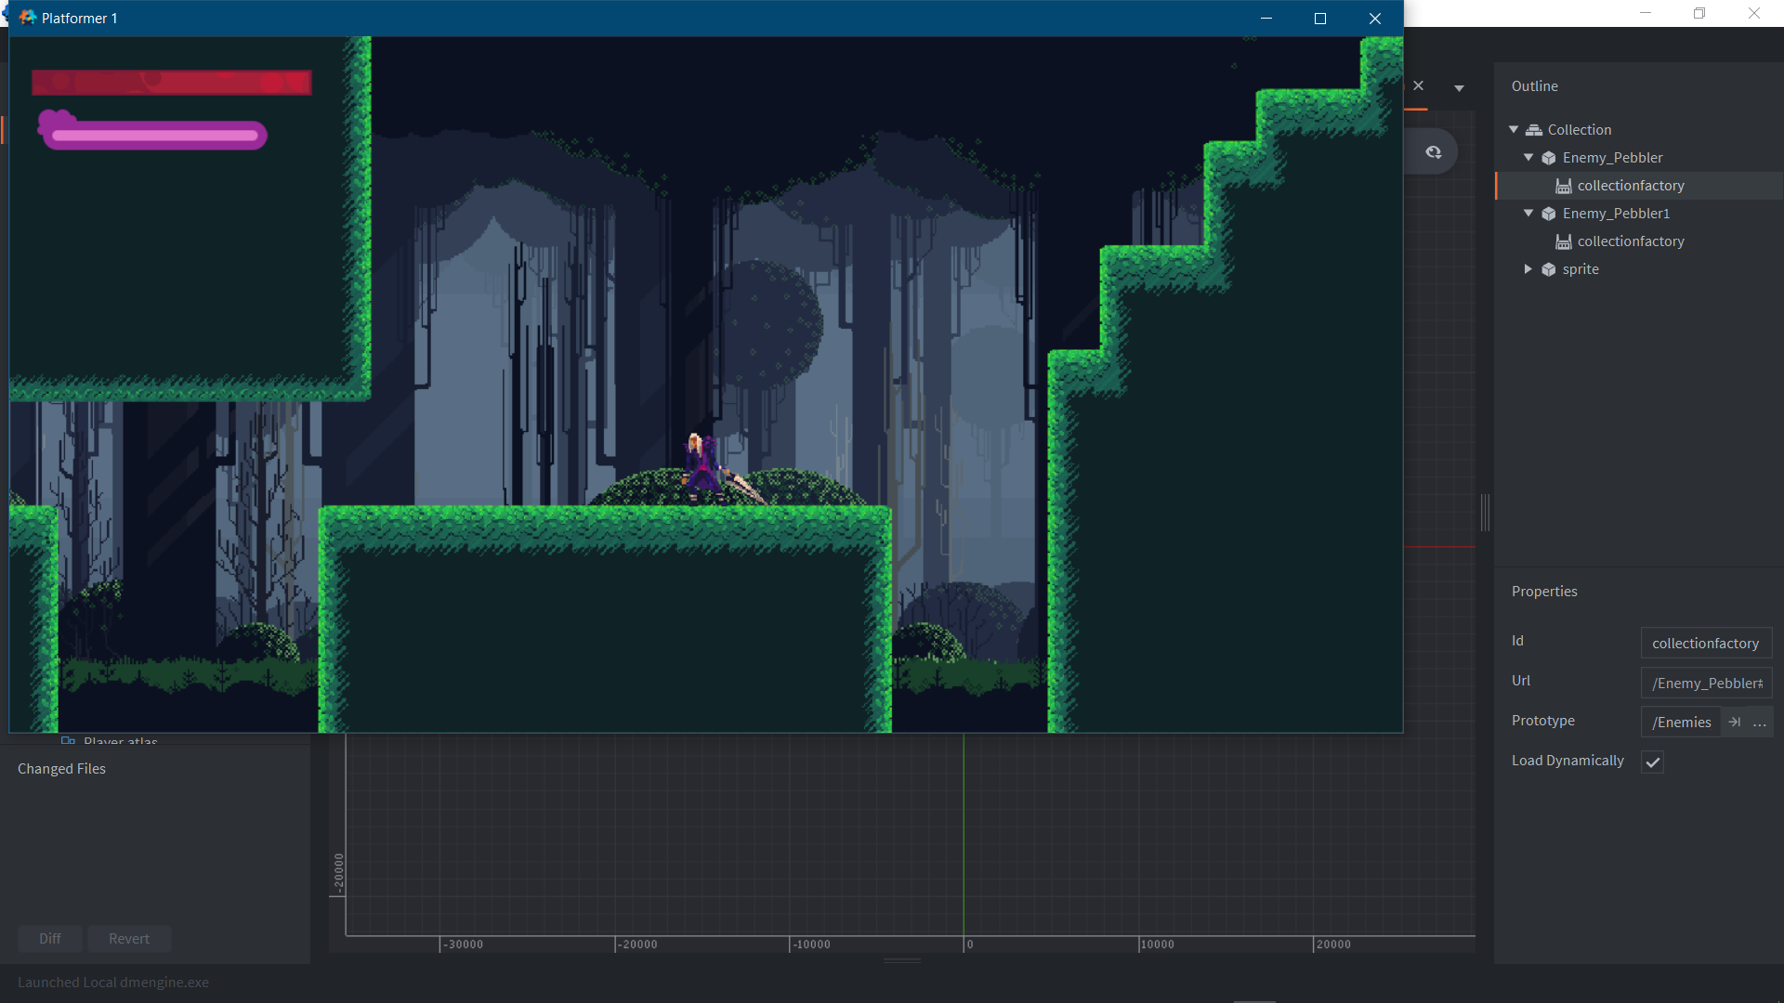

Player testing feedback was a necessity to get the feel of the camera right, as it was a noticeably clear issue that the screen’s max zoom was too far out for players to be able to comfortably read everything on screen as mentioned by my stakeholder. This led me to decreasing the total zoom present within the game and adding a lookahead system instead to increase the reaction time given to the player, this also led to me adding a camera pan command with the joystick for scenario’s where platforms cannot be seen due to being too high or low. This new camera set up proved to be much easier for players to use and handle with.

Overall, the camera controls had exceeded my initial ideas and expected relevance in the project- the camera became a crucial factor in toning the “feel” of the game as well as heightening the in-game experience for all the players.

Developing further, the camera would only undergo small tweaks, I do however have ideas for the camera to zoom in on specific effects or actions such as the attack, being damaged could also cause a small shake effect to play on the camera or the camera zooming out to view bosses. I also have planned to make trigger collisions for places in the world which may require the camera to be moved down lower to account for low platforms or an event where a specific portion of the level is panned over and viewed before the player themselves gets access to that portion. The main system of the camera would stay the same- however there are many cases that would need specific camera actions to play out and those are what would amass growth in the camera script code. The trigger pans would simply be colliders placed within the level collection which send individual messages to the camera controller to move it to a certain position.

Enemies

|  |  |  |  |  |
| --- | --- | --- | --- | --- |
| No. | What is being tested | Expected Output | Pass/Fail | Timestamp |
| 1 | Enemies that follow the player | Enemies that can track the player and go in the same direction as the player | Pass | 0:04 – 3:34 |
| 2 | Attack | Some form of attacks that damages the player and stuns them briefly | Pass | 0:04 – 3:34 |
| 3 | Death | Health attached to the enemy that when reaches 0, results in the enemy dying and staying unloaded in the level. | Fail | N/A |
| 4 | Multiple Enemies | Multiple Enemies which range in size, power, and health. | Fail | N/A |

The first milestone was fully achieved and tested by moving into the enemy's detection range and then watching to see how accurate the follow detection is. The attack was also fully achieved tested through running close to the enemies and waiting for their attack to initiate.

Having Enemies or any type of obstacles in a game is important- as it gives the game a force to fight against, and gives the game more active immersion. My overall idea with the enemies was to have a system where enemies larger in size have larger health values and would require more powerful attacks to defeat whilst also bearing more dangerous damaging attacks and complicated attack patterns. In context to the idea of my attack and with the idea of a potential scoring system, I would design my enemies to be two types: “group gangs” where if played correctly, the player can line up their attack to attack and defeat multiple enemies at once, increasing their score multiplicatively and giving speed benefits; and large brawlers, where the player must work around building up their speed and whilst dodging enemy attacks to defeat the enemy in the least amount of hits as possible. Larger enemies such as this is what would spur ideas for bosses, or mini bosses at the very least. These would be implemented as new collections that use larger sprites with different attack patterns and higher health/ damage values associated to them. These enemies would then be called in various places in the level through collection factories.

The enemy that I did produce, is a product of the first philosophy for enemy design, a quick, low damage, low down time enemy which has no trouble keeping up with the players speed and works well in a large group of each other, granted they can keep the player locked down. I believe that Pebbler (the enemy) in its current state is a good representation of the feel I want for the enemy to have. Right now, with multiple player movement values needing to be tweaked and speed to be worked in a way that can be used as a reward, the enemy’s speed and lock on range are not final as they would always be intrinsically linked to the limitations of the player.

Focusing on how the enemy attacks however it has no problem keeping up with the players speed with the boosts in speed it gets when it attempts to attack the player, even with its small damaging hitbox the timing at which it boosts towards the player makes them quite a threat when giving chase- especially with the knock-up effect it has makes it a difficult enemy to work with. I have found however three faults with the enemy, the first one is intentional as the damaging hitboxes are so small after you build proficiency with movement it becomes quite easy to dodge in free air space. The second is that the enemy AI is extremely basic and can sometimes miss the player if they are standing completely still, as they are designed to aim for where the player is going to be while they are running, this can result in some funny situations where the player is standing still with the enemy struggling to be able to hit them. The third problem I have found is again through player testing, the enemy, especially when in a large group of themselves- if they knock the player down into a small pit it is almost impossible for the player to be able to escape the pit even with perfect wall jump commands, the enemies are too overbearing and do not give the player enough lenience to be able to escape a situation where they are all hovering around them. This would be a revision for the near future to see how I could make them less bearing in these situations- it could be as simple as increasing the invincibility frames, or reducing the recovery time if colliding with a wall, however I would like to produce a solution that does not impact the rest of the game based off of a single enemy.

Although the enemy that I have currently produced is very satisficing for the current state of the game the development of enemies has not reached the level of development I had originally planned for the project. This was due to a mix of my initial idea being quite a reach for the development period set, having multiple different sized enemies all with different AI systems and world interaction all with different attack patterns and damage values is a much larger feat than given time for. With the main goal for the enemy system not being reached the single enemy developed is a success in achieving a good basis for design of all future enemies and allows me to test further the limitations of player movement.

For future development, my main aim would be to increase the variety of enemies within the world and to give them systems to unload and reload when far enough away from the camera/ when the camera gets close enough, this would be very performance effective whilst also expanding on the games roster of things to do. I would also aim to create a large boss which has multiple attack patterns and phases that initiate from the depleting of their health. The boss would be created as a collection with a large sprite and multiple different types of attacks and associated collisions, it would then be place in an area or a form of endless runner space which allows the player to build up speed and attack the boss.

Health and HealthBar

|  |  |  |  |  |
| --- | --- | --- | --- | --- |
| No. | What is being tested | Expected Output | Pass/Fail | Timestamp |
| 1 | Health affected by attack | Health that gets reduced when being attacked by an enemy | Pass | 0:00 – 3:38 |
| 2 | Passive Health Regeneration | The health value slowly increasing over a period | Pass | 0:00 – 3:38 |
| 3 | Healthbar | A simple healthbar which shows the player how much health they have left | Pass | 0:00 – 3:38 |
| 4 | Healthbar Warning | A warning to the player that their health is dangerously low | Somewhat Pass | 0:00 – 3:38 |

The health system and healthbar is functional, however it has room for improvement. At this point in development health is just a simple value that is always passively increasing and initiates a death protocol once it reaches 0. I have made two prototypes of health bars to try and portray the amount of health left but I am not satisfied. My target is to make a fighter style health bar which shows two bars inside the health block. The second bar would portray how much the player can heal up to as long as he does not get hit before the healing takes place, this means that the player will have a permanent repercussion for being hit but will still be able to make up for their mistake by playing the game well. As an example, a hit of damage 200 would bring the health down by 200 but would reveal a second bar, this second bar would only be reduced by an amount of (example) 100; in this scenario if the player is then able to play the game without being hit, they can get a maximum heal of up to 100 from where they were. So, using 1000 as a base value for max health a hit of 200 would bring the health down to 800 however the player would be able to passively heal back up to 900 unless they are hit again- in this scenario it would mean each hit has the potential to do half damage if you are able to make up for your mistake.

Health bar systems are extremely important as they can be very defining to how your game is played and the personality of your game. Using Sonic as an example he has an extremely forgiving health system, giving you a free hit of damage as long as you have coins, and then putting the coins right next to you once you get hit- this philosophy lends to going fast as you do not have to go out of your way to reach the prior level of security, whilst at the same time being punishable if you get hit before you can find more coins. I feel like the system I had just described here replicates this, not being able to completely remove the punishment of being hit but also not being something that the player must overly focus on, due to being able to heal up the player can focus more on going fast and playing well enough to not take or heal up any damage instead of worrying about each hit being permanent damage.

The next steps for developing my health system would be to focus on the visuals so that the player can accurately read the healthbar whilst also being visually appealing, my idea would be to mix the two prototype health bars together to make one which is as interesting as the first, whilst being as simple and readable as the second.

Death Protocol

|  |  |  |  |  |
| --- | --- | --- | --- | --- |
| No. | What is being tested | Expected Output | Pass/Fail | Timestamp |
| 1 | Death | The user loses player control and the level resets | Pass | 0:51 – 0:34 |

The Death Objective has been fully achieved as it was a short milestone to fill.

The death system in the project is very underdeveloped- as it only serves to restart the game with no wider effects on gameplay. The one thing important about the restart initiated from the death is the speed at which it reloads and resets the level at, through research I found that games with longer restart timers on death (for example the New Super Mario bros. Series) tend to result in higher “rage” to players than games which quickly restart the level. NSMB exaggerates this effect through its iconic forms of the death music which is synonymous with failing a level, this death theme along with the amount of time the player waits for the level to reload can be a heavy detriment to player retention and simply wastes a lot of extra time. For my death sequence I wanted it to play like that of “Celeste” which is a more complicated form of blackout which leads to the level restarting as fast as possible, my death sequence is not as seamless as Celeste due to coding inefficiencies and the limitations of the Defold engine however it tries to be as fast as possible.

Going forward the development of the Death Protocol is linked directly to the development of the game. There are two main routes I could go down, the arcade system and the modern system, the arcade system simply being lives which are depleted every time you die, usually with all of them being depleted sending you back to a further part of the game- or the modern system which uses either currency as a forfeit or some other type of punishment, some games do not even use lives at all. At this current point in time, I cannot make a clear decision on where the Death system will lean over towards, as it is too heavily dependent on the development and feel of the entire game.

Missed Milestones

From Here on these milestones were all missed due to time constraints, in my development process I have gotten as far as beginning the visuals for the attack. These are now plans for the development of this project that will build upon the game and work towards my initial aim and goal for this program.

The Attack and Scoring System

For my attack system, I have simply only started with testing out using more shaders to show the range indicator and aiming direction. This requires shaders to be developed as the range would change continuously in proportion to the speed of the player, so would not be able to be accurately depicted with simple sprites, even with the prospect of manually increasing sprite size would not keep the thickness of the range indicator constant so is not an applicable solution.

On further development, the aim is for the attack to work with two segments- being another boost in aerial movement for the player, and have a collision with enemies that can range in size and dimensions. The first section would be incredibly similar to the already implemented boost however with a variable amount of force and not being limited to 45-degree angle increments. With Defold’s limitations however, being able to simulate a collider which varies in size will be much more difficult as it is not innately supported in defold- and would have to be simulated by using code to create a collision shape at run time, receiving collision messages from this system and passing it into other scripts would be an extremely perplexing task as was the main reason that I had put off developing the attack without as developed knowledge of Defold as I have now.

The Scoring system would logically be the next feature to be developed off of the Attack as the attack would have the most effect on the score. I have a clear idea for how the Scoring system would work: the larger and higher the health the enemy the more points they garner for being defeated and the more enemies defeated using a single Attack raises the points gained from all of them by a multiplier proportional to how many enemies attacked. The score would also be influenced by the number of times hit, time taken to complete the level and even further development- adding features such as a “perfectly timed” wall jump to increase speed and score if performed properly.

The Boss

The eventual development of the boss was completely dependent on the completion of all other features of the main game, and suffered from the project not having a set level and just a test space. The Boss itself had no concrete idea in mind, and could have ranged from being a large enemy with a high health value and more complicated attacks, to a barrage of enemies, or even a massive titan like monster that the player must somehow evade the destruction of.

Developing the Boss would be split up into phases, where the boss is given multiple different forms of attack and the attacks which increase in damage, speed, and difficulty of avoiding would be cycled to the lower the health of the Boss gets. These phases would lock off these abilities from being used by the Boss at specific points, and would lead to a build-up of desperation / anger in the enemy before they are finally defeated. The boss would be loaded in by a trigger collider set inside of the level and would have a dedicated arena / endless runner section dedicated to it. On the defeat of the enemy the level would be completed and would signal for the end of the game.

Level Design and Visual Fidelity

My project currently runs as more of a tech demo than an achievable game, so I have not been able to explore different facets of level design to appeal to my characters move set and focus on speed. I do however want the player to feel less dependent on using the boost as a main movement option and use it as an aerial re-alignment tool when in a problematic situation- this would reflect my level design by having jumps that are easily achievable without a boost and slowly increasing the players confidence on non-boost jumps so that they can use the main jump to its full powerful extent, I would also like to make the levels somewhat of a world to explore- however still with a clear linear paths, I wouldn’t want to leave too much air space and give the player walls and platforms to be able to use to jump up off from. Following the design philosophy of classic sonic games, I would make a path system which rewards you for being able to stay higher up on the more efficient, but difficult to platform on paths. Although I have ideas set for level design, it is extremely hard to tell what works without being able to test in game and my game philosophy could completely change based on stakeholder input from player testers in my sixth form.

The Visual Fidelity of the game refers to adding small animations and different shaders to make the game look nicer. Gameplay wise I would add on screen affects when health gets low so the player does not have to constantly check and look between the game state and their healthbar and can instead “feel” when their health is low. An effect to depict low health can also increase immersion and make the situation feel more dangerous as they are a couple/ single hit away from dying.

Stakeholder Feedback and Testing

My Stakeholders in the form of my sixth form colleagues have been consistently testing and giving feedback on the different stages of development and features of my game, they have directly impacted features such as the camera, the speed of the player and the usage of the wall jump. Now viewing the project overall, it is clear that the ability to attack is the main feature that player testers wish to see developed. They are satisfied with the movement options and inputs in the game but quickly find themselves losing things to do within the game. With a good basis for how my game will run, it is now vital that I build a way to fight back within the game and implement a main goal to achieve also.

Testing through the game has seen success stakeholder wise for all the currently developed features, they enjoy the current design in the test scene and can use their movement options to the best of their ability. However, at current due to the movement abilities of the enemy play testers struggle to work around avoiding the enemies’ attacks as they are too fast. Eventually I would work on balancing the enemy’s values and making the players’ attack a good balance from being effective but not removing all difficulty.

Limitations

There have been many limitations in the development process of building this game, many have been able to be worked around but resulted in a lot of programming time being wasted on solving issues that would not be present in an ideal programming experience. The main limitation programming wise has been the software used for the Defold editor; Defold uses a lot of old software such as their collision engine for 2D colliders (Box 2D), this collider they have is so old it does not support new additions such as Composite Collider which would fix my Tile Glitch that resulted in me making many workarounds to eliminate from the player experience. As well as this the Defold Engine can be very unreliable to use, in many scenarios the engine has suddenly frozen or suddenly lagged out causing my player to get sudden explosions in force, or be unable to read collisions and end up teleporting to inside ground collisions where they cannot escape. This has made testing the game take up much more time than needed as it has wasted time on randomly, non-code caused issues that I have not been able to reliably fix.

Another Issue is Defold/ Lua parity, although Defold uses Lua, many of the scripts that you write are not written in Lua format, meaning learning how to perform techniques in Lua have to be manually translated into Defold’s innate language- in saying this however, defold has a very simple and easy to learn syntax which has helped massively in being able to quickly learn and understand its usage cases.

An In-game limitation that is present is the absence of any aim/ goal to get to, as I had focused on polishing and making a developed physics and movement system, as well as polishing and focusing on the player-enemy interaction, I have not been able to develop a proper level and end sequence to the game, making it play as a tech demo then winnable game. This has heavily reduced the retention of my player testers making getting information from them take slightly longer than it would have if they had a goal to work towards.

Finally, I have a limitation with my game being programmed for controller only (Left Joystick and L1), there are some keyboard inputs (Arrow Keys and A) for simple left-right movement and jump, however the Boost Jump specifically requires the input command from a controller, limiting the wall jump and boost in any other direction apart from up to be only accessed via controller. Although my original idea has always been to develop a controller only game my colleagues' keyboard-controlled projects do have a higher ease of use than mine.

Maintenance

After implementing all features, I plan to create maintenance features such as an update system which automatically redownloads all the games files to its most current version whilst keeping all user specific data (such as high scores). Additionally, I can add a report feature where the player can report any bugs that they may have encountered as well as being able to send video evidence of the exploit so that I can look on it and fix the issue myself.

Final Words

The development process of this game has been a helpful experience in growing knowledge in developing games and learning about facets of game design. Overall, the project I have developed so far is an extraordinarily strong basis to build an entire game off of, and has high potential for growth.

Scripts

*All Held Within the Assisted Game Project File*